Recorded: | 28 AUG 2013 | File: 1 of 3
Interviewer: | Margaret Horsburgh
Abstracter: | Margaret Horsburgh
Equipment type: | Fostex FR- 2LE Digital Recorder

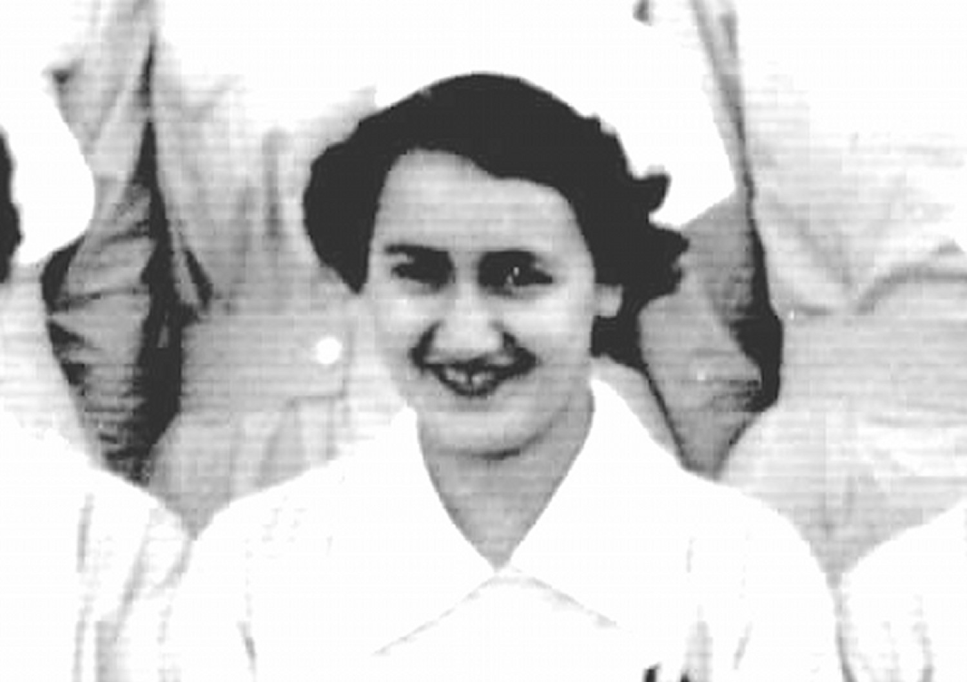Photo 1 | 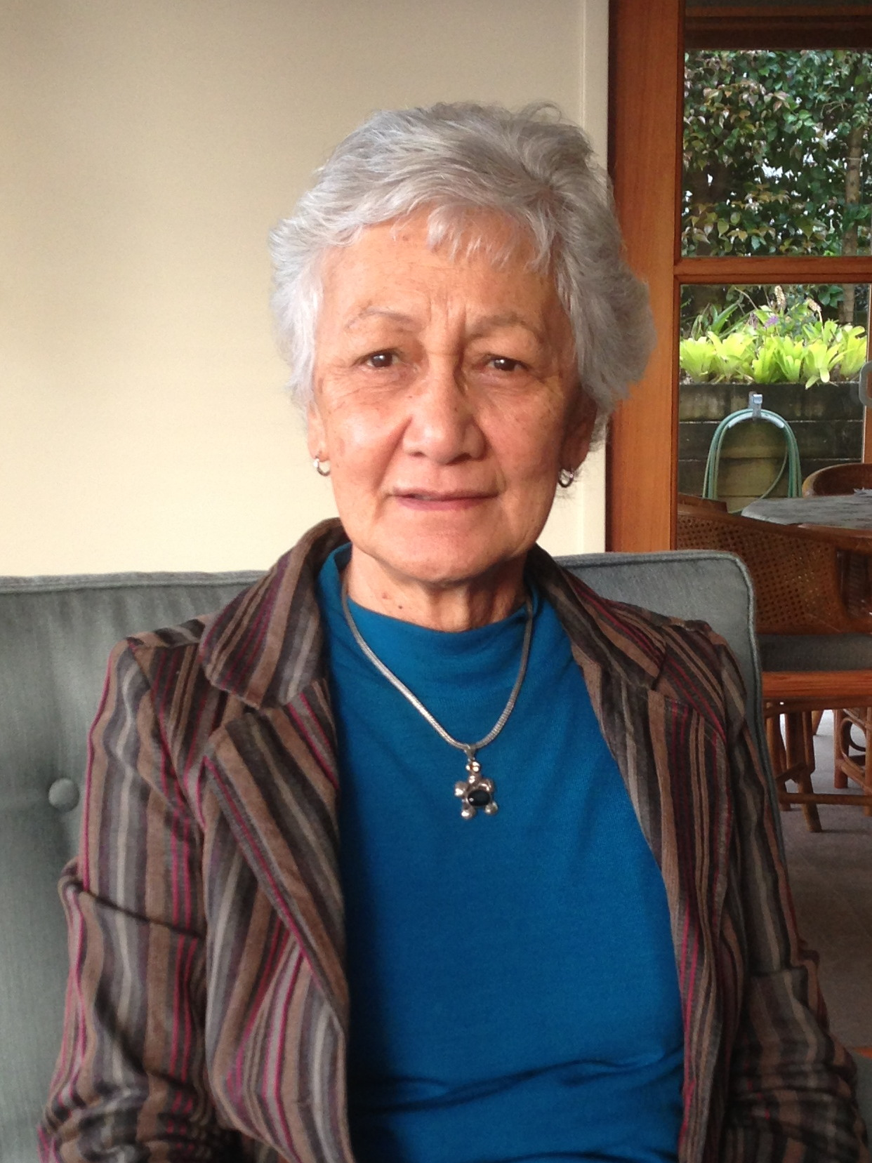Photo 2 | 1. Elizabeth Nathan, Preliminary School  2. Elizabeth Mitchelson, 28 August 2013

000'20" | INTRODUCTION TO FILE 1
000'34" | GROWING UP
Born [1935] and grew up in POUTO, KAIPARA HARBOUR. Lived with maternal grandmother until age 7 years, returned to live with parents when grandmother died. First child in family, grandmother took eldest child from each of her children to live with her. Parents lived on farm, 'about 20 kms from grandmother'. Details.
Nearest town, DARGAVILLE. No road to POUTO, 'recall riding with grandmother to the point where the delivery van arrived with groceries'. Shopping 'went by launch between POUTO and DARGAVILLE and also POUTO to HELENSVILLE'. Details.
004'04" | FAMILY
Father a labourer on a farm, mother had married young. Younger siblings, three sisters and two brothers. Describes.
When returned to live with family, only one sister. Grew up helping look after younger siblings. Describes.
005'51" | SCHOOLING
Attended local primary school, 'could walk along road or along the beach ... if the tide was out'. Nine MAORI pupils at school. Describes.
RUAWAI DISTRICT HIGH SCHOOL for secondary education, mother often ill, 'father would get me home to help care for her ... completed third and fourth form and then correspondence when home ... needed at home'. Describes.
008'15" | EARLY NURSING INTEREST
 | Aunt, mother's eldest sister, 'did all the birth deliveries in the area... not a nurse ... or trained midwife ... delivered all the babies ... thought quite a nice career’. Describes.
008'59" | HELPING FAMILY IN AUCKLAND
 | Uncle, father's brother, in AUCKLAND, had twin sons and a three year old, 'offered my services to come and help ... care for the children'. Lived with them in HERNE BAY, AUCKLAND, moved with them to OREWA. 'Started working in one and only shop in OREWA ... change from looking after little boys'. Describes.
010'50" | DETERMINED TO APPLY FOR NURSING
 | Determined to train as nurse. Father could not understand. Made an appointment for interview at AUCKLAND HOSPITAL. Describes.
011'23" | INTERVIEW
 | Travelled alone by bus from OREWA for interview, 'shaking in my boots'. Chest X-ray and other examinations required. ‘Didn’t think I would have the courage to do it on my own.' Describes.
013'29" | ARRIVING TO START TRAINING
Commenced nurse training, May 1954, AUCKLAND HOSPITAL. Came alone in bus from OREWA. Had been provided with list of what to bring, 'why do I need to bring a cup and saucer?'. Very nervous. Describes.
Arrives MARKET ROAD, PRELIMINARY SCHOOL. Explains.
015'10" | NURSING CLASS
 | Thirty girls in class, one other MAORI girl, from HELENSVILLE. Most of girls straight from school, from around AUCKLAND area. Describes.
016'54" | PRELIMINARY SCHOOL
PRELIMINARY SCHOOL 'was very strange... regimented... bell went and you went to breakfast ... bell went and you went to class'. Wore uniform, pale blue, white shoes and stockings, white hats. Twelve weeks. Describes.
Classes included ANATOMY and PHYSIOLOGY, 'very different from anything learned before... SISTER taught the practical'. Describes.
Saturday spent day in the wards, AUCKLAND HOSPITAL. Explains.
020'00" | NURSES' HOME
 | Moved to NURSES' HOME at AUCKLAND HOSPITAL, comfortable, 'good to be all together'. Own rooms, shared bathrooms, lounge for visitors, swimming pool. Describes.
021'51" | MAINTAINING LINKS WITH FAMILY
One day off a week, 'wasn't possible to get a bus to home and back again'. Went home only in holidays. Did visit homes of fellow trainees, had aunts in AUCKLAND, 'got bus to visit them occasionally'. Describes.
Mother interested in training progress, 'father had got used to idea'. Describes.
023'05" | SIBLING CAREERS/ANOTHER NURSE
 | Sister worked in telephone exchange in AUCKLAND, eldest brother farm work, another 'really good shearer'. Took one sister for an interview for nursing, 'she took one look and no way she was going to be a nurse.' Youngest sister trained as COMMUNITY NURSE, ST HELENS HOSPITAL, later went to work in ABU DHABI. Describes.
026'22" | JUNIOR NURSE
Started in MEDICAL WARDS, some SISTERS difficult. One WARD SISTER, 'like a SERGEANT MAJOR ... used to stand at main door and bellow ... ran ward like clockwork'. Describes.
Tasks as junior nurse, cleaning and tidying the sluice room, damp dusting. Describes.
029'28" | PATIENTS
Patients in hospital, with PNUEMONIA, CHEST AILMENTS, HEART ATTACKS, stayed in bed, 'assisted to sit up while made the bed'. Describes.
No disposable equipment, stainless steel. 'Some of senior nurses very good ... got you to do the dressings'. Describes.
031'45" | MIDDLEMORE HOSPITAL
MIDDLEMORE HOSPITAL for ORTHOPAEDIC nursing, 'so different from AUCKLAND ... patients were well except for their fractures ... much easier to engage with them... many young ... a lot of fun'. Describes.
'Back brace ... complicated piece of apparatus... under the bed trying to strap on ... saw MATRON floating up ward'. Describes
034'27" | NIGHT DUTY
 | Started doing NIGHT DUTY towards end of first year. Explains.
034'55" | WARD SISTERS
 | 'Could warm' to some WARD SISTERS. WARD SISTERS wrote reports at end of each time in ward. Describes.
035'37" | STUDY BLOCKS/TEACHERS
 | Regular Study Blocks at AUCKLAND HOSPITAL. DOCTORS gave lectures. TUTOR SISTERS taught practical things. SISTER BROWN, 'was absolutely adorable ... quiet manner ... good way of teaching'. Describes.
037'43" | COMMUNITY AND MATERNITY EXPERIENCE
 | No COMMUNITY experience. MATERNITY at PUKEKOHE HOSPITAL, at end of training, six months. Describes.
038'40" | EXAMINATIONS
 | 'Very nervous ... managed to pass them all.' Practical examinations, hospital and STATE examinations. Explains.
039'31" | EMOTIONAL SUPPORT
 | 'Made very good friends ... sometimes go to their homes.' Would get together in NURSES' HOME, ‘supported each other as individuals'. Describes.
040'46" | NURSING WAS AS EXPECTED
Some of class 'dropped out', MAORI student in group dropped out. Explains.
By end first year, realised depth of knowledge needed, 'I was coming in blind... had only seen aunt 'when she was delivering babies'. Describes.
042'24" | DOCTORS
DOCTORS 'used to put fear of GOD into me ...NEUROSURGEON ... everyone fearful of him'. Describes.
Did not go on DOCTORS' ward rounds, SISTER'S role. More to do with HOUSE SURGEONS. Describes.
Senior nurse, third year could call DOCTOR. Explains.
044'02" | SOCIAL LIFE
 | Social life included going to movies, local dances, ORANGE HALL, TRADES HALL, MAORI COMMUNITY CENTRE. Describes.
045'23" | KEEPING IN TOUCH WITH FAMILY
 | Went home for holidays, family gatherings. Explains.
045'42" | HOSPITAL SOCIAL
 | HOSPITAL had dances in dining room, nurses, police came. Explains.
046'22" | SMOKING AND ALCOHOL
'Three or four in class who smoked like chimneys ... had one cigarette ... spent more time going to the bathroom to brush my teeth ... never smoked.' Many people smoked. Describes.
Alcohol very rare, cup of tea and cake at dances. Describes.
047'22" | HOME SISTERS
Rules around time to be in NURSES' HOME, SISTER GODDARD checked that people were in. HOME SISTER looked after NURSES' HOME. Describes.
Attended SICK PARADE when sick. Explains.
048'58" | BASKETBALL TEAM
 | Played in Hospital, basketball team 'went as far as THAMES HOSPITAL'. Describes.
049'46" | CHRISTIAN LINKS
 | NURSES' CHRISTIAN group met. ‘Went to Church on Sundays when not on duty ... ST MATTHEWS ... uncle was Vicar at ALL SAINTS CHURCH', AUCKLAND. Describes.
051'21" | BOYFRIENDS
 | 'Didn't have time for boyfriend ... some friends had boyfriends.' Describes.
052'03" | MARRIAGE AND PREGNANCY NOT ALLOWED
 | Required to leave training if became pregnant, no-one was married. Explains.
052'33" | PAY AND CONDITIONS
 | Very small pay, 'but we managed'. Sister worked in telephone exchange, 'she probably earned twice the amount I was earning ... we had free board and free food'. Did 'grumble' about pay and conditions. Describes.
054'30" | KEEPING IN TOUCH WITH HOME
One day off a week, 'reason I couldn't get home... too expensive to have a car ... getting home and back to AUCKLAND far too complicated'. Describes.
Kept in touch by telephone and wrote letters. Explains.
054'30" | ENJOYED NURSES' HOME
 | 'Didn't have to worry about much ... get on duty on time.' Describes.
055'20" | FINAL EXAMINATIONS
 | HOSPITAL final examinations, included practical, being 'watched'. STATE FINAL exam results were published in the newspaper. Describes.
056'57" | AFTER GRADUATION
 | After graduation, went to PUKEKOHE HOSPITAL for MATERNITY training, then [BRIGHTSIDE HOSPITAL], private surgical hospital for a period. Describes.
057'47" | GRADUATION BALL
 | Graduation ball, 'great fun ... went with partner'. Describes.
058'49" | END OF FILE 1

Recorded: | 28 AUG 2013 | File: 2 of 3
Interviewer: | Margaret Horsburgh
Abstracter: | Margaret Horsburgh
Equipment type: | Fostex FR- 2LE Digital Recorder

000'06" | INTRODUCTION TO FILE 2
000'26" | PUKEKOHE HOSPITAL
 | Chose to complete MATERNITY training at PUKEKOHE HOSPITAL, STAFF NURSE, six months, final exam to enable to register as MATERNITY NURSE. Describes.
001'59" | BRIGHTSIDE HOSPITAL
 | Had applied to work at BRIGHTSIDE HOSPITAL, second MATRON, MISS HENDRICSON, from AUCKLAND HOSPITAL was in charge. JUNIOR SISTER, surgical nursing, general surgery, remained a year. Describes.
004'06" | AUSTRALIA
Group of four travelled to AUSTRALIA [1958], 'closest country to NEW ZEALAND in case we changed our minds'. Travelled on T S S MONOWAI to SYDNEY. Worked in several hospitals, ST VINCENTS HOSPITAL, PRINCE ALFRED HOSPITAL, MATER HOSPITAL, private nursing. Group lived in flat. Describes.
Nursing was different from NEW ZEALAND, ‘manner in way some people communicated'. Describes.
007'56" | CHANGING CIRCUMSTANCES
 | Planned to travel further afield, but girls travelling with 'all went off and got married'. Closest friend came back to NEW ZEALAND. Describes.
009'42" | RETURN TO NEW ZEALAND/MARRIAGE
 | Mother very ill, came home to look after her, she died. 'Unintentionally met up with this guy and ended up getting married.' Describes.
010'24" | NEW ZEALAND NURSING ROLES
Worked in BLOOD TRANSFUSION UNIT, PHELBOTOMIST. MIDDLEMORE HOSPITAL in OUT-PATIENTS' CLINIC, SISTER-IN-CHARGE. Describes.
Difficulties for people travelling from long distances for clinic appointments. Describes.
012'22" | MARRIED
Married 1964, husband 'good friend with my cousins'. Explains.
Worked in MEDICAL LABORATORY as PHELBOTOMIST until had children [1965]. Describes.
013'55" | NURSING FITS IN AROUND FAMILY
'Bored' at home with children, got a job working at night, WARRENGATE PRIVATE HOSPITAL. 'MATRON ... said you better go home and check with your husband'. Worked Saturday nights, medical patients. Describes.
When both children at school, went back to MEDICAL LABORATORIES. Describes.
016'20" | EDUCATION ROLE/UNITEC
Sons were working when took full-time job at UNITEC [CARRINGTON POLYTECHNIC 1985]. Describes.
Started working with PRE-NURSING groups, people with insufficient qualifications for nursing, promoting MAORI into nursing. Describes. Course had started before School of Nursing opened. Describes.
ROSEMARY THOMPSON ran a general introductory course, pre-nursing course not needed. Describes.
019'10" | DIPLOMA OF NURSING TEACHING
Role teaching practical nursing and 'TANGATA WHENUA health issues'. Describes.
Maintained strong links with MAORI heritage, spoke TE REO. Describes.
020'23" | TEACHING TANGATA WHENUA
 | Remained at UNITEC 1985-2012. Many changes in nurse education. Initially 'not easy teaching TANGATA WHENUA ... some people very sceptical '. Some colleagues very supportive, sometimes disagreement. Describes.
022'26" | NATIONAL COUNCIL OF MAORI NURSES
NATIONAL COUNCIL OF MAORI NURSES started early 1980s, to encourage MAORI into nursing, 'lack of understanding in terms of cultural issues'. Describes.
Organisation has continued, some changes, 'some very able young MAORI nurses now working in significant areas'. Very few MAORI men in nursing. Describes.
025'15" | FURTHER STUDY
Studied and completed BACHELOR OF NURSING at UNITEC [1995], colleagues supportive. Describes.
BUSINESS DIPLOMA, UNIVERSITY OF AUCKLAND [1996], 'difficult because whanua comes first', hard to find time to study. Describes.
026'43" | MEMBERSHIP ON MANY COMMITTEES
 | Involved in many National and Local Committees. NAIDA GLAVISH [MAORI leader] puts her name forward for many roles, ROYAL DISTRICT NURSES. KEN MASON, ex-judge, from ROYAL AUSTRALIAN NURSING SERVICES invites to join committee. Invited by GENERAL MANAGER of AUCKLAND ALZHEIMERS ASSOCIATION to join board. 'If I can help in anyway of course I am interested'. Describes.
031'34" | NURSING AND OTHER COMMITMENTS
 | Has seen many changes in nursing over career. Nursing has fitted in around family and whanua. Husband, non-MAORI, has been supportive, 'involved with many MAORI organisations ... many MAORI meetings. 'Nursing has taught me how to bite my tongue and be more tolerant'. Describes.
034'22" | POSITIVE CHANGES TO NURSING EDUCATION
 | Changes in nursing education positive, 'nurses far more advanced now'. Describes.
035'11" | END OF FILE 2

Recorded: | 5 SEP 2013 | File: 3 of 3
Interviewer: | Margaret Horsburgh
Abstracter: | Margaret Horsburgh
Equipment type: | Fostex FR- 2LE Digital Recorder

000'08" | INTRODUCTION TO FILE 3
000'28" | BEGINNING OF NURSE TRAINING
Settling in to Nurses' Home difficult, 'whole environment very foreign ... helped to have single room'. Describes.
Three cousins from HELENSVILLE training at AUCKLAND HOSPITAL. THOMPSON sisters, AROHA YVONNE, year 1, REBECCA, year 2, MAY, year 3. Were not able to welcome as started in PRELIMINARY SCHOOL at MARKET ROAD. Describes.
Had not been an influence on career decision, 'just determined from early age to go nursing'. Describes.
003'51" | OTHER MAORI NURSES
Several other MAORI nurses at AUCKLAND HOSPITAL, WIKI RAPATA, HELEN? HAYWARD, NGAIRE TUTARA, MEREANA TE HAU. Would get together if all off duty together. Describes.
Own mother had been brought up 'in PAKEHA way... fluent in TE REO ... MAORI practices ... all of nursing not very foreign'. Describes.
006'38" | TE REO
Grandmother spoke TE REO, fluent in TE REO when lived with her, grew up able to understand 'but because didn't practise it difficult to maintain'. Describes.
Approached by WARD SISTER, Ward 28, to try and communicate with nervous MAORI woman patient. 'Another MAORI lady in that ward ... cursing me... in MAORI ... she was from another IWI'. Describes.
Not generally asked to work with MAORI patients. Explains.
009'55" | SAFE AND SUPPORTIVE ENVIRONMENT OF NURSES' HOME
 | Easy to develop 'whanau concept' in NURSES' HOME. May go into AUCKLAND DOMAIN on study days. Safe to walk around local streets. Describes.
011'52" | AUSTRALIA
After nurse training cousins all went to AUSTRALIA, several married in AUSTRALIA. Describes.
Came home early 1964 to look after mother. Explains.
013'35" | FOUNDATION COURSES, CARRINGTON POLYTECHNIC
CARRINGTON POLYTECHNIC [UNITEC], from 1985, initially with FOUNDATION COURSE, 'great job satisfaction ... sees young people ... develop'. Recruitment into course by word of mouth. GOVERNMENT departments provided initial finance for course. Describes.
NATIONAL COUNCIL OF MAORI NURSES already established. Explains.
016'55" | NATIONAL COUNCIL OF MAORI NURSES
 | Helped establish NATIONAL COUNCIL OF MAORI NURSES. COUNCIL, hoped to establish MAORI SCHOOL OF NURSING. Describes.
017'31" | CULTURAL SAFETY
CULTURAL SAFETY came in waves, 'lot of hurt ... struggled through ... IRIHAPITI RAMSDEN ... working in GOVERNMENT Department helped'. Describes.
Term coined from KAWA WHAKARURUHAU. Explains.
019'42" | TEACHING CULTURAL SAFETY
Teaching in three-year nursing programme, 'role to incorporate CULTURAL SAFETY'. Supportive TUTORS, LESLIE SMITH, MIA CARROLL, TRISH SEYMOUR. ISABELLE SHERRARD, HEAD OF DEPARTMENT. Describes.
Goal to help students understand how to care for a MAORI client, 'explain importance of TAPU and NOHA.' Describes.
Students didn't always accept, 'quite emotional at times ... students quite anti'. Students expressed themselves very openly. Describes.
Teaching became easier over time, mixture of cultures has helped, NEW ZEALANDERS more aware, 'understand TREATY OF WAITANGI'. Describes.
024'27" | RETIRED FROM UNITEC
 | Retired from UNITEC after nearly 30 years, PAKEHA staff now teach CULTURAL SAFETY. Describes.
025'58" | INVOLVEMENT IN MANY HEALTH ORGANISATIONS
Now has role with ALZHEIMERS AUCKLAND, 'willingness to include cultural care into practices ... more aware'. Involved with primary health organisation, PROCARE, ROYAL NURSES SERVICE DELIVERY, 'delivers care to the district ... trying to ensure care for elderly very good'. PLUNKET at a national level. Describes.
Nurse training and experience has contributed. Describes.
031'18" | REFLECTIONS ON NURSE TRAINING
 | Wearing nurse uniforms in the community, 'doesn't appeal to me'. Reflects.
032'32" | END OF FILE 3

