Recorded: | 18 FEB 2013 | File: 1 of 2
Interviewer: | Margaret Horsburgh
Abstracter: | Margaret Horsburgh
Equipment type: | Fostex FR- 2LE Digital Recorder

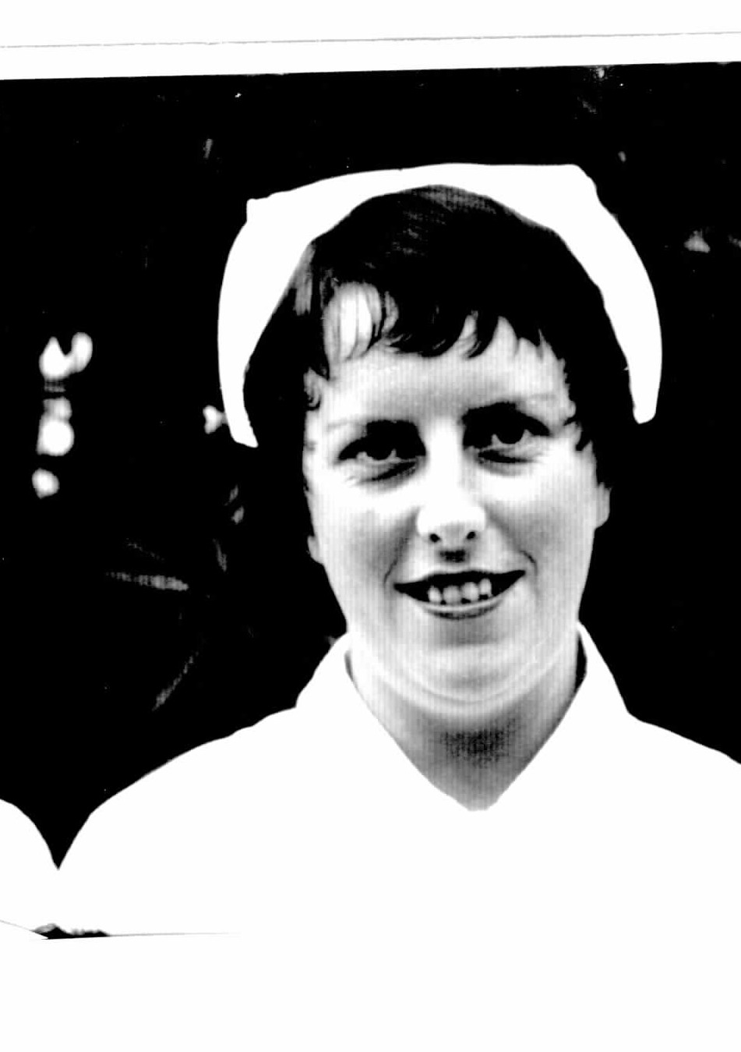

000'10" | INTRODUCTION TO FILE 1
000'31" | GROWING UP
 | Born in OAMARU, NORTH OTAGO, 10 November 1935. Middle child of a family of nine; four sisters, four brothers. Parents had mixed farm; animals and harvesting. Father 'tilled the ground with Clydesdale horses'. Machinery came in and revolutionised farming. Describes.
002'33" | SCHOOLING
 | Farm was near small town of KAKANUI; primary schooling was at KAKANUI PRIMARY SCHOOL; secondary schooling at WAITAKI GIRLS HIGH SCHOOL, OAMARU. Explains.
002'52" | PARENTS’ BACKGROUND
 | Mother came from IRELAND at age six years; lived in MAHENO, near KAKANUI. Father lived in DUNTROON; came from farming family. Explains.
003'37" | FARM AND FAMILY LIFE
 | Did a lot of the manual work on the farm as children; in holidays 'had to pick up the potatoes ... thinned out swedes ... turned over peas that had to be dried ... helped with baling ... cows to be milked'. Mother 'always had a little bubby ... harvest time ... feeding all the workers ... they stayed on the property ... it was from morning to night'. Mother did have some help from a 'woman in the district'. No refrigeration. Describes.
005'37" | PRIMARY SCHOOL
Walked quite a distance to primary school. One pony 'just luck if got there first ... horse used to almost hide from us ... could be tethered in paddock behind the school'. Stability of teachers. Lovely grounds. 'Nursery-men at KAKANUI supplied plants ... flowers that were a picture ... were able to go out and weed'. Describes.
Walked to school in all seasons; ' broke the ice in the puddles'. Describes.
008'03" | HIGH SCHOOL
 | Walked to catch bus to go into OAMARU; WAITAKI GIRLS HIGH SCHOOL. Bus did a circuit to collect pupils. Completed two years secondary education. 'Mum decided I should go nursing ... had a lot of hands on with brothers and sisters ... getting up in night for mother'. Describes.
009'12" | SIBLINGS
Two brothers went into harness horse racing; racing studs. Two brothers became famers. One sister stayed at home until she married 'and had nine in her family'. Second sister also at home until she married. 'I was one out of the girls who went to work early'. One sister married a farmer and youngest sister 'went to work at RUAKURA'. Describes.
Emphasis not on education for girls, 'had wonderful home life'. Describes.
011'59" | NURSE AIDE AT AGE 15 YEARS
Left school at age 15. Nurse aided until aged 20 years when started nurse training. Explains.
Nurse aided at OAMARU PRIVATE HOSPITAL. Pleased to be earning a living. Lived at Nurses' Home; 'got home as often as I could'. Describes.
013'09" | OAMARU PRIVATE HOSPITAL
 | OAMARU PRIVATE HOSPITAL, 'looked after people who were pretty well-off ... mainly stroke cases who were permanent ... local people ... DOUGLAS REID had a big stud ... was there for years ... did not get out of bed ... didn't have bed-sores like another long-term patient did'. 12-15 bed hospital. Run by local DOCTORS, Dr FITZGERALD. Describes.
015'02" | NURSE AIDING
NURSE AIDE for three years. SISTERS taught what to do. Medical and surgical patients. Permanent THEATRE SISTER, SISTER DICKSON; MATRON was 'hands-on'; MATRON BUSE (later MARSHALL). Describes.
'Beautiful copper sterilisers'. Lot of cleaning; 'meal trays were silver'. Describes.
Shift work over three shifts; six days a week. ‘MATRON lived on premises ... could call if had any problems'. Describes.
On NIGHT DUTY was on alone; 'had to go outside and stoke the donkey ... big coke operated furnace ... heated the water'. Describes.
Patients were 'locals ... families I knew'. Explains.
017'51" | MATRON SUGGESTS TRAINING
 | Applied to train as a nurse at DUNEDIN PUBLIC HOSPITAL; aged 19 years; 'marvellous if could get some qualification'. Explains.
018'34" | COMMENCING NURSE TRAINING
 | Commenced General Nurse training January 1955. 17 girls in class. 11 finally registered as nurses. Girls had come from over SOUTH ISLAND. Explains.
019'56" | OTHER TRAINING OPTIONS
 | WAIMATE HOSPITAL trained NURSE AIDES; OAMARU HOSPITAL had a nurse training school; MATRON had suggested DUNEDIN. Explains.
020'31" | PREPARATION FOR NURSE TRAINING
 | Chest X-Ray required. Explains.
020'54" | PARENTS TAKE TO DUNEDIN
 | Mother and father drove her to DUNEDIN; delivered to NURSES' HOME. Explains.
021'18" | UNIFORMS
 | 'Uniforms were superb', lavender button-up frock with white over-frock which buttoned down the back; 'wore this on wards ... discarded when came off', red capes, white shoes and stockings. Describes.
022'16" | NURSING CLASS
 | Did not know any other girls in class; varied ages. 'One had gone to UNIVERSITY ... done two years and then came nursing'. Explains.
022'54" | PRELIMINARY SCHOOL
 | PRELIMINARY SCHOOL for two months, 'learning equipment ... bed making ... cleaning ... right way to clean'. Describes.
024'18" | WARD WORK/SWEEPING THE FLOORS
First ward, BATCHELOR WARD, GYNAECOLOGICAL WARD. WARD SISTERS influential on learning. 'They were there to help you ... supervise you'. Explains.
First routine of day 'reading the report ... then sweeping right through ward ... long wards ... throw tea leaves under the beds to collect the dust'. Junior nurse responsibility to do the sweeping. 'All the lockers had to be cleaned by the nurses'. Describes.
Cleaning and sterilising enamel bedpans, 'made a lot of noise'. Describes.
027'07" | RESPONSIBILITIES INCREASE
 | Responsibilities increased to do dressings. Set up trays. Screening patients sometimes 'with heavy wooden screens'. Describes. More senior nurses 'did the medicines'. Explains.
028'45" | STAFFING PATTERNS/SHIFTS
Staffing included WARD SISTER and STAFF NURSE in the mornings. Explains.
Three shifts. Possibly started in mornings at 6am until 2pm; 8 hour shifts. 'Woken by HOME SISTER ... cup of tea ... cigarette on way'. Describes.
030'01" | USING INITIATIVE
Well supervised but able to take initiative; 'soon realised if it wasn't right'. Explains. 'Floating SISTER' on afternoon and night duty, ‘someone you could call on'. Explains.
As a third year student would be in charge of a ward on afternoon or night duty; 'always someone you could call on'. Explains.
031'31" | PATIENT CARE
 | Spent most of training in surgical wards; ORTHOPAEDIC; GYNAECOLOGICAL wards; very little medical nursing. Explains. 'There were a lot of dressings ... metal clips ... big rubber stitches'. Describes.
032'56" | WORKING WITH DOCTORS
'Intimidated a bit by the DOCTORS ... ward rounds had to have patient beds just perfect ... everything had to be neat ... patients had to be sitting ... MATRON often came around too'. Describes.
HOUSE SURGEONS 'were around the wards'; not a great deal to do with them; 'just how it was ... we just got on with our work ... so much to do'. Describes.
035'19" | NURSE TUTORS
Block system, came off wards for periods of instruction; SISTER BRAITHWAITE, SISTER MACHAELAS, 'ones you could talk to'. Describes.
DOCTORS gave some lectures; Mr MITCHELL, SURGEON; Dr IRONSIDE, PSYCHIATRIST; Dr BORNE. Explains.
036'48" | COMMUNITY NURSING
 | DISTRICT NURSING. 'Helpful to meet people in their own homes'. Care was mostly injections, dressings, 'ulcer dressings'. Describes.
037'52" | EXAMINATIONS
Struggled with examinations. JUNIOR STATE at end of first year. Assistance to study was through Block system. Results pinned up on wall. Describes.
Missed JUNIOR STATE first time, 'but just went on', re-sat in six months. Describes. 'Knew practical pretty well ... but interpreting theory was difficult'. Describes.
040'18" | OTHER HOSPITAL EXPERIENCES
 | Spent fortnight at LAWRENCE HOSPITAL [CENTRAL OTAGO] relieving. Explains.
041'12" | PATIENT CONDITIONS
Patients were having a lot of surgery. Explains.
Some wounds did not heal because of 'cancerous' condition, ‘terribly sad ... big sutures opening up'. Describes.
'Somehow we coped'. Describes.
044'31" | NURSES' HOME LIFE
'Sturdy brick building'; single rooms; list of requirements of what had to bring; 'included white blouse and black gymnasium bloomers ... "bathing suit for postural examination" ... so modest'. Describes.
Shared bathrooms. Meals in dining room in NURSES' HOME; 'wonderful breakfasts ... overseen by a DIETITIAN'. Describes.
Had to stand when MATRON and SISTERS came into dining room. Describes.
Could make own cups of tea in cafeteria, 'run by a doctor's wife'. Describes.
Two laundry bags required. Did own personal laundry. Clean uniforms available every day. Describes.
049'20" | NURSES' HOME RULES
Curfews at night; 11pm; not too restrictive; '... we worked so hard ... had to be sensible'. Describes.
Two sitting rooms where could take visitors; could take female visitors to own room. Describes.
050'47" | SPECIAL FRIENDS
 | Developed very close friendships; class friends continue as friends. Explains.
051'22" | TRAVEL HOME AND CONTACT WITH HOME
Travelled home on MIDLAND bus for days off. Father collected from bus-stop; bus left late in evening, 'CHRISTCHURCH to DUNEDIN bus ... very few stops'. Describes.
Rang mother 'and talked to the kids on a regular basis'. Telephone in NURSES HOME. 'I probably paid ... we got our pay three pounds a week'. Describes.
053'21" | MEMORABLE NURSES
 | MATRON, Miss WHITEFORD knew all nurses; 'addressed you by your name ... she was just so human'; later became MATRON of WAKARI HOSPITAL. Describes.
054'54" | SOCIAL LIFE
Dances, movies, beach; 'had so many people around you'. Explains.
During first year spent time at PARKSIDE HOSPITAL [near ST CLAIR beach]; sunbathing on beach in October, 'nurse got severe sunburn'. Describes. Lived in buildings at PARKSIDE 'built for the nurses ...called the shades'. Describes.
GERIATRIC NURSING at PARKSIDE, very heavy. Explains. [Corrected; only part of first year spent at PARKSIDE HOSPITAL and main experience was to learn how to do dressings].
057'12" | SMOKING AND ALCOHOL
Nurses smoked. 'I never smoked until I started nursing ... MATINEE ... very feminine ... smoked for about ten years ... because everyone else did'. Describes.
Very little emphasis on alcohol; 'one time at "big brown house" ... where put on evening for nurses graduating before you ... can remember being so sick... cherry brandy'. Describes.
059'33" | BOYFRIENDS
 | Boyfriends came to front door of NURSES’ HOME. 'People peering to see who your boyfriend was'. Describes.
060'45" | SPORT
 | Hospital had tennis and basketball teams. Explains.
061'24" | END OF FILE 1

Recorded: | 18 FEB 2013 | File: 2 of 2
Interviewer: | Margaret Horsburgh
Abstracter: | Margaret Horsburgh
Equipment type: | Fostex FR- 2LE Digital Recorder
000'05" | INTRODUCTION TO FILE 2
000'26" | PAY AND CONDITIONS
 | Free board, wonderful meals, laundry done, ‘I don't think we could complain'. Some grumbles about the work. Long days. Hard work; 'on your feet all the time'. Describes.
001'53" | FINAL EXAMINATIONS
STATE FINAL 'not good ... I didn't get that'; achieved when sat again in six months. 'Putting down what you knew was difficult ... finally got that lovely medal'. Describes.
Practical examination; 'patient was to get out of bed for first time ... took her pulse and temperature ... patient happened to be the THEATRE SISTER'. Describes.
Several girls failed the examination and didn't re-sit. Explains.
004'09" | THREE STAR NURSE
 | Level of training indicated by red stars on UNIFORM; continued with three red stars while waiting to re-sit examinations. Describes. Increased responsibility. 'Had to read report ... follow instructions ... had to write report on every patient'. Explains.
005'06" | BECOMING REGISTERED NURSE
 | Working at SEACLIFF HOSPITAL when received notification that had passed STATE EXAMINATION; engaged to be married; PSYCHIATRIC HOSPITALS paid so well. Describes.
005'37" | CHOOSING TO WORK AT SEACLIFF HOSPITAL
PAY was excellent. Triple pay on public holidays. Two twelve hour shifts. Describes.
January 1959 received notification that had passed STATE EXAMINATION. Explains.
006'02" | GRADUATION
Didn't attend GRADUATION CEREMONY; parents were unable to come, 'they were the important ones'. Explains. Didn't attend GRADUATION BALL. Third year students did put on a party for nurses graduating. Describes.
Certificate was posted. Explains.
007'39" | SEACLIFF HOSPITAL
 | Applied to work at SEACLIFF HOSPITAL. 'They were glad of staff ... money the motivation rather than working in a PSYCHIATRIC HOSPITAL ... had worked in PSYCHIATRIC ward at DUNEDIN PUBLIC HOSPITAL'. Describes. No 'special' training to support work at SEACLIFF. Describes.
008'57" | GENERAL NURSE WORK AT SEACLIFF
 | Role was to 'care ... and supervise ... keep an eye on patients ... administering medication ... keeping them clean'. Describes. Worked there one year [1959]. Explains.
009'39" | PATIENT TREATMENT AT SEACLIFF
Patients received ECT [ELECTRO-CONVULSIVE THERAPY]. 'They walked in or were wheeled into room where ECT took place ... gag in mouth ... nurse on either side ... they convulsed uncontrollably ... very effective treatment for many'. Describes.
Medication included TOFRANIL [IMIPRAMINE], 'was a big break through ... people who were incarcerated were able to go out on medication ... those who couldn't cope outside'. Describes.
011'44" | SEACLIFF PATIENTS
Only worked with female patients. 'Male attendants only cared for male patients ... had to make sure they didn't harm themselves' or other patients. Describes.
Keeping patients clean 'as possible ... when they had visitors ... had own wardrobe of clothes ... helping lady …doing up buttons on coat ... she struck me ... knocked me over'. Describes.
013'40" | SEACLIFF ENVIRONMENT
Carried huge sets of keys at SEACLIFF. 'Locked and unlocked behind you’. Patients in long wards. Beds close together. Describes.
Many patients were incontinent. 'In morning ... stripped beds ... soiled linen thrown on the floor ... washed ward down with disinfectant'. Describes.
014'36" | SEACLIFF STAFFING
 | 'Real qualified PSYCHIATRIC NURSES ... did the administration of MEDICATIONS'; general STAFF NURSES didn't do the MEDICATIONS. Explains.
015'48" | MEMORABLE SEACLIFF PATIENT
 | Female patient with canvas straight jacket, 'in seclusion during off times'. Describes.
016'58" | SEACLIFF NURSES' HOME
 | Lived in SEACLIFF NURSES' HOME. 'It was so very cold ... built 1920s'. Describes.
017'42" | BECAME ENGAGED TO BE MARRIED
Was engaged to be married during period working at SEACLIFF; opportunity to build up some money through working at SEACLIFF. Explains.
Had met husband to be [JIM] at a dance in DUNEDIN; JIM an electrician; knew him 'about three years'; no 'real' problems having a steady boyfriend as a student nurse; married end 1959. Describes.
019'01" | RAWHITI MATERNITY HOSPITAL
 | After marriage worked at RAWHITI MATERNITY HOSPITAL [1961 -1962]. Hospital was just along street they lived in at time [still in same home]. Describes.
020'02" | PERIOD OUT OF NURSING
 | Had four children with eldest son born 1963. Returned to nursing when daughter [oldest child] aged 12 years. Explains.
021'39" | GENERAL NURSE IN MATERNITY HOSPITAL
Worked in local maternity hospital as a general nurse until birth of first child. Explains. Duties were varied; able to 'be in theatre during deliveries ... with babies in the nursery; 'disposable napkins came in. Washed the plastic on the outside'. Describes.
Cleaning mostly done by DOMESTIC STAFF. Describes.
023'18" | RETURN TO NURSING
Returned to work at ST LUKES GERIATRIC HOSPITAL [1988] which had been RAWHITI MATERNITY HOSPITAL. Small MATERNITY HOSPITALS had been replaced with large public facilities; QUEEN MARY MATERNITY HOSPTIAL in DUNEDIN. Explains.
Was able to walk to work. Explains.
024'30" | ST LUKES GERIATRIC HOSPITAL
Worked part-time at ST LUKES six or seven years with a period off for major surgery. Explains.
Responsibilities as the REGISTERED NURSE on an 8 hour shift; MEDICATIONS. 'Also hands-on'. Describes.
MATRON in charge; up to three or four NURSE AIDES on morning and afternoon shift; supervision of NURSE AIDES. Describes.
Limited activities for patients; ' showered them, dressed them ... they sat around in the big day-room'. OCCUPATIONAL THERAPIST came in. Describes.
027'24" | POST-REGISTRATION COURSES
 | Completed two post-registration courses on Aged Care at OTAGO POLYTECHNIC [1989]. Courses were advertised. Felt would be useful to be updated. Nursing care plans were introduced; 'that was so different'. Describes.
029'01" | VARIED CAREER
 | Career spanned cross section of nursing; 'GERIATRIC was the most enjoyable'. Describes.
029'58" | RETIREMENT
Retired following surgery which prevented Winsome from being able to 'lift patients' [end 1991]. Explains.
Life-long friendships from student nurse days retained. Explains.
030'37" | CHANGES IN NURSING
 | Found practice of 'new' nurses calling elderly people by their Christian names inappropriate; 'felt wasn't respectful'. Describes.
032'02" | END OF FILE 2

