Recorded: | 4 JUN 2013 | File: 1 of 2
Interviewer: | Margaret Horsburgh
Abstracter: | Margaret Horsburgh
Equipment type: | Fostex FR- 2LE Digital Recorder

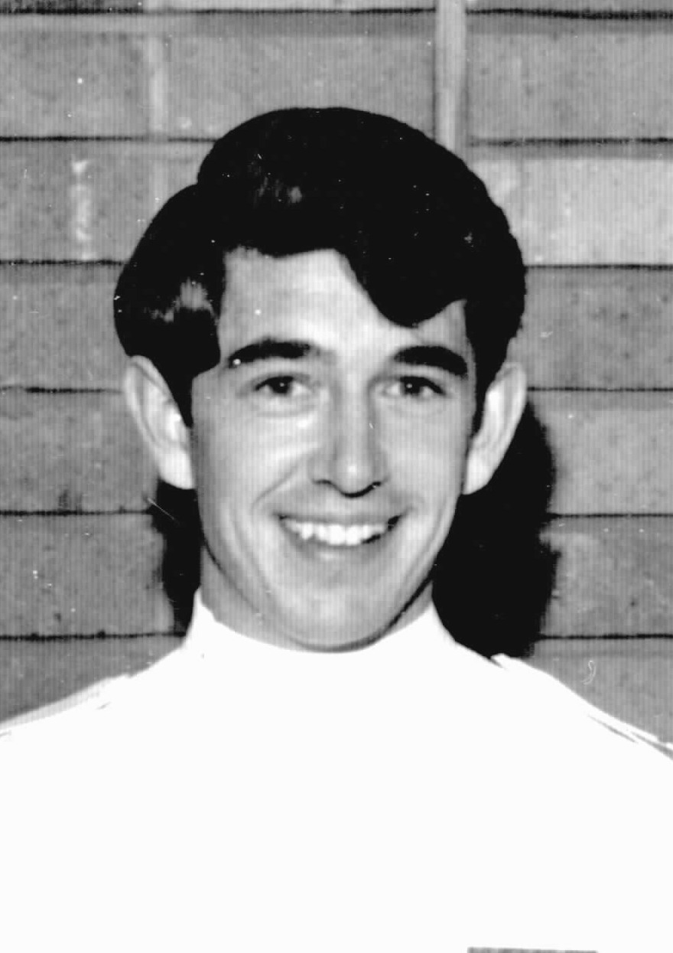Photo 1 | 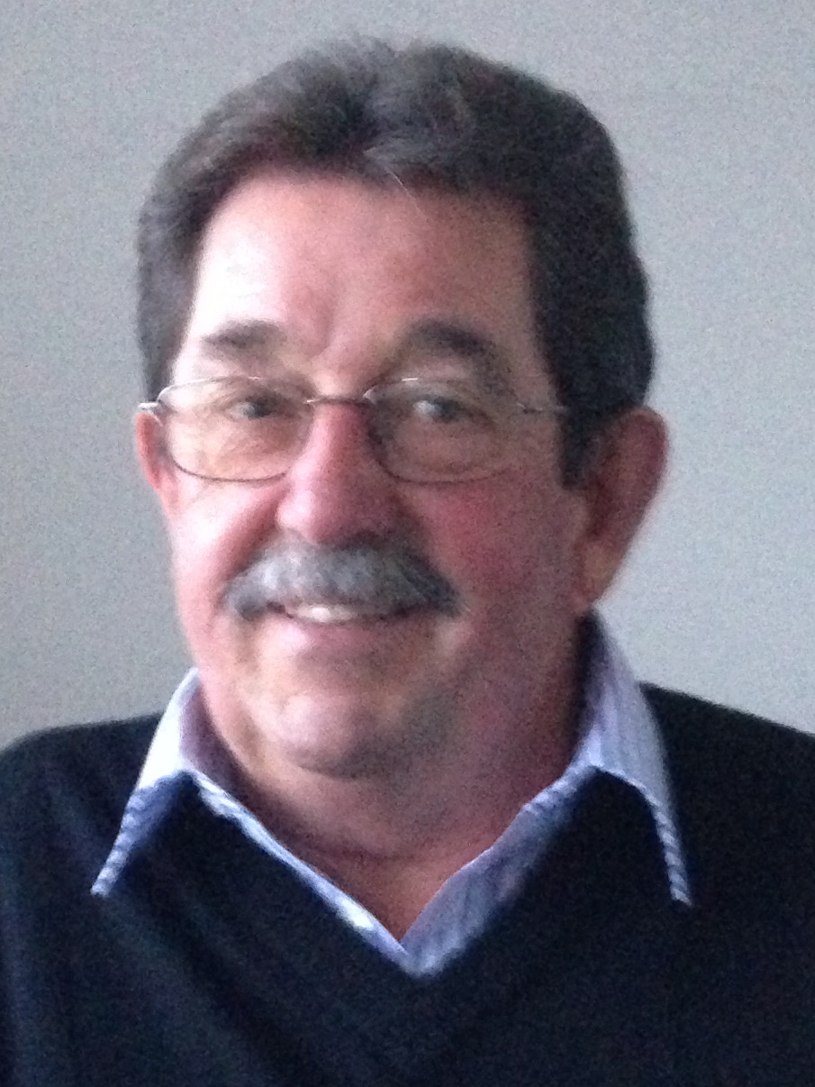Photo 2 | Photo 1. Class photo 1966, Paul Frische.  Photo 2. Paul Frische, 4 June 2013.

000'04" | INTRODUCTION TO FILE 1
000'39" | DUTCH ORIGINS
 | Born [1946] ROERMOND, HOLLAND. Came to NZ aged four and half years, 1951, with parents and three brothers. Explains.
001'17" | DECISION TO COME TO NZ
 | Parents had lived close to BELGIUM-GERMANY border, GERMAN invasion World War 2 had come through town. Parents felt that with young family opportunities would be better outside HOLLAND, had friend in NZ. Describes.
002'12" | ARRIVING NZ
Arrived AUCKLAND airport 1951, furniture had been shipped, water-front strike delayed access to possessions. Friend suggested family locate to BAYLEYS BEACH, DARGAVILLE, remained there two and half years, father worked in DARGAVILLE, 'doing accounts in engineering mechanical shop'. Describes.
Father had 'reasonable ENGLISH ... from school ... difficulties ... Hot Pies spelt that way in HOLLAND meant warm urine'. Describes.
Frightening for mother, outside toilets, house not properly lined. Describes.
003'27" | YOUNG BOYS AT BAYLEYS BEACH
 | Brothers wandered over sand dunes, ignored dangers of west coast beach, abundance of TOHEROAS. Describes.
005'23" | EARLY SCHOOLING
 | Started school aged five and half years, long bus trip to school. Third in family, older brothers looked after, initially didn't speak ENGLISH. Describes.
006'58" | MOVE TO WHANGEREI
 | Family moved to WHANGEREI 1953, supportive MAORI neighbours. Describes.
007'58" | RELIGIOUS INFLUENCES
 | ST JOSEPH'S PRIMARY SCHOOL, family strong CATHOLIC religious beliefs, frequently meant was an 'altar boy'. Parents wanted PAUL to be a priest, older brother became a priest, ‘allowed to study for hours on end ... expected to do the same'. Describes.
009'24" | SIBLINGS BORN IN NZ
 | Sister born in 1953, only lived for six weeks, then two more boys born in NZ. Describes.
010'11" | SECONDARY SCHOOLING
 | WHANGEREI BOY'S HIGH SCHOOL for five years, achieved SCHOOL CERTIFICATE, ‘not overly scholastic'. Academic subjects included languages, LATIN, had wanted to do woodwork, practical subjects. Describes.
011'59" | PARENTS WORKING
 | Moved to WHANGEREI, father worked for construction company, 'doing salary and wages', mother worked in evenings cleaning, 'did that for 25 years'. Parents worked very hard, 'had ended up with fifty pounds after paid to get everything off the wharf ... by time I started high school had built their own home'. Describes.
013'23" | CARING FOR MOTHER
 | Mother now 95 years old, living in own home, 'because I am a nurse ... brothers expect I will care for mother'. Describes.
014'29" | HOSPITAL ORDERLY
Didn't know what to do after school. Made enquiries about teaching. 'One of my friends said, “why don't you come to the hospital and be an orderly?” ... no idea what involved.' Worked WHANGEREI BASE HOSPITAL for just over one year from 1964. Describes.
Orderlies 'mostly older males ... took over role to shower two patients and shave the rest ... could complete in one hour', could have one hour spare time, 'sit around smoking ... MATRON heard about it ... ended up cleaning bedpans and bowls'. Would race linen carts, 'evenings ... would jump out at nurses coming on night duty and frighten them'. Describes.
Moved to live in staff quarters. Explains.
018'09" | NURSING SUGGESTED
 | Called into MATRON'S office, ‘should be doing nursing training ... no clue what letting myself in for'. Joined by second young male, COLIN and had a three month holiday before starting training. Describes.
018'54" | HOLIDAY BEFORE TRAINING STARTS
 | Three month working holiday in SOUTH ISLAND, picking tobacco, sleeping in car. Describes.
019'19" | NURSING COMMENCES
 | Training commenced May 1966. Explains.
019'27" | BROTHERS' OCCUPATIONS
 | Brothers' occupations included farming, welding, and ‘rag trade', own business making sail covers. Older brother became a PRIEST. Younger brother was a hospital orderly and had intended to train as a nurse, 'but ended up in restaurant business'. Describes.
020'56" | PARENTS DISAPPOINTED IN DECISION
 | Parents 'pretty disappointed' in decision to be a nurse, 'non-approval from Dad', parents never came to graduation. Reflects.
022'08" | COMMENCING TRAINING
 | Closest male nurse training school, GREEN LANE HOSPITAL. Applied to enrol to MISS HOSKING, Head of SCHOOL OF NURSING. Two males joined a class of 23 female trainees, 'shock to be sitting behind a desk all day ... meant to be 8am to 4.30pm ... dragged on ... next day at 4.30pm Colin and I pack up our books and walk out ... ended up in front of PRINCIPAL TUTOR ... told this was a profession... stay there until dismissed ... like being back at school'. Describes.
024'34" | MALES SEGREGATED/CORNWALL HOSPITAL
Male staff based at CORNWALL HOSPITAL, male staff quarters next to administration block. Describes.
CORNWALL HOSPITAL 16 ward GERIATRIC HOSPITAL, base hospital, accountable to MATRON, MISS JEFFRIES. 'End of corridor of male quarters blocked off from main corridor ... had to walk outside to get to main hospital ... sense of males can't be trusted'. Describes.
026'39" | DEROGATORY COMMENTS
 | Had comments such as 'where is your handbag?’ ... not aware ... ‘people saying most male nurses are gay'. Describes.
027'05" | SELECTION PROCESS
 | No interview required, selected on 'paper-work', medical examination in WHANGAREI. Describes.
027'40" | REGIMENTED LIFE
 | Shock from leading own life to very regimented life. Explains.
028'12" | MALE STUDENTS/STUDY
Walked to classes at GREENLANE HOSPITAL. Owned a car. 'Colin, only lasted six weeks ... had girlfriend in WHANGEREI'. Third male had joined class two weeks after it had commenced, CHRIS FOGARTY from BLENHEIM. Describes.
Useful to have another male student in terms of study, 'not allowed in NURSES' HOME ... learning on own ... useful to discuss problems ... learning with other male nurses'. Describes.
029'46" | OTHER TRAINING OPTIONS
 | At time training commenced not aware of other training opportunities, found out about PYSCHIATRIC NURSING later. Explains.
030'18" | TRAINING BROAD AND NARROW
 | Training included experience in all AUCKLAND HOSPITALS. Only allowed to 'nurse males ... and only 16 upwards'. Describes.
030'35" | UNIFORMS
 | Uniforms similar to chefs, high collar, all white, white shoes and socks, long sleeves for wear when off wards. Could walk from CORNWALL to GREEN LANE HOSPITAL in uniform. Describes.
031'18" | CLINICAL EXPERIENCES
 | AUCKLAND HOSPITAL, GENITO-URINARY, MIDDLEMORE HOSPITAL, ORTHOPAEDIC, THEATRE, OUTPATIENT experience. Describes.
031'32" | ADJUSTING TO BEING IN SCHOOL
 | 12 weeks PRELIMINARY SCHOOL, end of week 'liked to go out for a beer ... not allowed in quarters ... under-age', spent weekends with family members in AUCKLAND. Describes.
032'50" | PRACTICAL LEARNING
 | First year practical training mostly with elderly at CORNWALL HOSPITAL, separate from female students. Explains.
033'30" | TUTORS
TUTORS, SISTER MCALEER very strict. SISTER CATO 'easy to get on with'. TUTORS supportive, 'realised on own'. Describes.
'Told firmly when any lectures on GYNAE or OBSTETRICS to get out ... didn't need to know anything about females'. Describes.
TUTORIAL SCHOOL based at GREENLANE HOSPITAL. Explains.
036'40" | RULES
 | Supervision in clinical areas was from senior nurse or CHARGE NURSE. MATRON'S rounds required 'everything to be shiny ... beds ... mitred corners ... difficult to understand'. High standards expected. Describes.
039'01" | ISOLATED LOW POINT
 | Always felt supportive, helped by staff. One difficult experience in surgical ward 'felt not respected ... because male ... twice the workload of the females ... SISTER on back all the time ... refused to sign ward report ... scrawled across … comments are biased'. Describes.
042'51" | MALE STUDENT NURSE SEGREGATION
 | Able to join in with females 'after first year ... socialised with them'. Not allowed to be in class photo, only to be photographed with PRINCIPAL TUTOR, HOSPITAL MATRON, and HEAD OF SCHOOL. Separate curriculum, living accommodation, MALE STAFF QUARTERS. Female students were inclusive. Describes.
044'58" | WARD WORK
Requirement to stand up when someone senior came into room. Might work eleven days without a break. Worked in a team. Duties in first year as for female students. Later 'would be called to do all male CATHETERISATIONS'. Describes.
Cleaning 'was standard ... sluice room ... stainless steel ... autoclaves.' Describes.
047'46" | MOVING AROUND HOSPITALS
 | Moved around hospitals, lived at CORNWALL HOSPITAL, male quarters at MIDDLEMORE HOSPITAL. Placements linked with tutorial work, 'just fronted up and try and find way around'. Used own car for transport. Describes.
050'06" | SHIFTS
Shifts 7am to 3pm, 2.30pm to 11pm. Explains.
After afternoon shift at CORNWALL HOSPITAL, 'group might walk up ONE TREE HILL ... take a guitar ... few bottles of beer ... relaxation.' Describes.
051'29" | NO FEMALE VISITORS
Security and AFTERNOON SUPERVISOR came into quarters when female visitor had called, 'given the riot act'. Describes.
Occasion when colleague dressed in girlfriend's uniform, 'ran in ... then took uniform off ... accused of having female in room ... asked for official report that being harassed ... made point.’ Details.
054'54" | LEVEL OF RESPONSIBLITY
 | Second year on night duty with one other nurse only, by third year in charge of a ward. ‘Three cardiac arrests in one night ... in charge'. Describes. Compares with current practice when care-givers not able to administer drugs.
057'32" | EXAMINATIONS
 | Regular tests throughout year, STATE EXAMINATION at end of first year, hospital final examination at end of third year and then if passed allowed to sit STATE FINALS. Specific papers for male nurses, focus on GENITO-URINARY areas. Study in 'own time ... found difficult to get head around ENT [EAR, NOSE and THROAT] ... had to re-sit’. Describes.
060'20" | END OF FILE 1

Recorded: | 4 JUN 2013 | File: 2 of 2
Interviewer: | Margaret Horsburgh
Abstracter: | Margaret Horsburgh
Equipment type: | Fostex FR- 2LE Digital Recorder

000'05" | INTRODUCTION TO FILE 2
000'27" | SOCIAL LIFE
 | Shift work made it difficult to have a social life. Prior to nursing involved with sport, had participated at representative level in fencing, unable to continue sporting club involvement. Male colleagues likely to be on opposite shifts. Lonely living in male quarters, car enabled some ability to get out. Describes.
002'37" | RELATIONSHIPS WITH FEMALE STUDENTS
 | Friendships with female students developed, 'learned very quickly to never go out with a nurse from hospital you were working at ... always gossip'. Went out with groups of nurses, girls had to be back by 10pm, 'pulled over for speeding trying to get people back by 10 ... gentleman I was nursing at time', able to have fine reduced. Describes.
005'31" | NO CURFEW IN MALE QUARTERS
 | Male quarters did not have a curfew, had own key. Explains.
005'58" | GIRLFRIENDS
 | Over course of training had several girlfriends, end of second year, girlfriend moved into flat, created some freedom, always girlfriends were from different areas, 'part of growing up as young male ... learned as you went'. Describes.
006'54" | SMOKING
Smoking prevalent. Recalls smoking in ward offices. Had started smoking around age 14 years. Describes.
At CORNWALL HOSPITAL smoked in lounge areas. Occasion when to annoy older male nurse inserted 'tom thumb' cracker into cigarette, which he picked up. Describes.
009'44" | ALCOHOL
Alcohol part of social life. After morning shift 'might drive to ONEHUNGA for a beer ... race back before 6pm for dinner'. Describes.
Without big wages unable to purchase big quantities of alcohol. Describes.
Occasion at MIDDLEMORE on night shift after had been to OTAHUHU for a drink, needed to have a short sleep. Describes.
014'08" | HOSPITAL SOCIAL ACTIVITIES
 | Not involved in hospital social activities, moving around hospitals. Club room at CORNWALL HOSPITAL with table tennis and other activities. 'Made to feel that males and females shouldn't be interacting.' Describes.
015'44" | RELATIONSHIPS WITH DOCTORS
 | Never saw much of DOCTORS, hierarchy system precluded. Could call DOCTORS on afternoon or night shift, WARD SISTER’s role to call DOCTOR. Describes.
017'09" | MEMORABLE PATIENTS
Nursed first man to have a PACEMAKER, first accident on AUCKLAND HARBOUR BRIDGE, this man ended up PARAPLEGIC. Describes.
PARAPLEGIC patient bought a house with money received following accident, invited patients who had been with him at CORNWALL HOSPITAL to his house warming, PAUL and JOHN SKELTON [fellow male nurse] took two of the younger patients to party, aimed to get patients back by 10pm, one of patients quite disturbed following drinking home-brew. Details.
Used to take a 'beer' for younger patients from time to time, CORNWALL HOSPITAL had long term patients who might be quite depressed. Describes.
Ward 26, CORNWALL HOSPITAL, SISTER ROCHE's ward, rehabilitation ward, 'influenced what I ended up doing later on with rehab'. Reflects.
023'09" | PAY
 | Pay was not comparable with other males of same age, very poor pay. Episode of working as 'seagulls' on wharf on days off, received twelve pound a day, three - four gangs working on wharf, only needed to work for about four hours, pillaging rife. Details.
025'26" | HELICOPTER INTERUPTS RECORDING
 | Noise on recording is of helicopter landing on hospital roof.
026'09" | WORKING CONDITIONS
 | Worked long stretches without days off, 'part of what you were meant to do so did it'. Describes.
026'57" | ACCEPTANCE OF CONDITIONS
 | Accepted working conditions, 'wanted to be nurses ... hospital training helped'. Explains.
028'19" | GRADUATION/STAFF NURSE
 | Examination results came in the mail, flatting at time, REGISTERED MALE NURSE, back to base hospital, CORNWALL HOSPITAL, STAFF NURSE on rehabilitation ward, able to apply for position, limited choice. Describes.
029'53" | CELEBRATIONS
 | Class celebrated, mainly GREEN LANE nurses, not part of a graduation ball. Hospital MATRON, Miss JEFFRIES presented medals. Ceremony at the Town Hall, previously had received first year prize at a Town Hall ceremony, JEAN MELVILLE prize, nursing dictionary. Parents did not come to graduation ceremony. Describes.
032'00" | PARENTS' EXPECTATIONS
 | Parent’s expectation on graduation was missionary work, not what wanted to do. Explains.
032'15" | CAREER CHOICES
 | 'Double certified' with a PYSCHIATRIC qualification seen to give better scope for future, no guidance for career. Decided to enrol for PSYCHIATRIC NURSE training. Describes.
033'16" | PSYCHIATRIC NURSE TRAINING
Required to do two years for PSYCHIATRIC NURSE TRAINING, applied and was accepted for KINGSEAT HOSPITAL. Joined a class but never became part of class. Describes.
Worked in assessment unit , 'learned very quickly not allowed to talk to patients ... that was DOCTOR's job ... main treatment medication ... narcosis ... LARGACTIL ... told off if listening to patients ... charge people psychiatric trained'. Describes.
Pay better, 12 -15 hour shifts, stayed on if no-one turned up for a shift. Describes.
No lectures, no tutorial staff for six months, not allowed to sit first year examination 'because haven't had tutorials'. Describes.
036'49" | KINGSEAT EXPERIENCES
Chose KINGSEAT, stayed in male staff quarters, also part of fire brigade, alarms had been deliberately set by electrician to go off around 3am, 'could see how many males might be coming out of NURSES' HOME at night. Describes.
After orientation working in young adolescents’ villa, ' told to shave ... large blind patient ... knocked out', staff had set up to be knocked over by this patient, 'part of induction'. Describes.
Had not had any psychiatric lectures. Explains.
039'29" | NURSING KINGSEAT PATIENTS
Young adolescents, socio-pathic, unable to be in community, became friends 'if you gave them a smoke'. Describes.
Nursing involved keeping patients safe, healthy 'not much from psychological point of view ... that was DOCTOR’s job’. Describes.
040'54" | INTELLECTUAL DISABILITY AT KINGSEAT
 | Villa where doors locked, INTELLECTUALLY DISABLED mobile young people, incontinent. No curtains, peep hole at night, in morning people were directed through into big room showers, when people dressed for day, whole area was housed with fire hose. Describes.
042'52" | DECISION TO LEAVE KINGSEAT
 | Was in relationship with woman from PALMERSTON NORTH, had decided to get married. Saw job advertised at MANAWAROA CENTRE, PALMERSTON NORTH, was accepted for position [1970] to help establish centre. Describes.
043'41" | MANAWAROA CENTRE
DOCTORS MASON DURIE, JOHN WEBLIN, PSYCHIATRISTS setting up. Had been in CANADA and AMERICA. Philosophy for 20 bed unit, minimal drugs and ECT [ELECTRO-CONVULSIVE THERAPY], PSYCHOTHERAPY, exact opposite to KINGSEAT. Initially day care, nurses in two groups, had opportunity to get involved with therapy, work through issues with patients, group therapy sessions with two-way screens. Describes.
PSSCHIATRISTS training staff, 'brilliant learning for self'. Describes.
JOHN WEBLIN giving PSILOCYBIN, LSD [LYSERGIDE]. Describes.
Evening sessions for married couples. Very supportive environment. Describes.
049'00" | CAREER CHANGE INFLUENCES
 | Reached stage where felt needed more study, married with 2 children, mortgage, couldn't afford to take time out for study, 'wages not great'. Decision to return to WHANGAREI. Explains.
049'53" | NO NURSING POSITIONS WHANGAREI
 | Offered position at WHANGAREI BASE HOSPITAL, STAFF NURSE, medical ward, resigned from MANAWAROA CENTRE, had to delay return to WHANGAREI for a month, worked in freezing works, very well paid for one month. 'Presented to WHANGAREI HOSPITAL ... we can't employ you ... ceiling on staffing levels'. Describes.
051'41" | WORKING IN ENGINEERING TRADE
Became labourer for ship building company, needed a job. Worked in 'profile shop', gas steel cutting machine, learned quickly, experienced union differences, BOILER MAKER'S UNION and ENGINEERING UNION, expanded skills and employment opportunities. Details.
After six and half years expansion of oil refinery [MARSDEN POINT], new machine, biggest machine in AUSTRALASIA, got job to work this machine. Pay very good, 'some weeks earning $1000.00 ... never get in nursing ... kept nursing registration ... ran first aid room'. Workforce up to 350 people, organisation planning own health clinic, began to set up, 'within a week 100 staff laid off', health clinic didn't proceed. Details.
Working hours became 60 -72 hours a week, disruptive to family life, decided to return to nursing. Describes.
058'23" | STAFF NURSE PSYCHIATRIC UNIT, WHANGAREI
Applied to WHANGAREI HOSPITAL, sent cv, when they noticed that had psychiatric experience, 'asked when could you start'. Commenced work at hospital November 1983 and has maintained continuous service since. Describes.
Initially STAFF NURSE in PSYCHIATRIC UNIT, 'very much like KINGSEAT ... under-staffed ... lot of ECT ... PSYCHIATRISTS would sit in office ... people sat outside for two or three days ... interrupted DOCTOR ... expect you to see this man'. Helped patients get access to PSYCHIATRIST. Details.
062'01" | MANAGING PSYCHOTIC PATIENT
 | Caring for psychotic female patient, one on one basis, led to requesting DOCTOR to improve care for patient, transferred to CARRINGTON HOSPTIAL, AUCKLAND. Describes.
063'40" | CONDITIONS IN PSYCHIATRIC UNIT
Found working conditions and treatment very poor. CHARGE NURSE, RICHARD FIRTH, PSYCHIATRIC trained. Difficult to get staff. Older patients mixed with young patients. Describes.
Service and unit has now improved, purpose built unit. Describes.
064'57" | RETURN TO GENERAL NURSING
Remained eight months in PSYCHIATRIC UNIT, position came up as STAFF NURSE in GERIATRIC WARD, day and evening shift. Enabled learning to catch up, and then secure position as DEPUT Y CHARGE NURSE on 36 bed MEDICAL/LONG STAY ward. Describes.
Main role educating young staff, workload of own patients, elderly and acute patients. Technology, medications and nursing had changed from training. As a student male nurse 'called out to do the heavy lifts ... people more ambulatory ... compared with early stages of training ... oedema up to mid-thigh ... feet in bucket with pin pricks to drain fluid'. Describes.
068'41" | CHARGE NURSE
Became CHARGE NURSE after three years, having male and female 'at top ... balanced things out ... a very stable staff ... good team', no hospital training students, POLYTECHNIC students, ENROLLED NURSE students. Patient acuity increased. Describes.
Ward moved in 1985 from old Ward 5, 'equipment wasn't very good', ward layout inappropriate. Describes.
071'32" | ADVANCED DIPLOMA IN NURSING (ADN)
Recognised need for further education if wanted to branch out, 1988, DEPUTY CHARGE NURSE, confident in role. Accepted for course [ADN], supported and funded by employer. Describes.
Difficult year, 'left on Sunday evening to be in AUCKLAND ... for Monday morning', back Friday afternoon, 'all just travel, study, travel', lived in NURSES' HOME, AUCKLAND HOSPITAL, studied NORTH SHORE, clinical work at NORTH SHORE HOSPITAL. Study difficult, 'lot of assignments', family issues became difficult. Achieved well, 'got a lot out of it ... strain on family'. Describes.
074'25" | REHABILITATION WARD CHARGE NURSE
Opportunity to start-up REHABILITATION WARD, 1990. GERIATRIC WARDS had closed, in interim took over 'old' Ward 15, no facilities, 'while working on developing 16 bed unit on ground floor ... purpose built for rehab ... aged 65 years and over ... STROKES, falls, hip fractures ... whatever came our way', multi-disciplinary team, able to choose OCCUPATIONAL THERAPIST, PHYSIOTHERAPIST, SPEECH LANGUAGE THERAPIST, SOCIAL WORKER and nursing staff, HEALTH CARE ASSISTANTS, ENROLLED and REGISTERED NURSES. Details.
Designed all processes and systems, 'twenty years later ... third of staff still there'. Describes.
076'44" | UNIT CLOSES
 | Purpose built unit closed after two years, 1993, 'long-stay was no longer going to be in hospitals ... two weeks to close unit ... get 20 people into REST HOMES', redesign rehabilitation processes and systems, moved to ward where design and space, toilets inappropriate for rehabilitation. Describes.
078'20" | UNIT/NURSE MANAGER STROKE UNIT
Unit slowly improved, STROKE unit incorporated. Became UNIT MANAGER, NATIONAL COUNSELLOR for STROKE FOUNDATION, developed with MINISTRY OF HEALTH STROKE, Best Practice Guidelines. Remained in role to 2004. Describes.
Positive changes in care of STROKE patients, specialist team, specialist nursing team and rehabilitation. Describes.
079'47" | HEALTH SERVICE CHANGES
 | Changes from HOSPITAL BOARDS, DISTRICT HEALTH BOARDS, with CEOs resulted in significant role change, budget of $3.5 million to manage, accountable to General Manager. Emphasis on BUREAUCRACY, 'forms in triplicate', HR [Human Resources] took over employment of staff, 'three months turn-around when someone left before could get someone ... got so frustrating'. Describes.
081'48" | EXPERT NURSE
As CHARGE NURSE and UNIT MANAGER for 17-18 years would be on duty to meet night staff, receive patient handover, understand all patients, 'ward round with two different doctors ... my responsibility to know the patients ... drug round in morning to keep my eye on what going on ... eyeball the patients'. Found when went on to other wards to assess patients for rehab, nurses might know little about patients they were looking after. Describes.
Expertise meant ‘could also keep the doctors in line ... HOUSE SURGEONS ... GERIATRICIANS would tell them to listen to nurses.' Nurses would look at everything. Describes.
'Would decline to accept patients from other wards if nursing standards poor', might have referrals for nausea, vomiting or constipation, 'they would say haven't got time to toilet patients'. Standards and so could accept CHARGE NURSE recommendations. Details.
086'32" | COMMUNITY GERONTOLOGY NURSE
COMMUNITY GERONTOLOGY NURSE since 2004, position created in 1996 'off-shoot of REHABILITATION role ... sending people home who weren’t coping', GERIATRICIAN, DR ALAN DAVIS, supported development of COMMUNITY NURSE role, many problems with frail elderly with multiple problems living alone. Nurse visits fortnightly, works in with community groups, GENERAL PRACTICES, care providers, 'try to keep old people at home for as long as possible'. Describes.
Position had come up at time when 'frustrated' with UNIT MANAGER role. Explains.
089'07" | MANY ACHIEVEMENTS IN UNIT MANAGER ROLE
 | Hospital Unit had many achievements, awards for quality assurance, trial of equipment, new systems, fund raised for DOPPLER for bladder assessment. Many improvements in care of elderly, 'but still a way to go'. Describes.
090'39" | REFLECTIONS ON CAREER
Decision to retire in 2014, ten years in current job, 30 years at WHANGAREI HOSPITAL. Has been a very rewarding career, met many people, changes in medicine, changes in nursing. Describes.
Have found training on the job, with support around student 'has a lot going for it ... now see on the wards that relatives are doing a lot of the hands on care ... meant to be nursing job', many HEALTH CARE ASSISTANTS, 'with nurses sitting behind a computer'. Reflects.
Achieved through working with management a nurse: patient: staff ratio of 1:4 while others 1:6, without computer programmes [TREND CARE]. Describes.
POLYTECHNIC nurse graduates, 'need one year postgrad., commitment to nursing with supervision'. Describes.
095'51" | END OF FILE 2

