Recorded: | 8 MAY 2013 | File: 1 of 3
Interviewer: | Margaret Horsburgh
Abstracter: | Margaret Horsburgh
Equipment type: | Fostex FR- 2LE Digital Recorder

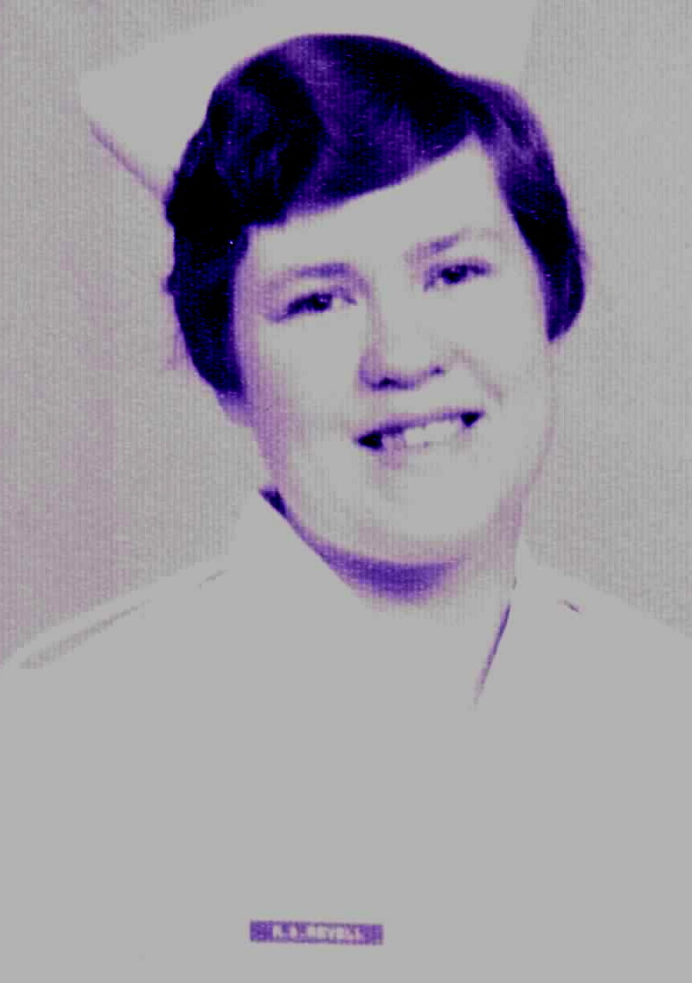Photo 1 | 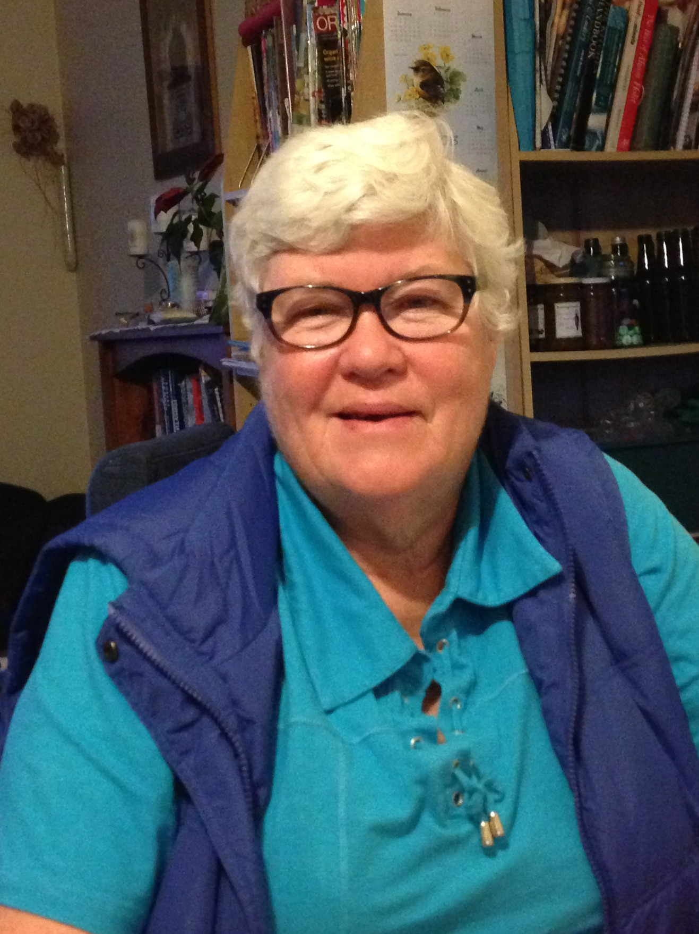Photo 2 | 1. Rosemary Revell, Studio Portrait, 1967  2. Sister Rosemary Revell, 08 May 2013

000'17" | FILE 1 INTRODUCTION
000'30" | PARENTS
 | Born HASTINGS [1948]. Mother a NURSE, trained at HASTINGS, MATERNITY training in TE KOPURU, worked in BRIGHTSIDE HOSPITAL, AUCKLAND, ROYSTON HOSPITAL, HASTINGS. Father had been QUARTER MASTER during World War 2. Describes.
002'00" | FATHER BECOMES SOCIAL WORKER OAKLEY HOSPITAL
 | Moved to AUCKLAND, 1958. Father applied for SOCIAL WORK position at CARRINGTON HOSPITAL [OAKLEY], AUCKLAND, had experience with placing people in work. Describes.
002'55" | AUCKLAND
 | Lived POINT CHEVALIER, AUCKLAND. Attended ST FRANCIS CONVENT [Primary School]. Explains.
003'16" | ADJUSTMENT TO AUCKLAND
 | Younger sister died from ACUTE APPENDICITIS 'day we moved to AUCKLAND'. Mother suffered depressive episode. As 10 year old cared for 11 month old brother until Mother recovered. Describes.
004'10" | MOTHER'S NURSING CAREER
 | Mother returned to nursing when ROSEMARY started secondary school, 'to pay the school fees'. Weekend night duty position at WARRENGATE PRIVATE HOSPITAL, MT ALBERT, followed by full-time position at CHRIST HOSPITAL, SELWYN VILLAGE, and then NATIONAL WOMEN'S HOSPITAL. 'Went from eternity to maternity.' Moved to Ward 28, COSTLEY BLOCK, AUCKLAND HOSPITAL. Describes.
006'11" | CAREER DECISIONS
 | Aware of Nursing from Mother but also interested in teaching. In sixth form year accepted for AUCKLAND COLLEGE of EDUCATION, but had not achieved UNIVERSITY ENTRANCE, decided to return to school for 'second year sixth'. In this year decided to apply for Nursing. Describes.
007'29" | SECONDARY SCHOOLING
 | Attended ST MARY'S COLLEGE, PONSONBY. Subjects included BIOLOGY, LATIN. Achieved UNIVERSITY ENTRANCE in 'second year sixth'. Interested and involved in 'everything that was going', prefect. Singing classes with DAME SISTER MARY LEO. Describes.
009'42" | SCHOOL LEAVER CAREERS
 | Few opportunities for women, teaching, nursing, secretarial. Several class-mates went to UNIVERSITY, did not know what were going to do. A number eventually 'ended up in high-powered jobs'. Many left school at aged 15 or 16 years. Describes.
012'08" | BROTHERS
Brothers attended, ST PAUL'S COLLEGE, AUCKLAND. Brother [LEO], three years younger accepted for MEDICAL SCHOOL, AUCKLAND, aged 16 years, from first year sixth form, had been second to dux, PAUL OKELFORD, currently MEDICAL ASSOCIATION PRESIDENT. Describes.
Shared learning material and study time with brother. LEO a GP [GENERAL PRACTITIONER], HAMILTON. Describes.
Youngest brother [BEN], nine years younger, completed one year of PYSCHIATRIC NURSE training at CARRINGTON HOSPITAL. COMPREHENSIVE NURSING courses just commencing. Became ORDERLY at AUCKLAND HOSPITAL, MOVED TO HAWKE’S BAY, completed two years of nurse training at EIT [EASTERN INSTITUTE OF TECHNOLOGY]. Personal circumstances led him to give up training, has always worked in jobs around hospitals, including as CARER for disabled person, ANAESTHETIC TECHNICIAN. Full-time carer for wife who has SCHIZOPHRENIA and brain injury. Details.
017'38" | APPLYING FOR NURSING
Aged 18 years when left school. Applied to AUCKLAND HOSPITAL BOARD while at school, went in school uniform 'on own' for interview. MRS HOLDGATE interviewed, formidable woman. Three choices for training base, GREENLANE, AUCKLAND or MIDDLEMORE HOSPITALS, 'got third choice' of MIDDLEMORE HOSPITAL. Describes.
Medical examination carried out by DR HOLDGATE at AUCKLAND HOSPITAL, X-RAY. Describes.
020'21" | DISREGARDED PSYCHIATRIC NURSING
 | Did not consider PYSCHIATRIC NURSING, father's place of work had influenced. Family did not have telephone, father's ex-patients would 'come to house ... didn't think would have the patience 'for people with mental illness'. Describes.
021'55" | AGED CARE INTEREST DURING SCHOOL
 | Interested in surgical nursing and also aged care, worked at SELWYN VILLAGE, kitchen hand, in school holidays. Describes.
023'07" | TRAINING SCHOOL
 | Not asked if MIDDLEMORE HOSPITAL would be acceptable for training, notified in December for January class. Explains.
023'42" | TRAINING BEGINS
Training commenced at MIDDLEMORE HOSPITAL. Tutors included SISTER BARBARA WESSELDINE, STAFF NURSE PRESTON, and SISTER ANDERSON. Explains.
Arrived Sunday afternoon, parents and brothers took her to Nurses' Home, measured for uniforms, alphabetical order for rooms. Describes.
Welcomed on Monday by MISS BARKER, MATRON, 'tall woman ... statuesque ... booming voice ... knew everyone'. Describes.
026'24" | CLASS
Forty-eight girls in class, merged with April class. 'At week eleven ... slid on floor of sluice room ... tore meniscus of knee ... MR LAMB, SURGEON' operated, several weeks rehabilitation, meant joined April class for some classes. Describes.
Two Maori girls in class, girls came from wide geographic area, many girls from out of AUCKLAND. Describes.
029'27" | PRELIMINARY SCHOOL
PRELIMINARY SCHOOL, two classrooms, library, in middle of hospital, ‘above the kitchen'. Describes.
Twelve weeks ' in prelim’, five days a week, 'first ones to have only five days a week', went to wards after two weeks. Describes.
030'43" | FIRST PATIENT SPONGE
 | First patient sponge, Ward 4, MEDICAL WARD, patient in low bed, 'had to kneel on floor to sponge him ... bowels had moved everywhere ... working with PAULINE REGAN ... STAFF NURSE PRESTON helped ... really good to have something hard on the first day'. Details.
032'55" | PRELIMINARY SCHOOL CURRICULUM
 | PRELIMINARY SCHOOL curriculum included practical techniques and procedures, patient lifting, bed-making, sponging. Theory included ANATOMY and PHYSIOLOGY. Describes.
034'33" | MIDDLEMORE HOSPITAL
MIDDLEMORE HOSPITAL had PLASTIC SURGICAL wards, many BURNS patients from all over NORTH ISLAND and some from SOUTH ISLAND. Children many with CLEFT PALATES, HARE LIPS from all over NZ and PACIFIC. Specialist service, long-stay patients.
ORTHOPAEDIC wards, children with CONGENITAL DISLOCATED HIPS, HARRINGTON RODS for SPINAL SURGERY from all over NZ. Nursing children in plaster, 'hard work ... DIARRHOEA outbreaks ... pressure area care'.
Male ORTHOPAEDIC WARD, Mr WROBLE, CHARGE NURSE. Several VIETNAM soldiers with AMPUTATIONS, RUKA HUDSON from OPOTIKI, 'saved someone from swamps ... own wounds had been so infected ... both legs amputated'. Details.
039'08" | MIDDLEMORE HOSPITAL CONTINUED
Three MEDICAL wards.
EYE WARD, 'CATARACT patients ... nursed with head between two sand-bags ... log roll'.
SPINAL, Ward 9, CHARGE NURSE, JOAN BENSEMAN, 'patients came as acute patients from all over NZ ... might have ten on STRYKER beds ... not just physical nursing'. JOAN BENSEMAN established SPINAL UNIT.
GALBRAITH BLOCK, included A & E [ACCIDENT and EMERGENCY], INTENSIVE CARE, ENT [EAR, NOSE and THROAT], long-term children recovering from TB [TUBERCULOSIS], four ORTHOPAEDIC wards, four general SURGICAL wards.
REHABILITATION wards for elderly. WARD SISTER, MAUD HULLAH for women's GERIATRIC Ward, 'so gentle and lovely'.
NORA O'DONAGHUE, CHARGE NURSE, Ward 20, ORTHOPAEDIC Ward, ' would say ... treat everyone as if they were one of your dearest relations'.
Details.
044'51" | MATERNITY HOSPITAL
 | Miss CRABB, MATRON of MATERNITY HOSPITAL, junior and senior OBSTETRIC NURSING experience, 'often never made it to the theatre... doing deliveries in corridor'. Describes.
045'57" | UNIFORMS
 | Uniforms 'they could stand up on their own ... so stiff and starched'. White, with wide belt, epaulettes to designate status. Long sleeved uniforms to go to meals, when in class and 'if had to see the MATRON'. White shoes and stockings and 'little paper hats'. Describes.
049'05" | SHIFTS
 | Shifts, 6am to 2pm, changed to 7am to 3.30pm. 'First lot of nurses to work only 5 days a week.' No night duty for first six months. On night duty had one nurse per ward, a 'runner' between two wards, STAFF NURSE over four wards. Describes.
051'31" | MORNING DUTY AS A JUNIOR
 | Morning duty staff ‘lucky to have three nurses ... and a STAFF NURSE'. Jobs allocated by level of seniority, junior duty to clean stainless steel bed pans. Many cleaning duties. Bed-baths, cleaning teeth, helping feed patients. Limited use of hoists [mobility aids] to help move patients. Describes.
054'19" | DUTIES CHANGED WITH SENIORITY.
 | Duties changed with seniority. On night duty 'realised had to know what had happened during the day ... as junior on day duty did as you were told ... but on night duty as only nurse on ... had to know everything about the patients'. REGISTERED NURSE SUPERVISORS taking ultimate responsibility ... but we were doing the work'. Describes.
056'02" | STAFFING
 | WARD SISTERS worked 8am to 6pm, with often early DOCTOR’s rounds, one STAFF NURSE or STAFF SISTER on each ward. REGISTERED NURSES main staff in A & E [ACCIDENT and EMERGENCY] and OPERATING THEATRE. Few COMMUNITY NURSES [ENROLLED NURSES]. Some general nurse students who failed in first year completed COMMUNITY NURSE training successfully. Describes.
058'37" | DOCTORS
Worked closely with DOCTORS on afternoon and night shift. SUPERVISING NURSE for wards 'may not be able to be there', working with HOUSE SURGEONS and REGISTRARS, 'from second year might take the SURGEON around'. OPERATING THEATRE provided opportunity to get to know SURGEONS.
‘Everyone knew everyone at MIDDLEMORE.' Describes.
060'17" | STUDY BLOCK VENUE
 | Study Blocks 'were over the railway line', TUTORS, MISS SHADBOLT, MISS MACDONALD until SCHOOL OF NURSING moved to GREENLANE. Explains.
060'44" | END OF FILE 1

Recorded: | 8 MAY 2013 | File: 2 of 3
Interviewer: | Margaret Horsburgh
Abstracter: | Margaret Horsburgh
Equipment type: | Fostex FR- 2LE Digital Recorder

000'04" | INTRODUCTION TO FILE 2
000'27" | TRAINING ARRANGEMENTS
 | Following 12 weeks in Preliminary School, study blocks, one to two weeks long. First and second year at MIDDLEMORE, 'classrooms over the railway lines'. MISS SHADBOLT and MISS MACDONALD, NURSE TUTORS. From first year allowed to wear 'mufti' in study block, 'saved on the laundry'. Doctors' lectures. Attempted to allow clinical work to coincide with classroom theory. Describes.
003'18" | ALIGNING TRAINING HOURS
 | Saw SISTER DOBSON 'if wanted time off', needed to align with requirement for certain number of hours in clinical areas. Combined some of classes with April class, some with January class, result of time off with knee damage. Describes.
004'36" | FIRST YEAR EXAMINATION
 | Not all students passed first year State examination, some allowed to re-sit, some asked to do COMMUNITY NURSING, others left. Explains.
005'29" | CENTRAL SCHOOL OF NURSING
 | Went to GREENLANE, CENTRAL SCHOOL OF NURSING for study blocks from end second year, mixture of students from AUCKLAND, GREENLANE and MIDDLEMORE HOSPITALS. NURSE TUTORS concentrated at GREENLANE, 50 students in a class. Came in from MIDDLEMORE by taxi. Describes.
007'26" | MOVING HOSPITALS FOR EXPERIENCE
Children's nursing 'medical' clinical experience at PRINCESS MARY HOSPITAL, AUCKLAND HOSPITAL. GYNAECOLOGICAL nursing at NATIONAL WOMEN'S HOSPITAL. Describes.
Able to 'live-out ... had a motor-scooter ... lived at home', otherwise moved into Nurses' Home for period. Describes.
Students from AUCKLAND HOSPITAL having experience at MIDDLEMORE 'hated it ... because it was so far away ... heavy patients ... weren't used to having their patients all in bed'. Describes.
009'44" | COMMUNITY NURSING EXPERIENCE
 | PUBLIC HEALTH in MANGERE area, MANTOUX testing. DISTRICT NURSING, home visits, fleas and nits. Describes.
011'27" | NURSE EDUCATION BEGINNING TO CHANGE.
MISS SHADBOLT and MISS MACDONALD 'got a few of us to look deeper into nursing issues ... CYTHNIA SHARP was one ...could tell something was afoot', nursing degree planned'. Explains.
Active in STUDENT NURSES' ASSOCIATION, became President following DEBBIE PATIENCE. MISS BARKER said, 'you will do it ... went to conference'. Describes.
014'08" | STUDENT NURSE ASSOCIATION POLITICALLY ACTIVE
 | Staffing issues very difficult, inadequate staffing levels, student nurses knew 'had to do something about it'. Wrote a letter to MISS BARKER and HOSPITAL BOARD, asked for wards that had been out of commission to remain closed, reported in local newspaper. Describes.
016'54" | EXAMINATIONS
Examinations each study block, could be asked to repeat block if failed. Describes.
Two of class failed STATE FINALS; one failed a second time, 'didn't have enough literacy'. Describes.
Often too tired to study after a duty. Describes.
Examination results came in the mail, addressed to home address. Always got prizes for practical nursing. [F P FURKERT MEMORIAL PRIZE FOR SURGICAL NURSING SECOND YEAR; OTAHUHU HOSPITAL AUXILIARY CUP FOR CLINICAL NURSING IN SECOND YEAR]. Describes.
020'18" | GRADUATION
Graduation ceremony in AUCKLAND TOWN HALL with students from GREENLANE and AUCKLAND HOSPITALS. Family came and people from 'Board office.' Describes.
Organised own graduation ball. Describes.
022'28" | MARRIAGE FOR SOME STUDENTS
Some students putting off marriage until graduation, one student married when training started. Describes.
Living-in Nurses’ Home expected during Preliminary School. Describes.
023'11" | MEDICAL TECHNOLOGY CHANGES
'What was extraordinary became basic', INTENSIVE CARE, CORONARY CARE, VENTILATORS, cardiac monitors on the wards. Patients following heart attack able to get up to toilet. Describes.
HIP RELACEMENTS underway, INTERNAL FIXATION for FRACTURED NECK of FEMUR, previously HAMILTON RUSSELL TRACTION, and patients encouraged to get up 'much easier nursing ... changed the whole way of things’. Describes.
Use of microscopes changed EYE SURGERY and PLASTIC SURGERY, 'people better quicker'. Describes.
028'30" | EMOTIONAL ASPECTS OF NURSING CARE
 | CHAPLAINS included DENNIS BROWNE, [later CATHOLIC BISHOP, and HAMILTON]. SUPERVISING SISTERS, CHARGE NURSES very supportive. KATIE BOYLE, Ward 17, ' always asked ... everything all right?' Describes.
029'46" | SUPPORT FOR COLLEAGUES
Fellow student, who became pregnant, 'MISS BARKER [MATRON] noticed ... took her to ST HELENS when she went into labour ... didn't want home to know ... adopted baby out ... continued on her training ... MISS BARKER so discrete'. Community feeling at MIDDLEMORE. Reflects.
MISS BARKER lived in flat in NURSES' HOME, walked past NURSES' INFIRMARY to get to flat. Describes.
031'08" | MATRON'S CONCERN FOR STUDENTS IN INFIRMARY
 | Serious episode of 'flu amongst nurses, some nurses in INFIRMARY for three weeks, every lunch time and evening MISS BARKER visited every nurse, 'sent us all home for two weeks after we got out of infirmary ... she was very kind'. Describes.
032'32" | NURSES' HOME
 | NURSES' HOME very comfortable, big lounge with open fire, kitchenette, guitar, 'would play music'. REGISTERED NURSES had own lounge, semi-apartment style accommodation. Senior students, 'third years', moved into 'new NURSES' HOME’. Describes.
034'51" | RULES BEGIN TO CHANGE.
Meals in NURSES' HOME dining room, choices for meals. Initially REGISTERED NURSES all sat together, 'by second year [1968] could sit anywhere’. Describes.
Similar changes with other rules, no longer required to stand with hands behind back when spoken to by a senior by third year. Describes.
036'49" | MATRONS SET TONE
 | MISS BARKER, MATRON with MISS DOW and MISS GUTHRIE as assistants, 'aged in early 60s ... outstanding nurses ... looking ahead'. Reflects.
037'32" | NURSES' HOME RULES
 | Curfew until 11 pm in first year, could apply for late leave once a week. Applied to HOME SISTER, 'she was a kindly person'. Would need to climb through window if locked out, night person could let in. Visitors not allowed in bedrooms. Describes.
039'08" | FLATTING
After STATE EXAMINATION results 'flatted' with three nurses, all on different shifts, 'rarely saw each other'. Describes.
Few students flatted 'mainly because of geography of MIDDLEMORE ... had a scooter by end of first year ... saved and bought a car by end of third year ... two or three buses to get home from MIDDLEMORE'. Describes.
041'12" | SOCIAL LIFE
 | Went home on 'days off', went to movies, 'known to go to HAMILTON for a hamburger'. Friend was married in third year, went to her home, and played cards. Describes.
042'23" | MALE NURSES
 | DAVID WILLS, later PRESIDENT, NURSES' ASSOCIATION, first male nurse at MIDDLEMORE. Explains.
042'58" | HOSPITAL SOCIAL LIFE
 | Wards all had CHRISTMAS parties, long-term patients. Carols around hospital on CHRISTMAS EVE. Wards frequently had functions. Parties in DOCTOR'S quarters, some nurses married doctors, LINDA FARR, DEBBIE PATIENCE. Describes.
044'21" | SMOKING AND ALCOHOL
Many nurses started smoking when training commenced, allowed to smoke in bedrooms, many hospital staff smoked. Describes.
Alcohol not allowed in NURSES' HOME. Explains.
045'35" | RELATIONSHIPS
 | Many girls had boyfriends. Not aware of intimate relationships between women, 'pretty naive'. Describes.
046'22" | SPORTS
 | Local netball team. Hospital had swimming pool, 'would spend hours at swimming pool'. Describes.
046'47" | CHRISTIAN GROUPS
 | NURSES' CHRISTIAN FELLOWSHIP, CATHOLIC NURSES' GUILD, associated with MERCY HOSPITAL, 'SISTER MARGARET RUSSELL came to talk to CATHOLIC nurses ... would go into meetings at GONZAGA HALL'. Describes.
047'32" | PAY AND CONDITIONS
First pay eleven pounds and eleven shillings, 'adequate for day ... on a par with what people of age were getting'. Could save to buy a car. Describes.
Conditions became of concern, staff shortages. Explains.
'Motor scooter ... cost 32 cents for tank full of petrol ... could go 100 kms'. Describes.
050'10" | TRANSITION TO REGISTERED NURSE
Straight on to Night Duty when became REGISTERED NURSE, no choice. STAFF NURSE year included three months night duty, three months surgical nursing, three months medical nursing and some choice for three months. Night duty 'over CHRISTMAS ... full wards ... helped old lady to the toilet ... she collapsed ... she died'. Tried to get relatives, 'rang the CATHOLIC PRIEST ... Ward 20 ... SISTER NORA O'DONAGHUE always said, “Did you get the priest?” ... FATHER DENNIS BROWNE', patient was actually a COMMUNIST. Details.
STAFF NURSE 'did the trouble shooting' on night duty, checked drugs. Describes.
054'36" | NIGHT DUTY HOURS.
 | Worked four nights on and two nights off, got into habit of sleeping during day. Describes.
054'47" | STAFF NURSE YEAR/CAREER DECISIONS
MISS BARKER asked if would be a TUTOR, thinking of entering the CONVENT, told MISS BARKER, 'she asked questions for about two hours', two SISTERS had done post-registration courses at MIDDLEMORE, SISTER DE SALES, SISTER BRENDAN. 'Very good way of making me sure of my ideas ... she really cared about the staff'. Describes.
Consolidate learning in STAFF NURSE year. Explains.
058'00" | STAFF NURSE DUTIES
 | Mainly 7am until 4 pm duty as STAFF NURSE, WARD SISTER came on at 8am. Some OPERATING THEATRE work, 'encouraged to try different new things'. Describes.
059'38" | END OF FILE 2

Recorded: | 8 MAY 2013 | File: 3 of 3
Interviewer: | Margaret Horsburgh
Abstracter: | Margaret Horsburgh
Equipment type: | Fostex FR- 2LE Digital Recorder

000'04" | INTRODUCTION TO FILE 3
000'27" | ENTERING CONVENT
Finished at MIDDLEMORE at end of May 1971. Entered CONVENT at ST MARY'S, PONSONBY [AUCKLAND], commenced POSTULANCY, introduction period into religious life. Describes.
REVEREND MOTHER did not drive, was able to drive her, take SISTERS to appointments. Describes.
Other young postulants included nurse trained at MATER HOSPITAL, and a teacher. '40 SISTERS living in house at time ... several at LORETTO HALL, CATHOLIC TEACHERS' TRAINING COLLEGE'. Describes.
Helped serve lunch for elderly NUNS. Describes.
004'06" | NOVICE
 | Became NOVICE in March 1972, structured training, 'in between called on to go driving', took REVEREND MOTHER to visit gardens after her cancer treatment. Describes.
005'20" | RELIEVING AT MATER HOSPITAL
From time as POSTULANT could be called to MATER HOSPITAL to relieve. As second year NOVICE may relieve for elderly SISTER, SISTER DE MONFORT, PATRICIA HOOK, trying to get them to retire, 'said won't have a day off unless a NUN relieves us ... regularly went two days a week to relieve'. Describes.
Variety of surgery in PRIVATE WARDS, knew many of the SURGEONS. Also worked in GERIATRIC wards, relieved SISTER, 'loved working with older people'. Describes.
008'26" | UNIVERSITY STUDY
 | During second year of NOVITIATE encouraged to enrol at MASSEY UNIVERSITY, SISTER RITA VESSEY completing degree, PATRICIA HOOK [PRINCIPAL NURSE, MATER HOSPITAL] suggested complete nursing degree. Completed nursing degree extra-murally, went to MASSEY UNIVERSITY, PALMERSTON NORTH for vacation courses, part-time study. Describes.
010'07" | STUDY AND PRACTICAL WORK
 | Mix of UNIVERSITY study, study for CONVENT with practical nursing and teaching in BIOLOGY LABORATORY at ST MARY'S COLLEGE [PONSONBY]. Practical laboratory work with DROSOPHILA flies. Describes.
011'17" | CARING FOR ELDERLY SISTERS
 | March 1974, FIRST PROFESSIONAL due, asked to look after elderly SISTERS, sole carer, also cleaner. Describes.
012'07" | MATER STAFF NURSE
 | STAFF NURSE, MARY AGNES WARD, GERIATRIC ward [1974- 1975], also relieved elderly NUNS that PATRICIA HOOK 'trying to get to retire ... had been there 50 years ... 7 days a week ... wanted lay nurse to take responsibility', lay CHARGE NURSES to be appointed. Describes.
014'19" | DISTRICT NURSING, MATER
DISTRICT NURSING, 1975 -1978, from MATER. Two cars, two REGISTERED NURSES, two COMMUNITY NURSES, 'on road seven days a week ... dressings, suture removal, baths, showers, checked babies'. Describes.
Patients all referred from MATER, or elderly from PARISH PRIESTS. Describes.
Base at back of CAIRNHILL, MOUNTAIN ROAD, [EPSOM, AUCKLAND]. Describes.
Elderly SISTER, SISTER MARY JOAN helped with some patients, 'patients loved her ... brought her home for lunch'. Describes.
018'34" | MIDDLEMORE/MATER RESOURCE DIFFERENCES
 | Disposable equipment at MIDDLEMORE, 'after a dressing just folded everything up and threw away ... at MATER ... had reusable stuff ... did not throw away ... recyclable ... hospital savings' important’. Describes.
020'49" | INTRAVENOUS INFUSIONS/ BLOOD TRANSFUSIONS
 | INTRAVENOUS FLUIDS in glass bottles, BLOOD for transfusion in plastic bags, 'one SISTER, RITA WIGG ... looked for expired blood ... for her garden ... had beautiful flowers.' Describes.
021'31" | HOURS OF WORK/MATER CHARGE NURSE
 | Worked six days a week, but when studying had an extra day off. CHARGE NURSE NUNS went to wards after breakfast, 8.15am, worked until after lunch, depending on what happening on ward may 'make a 'phone call ... then back at 4pm until about 6pm ... back about quarter to eight ... go around everyone ... back down by 9pm ... prayers at 9pm'. Describes.
023'38" | MATER STAFFING
 | Lay STAFF NURSES, all REGISTERED NURSES on wards, HOUSE MANAGER in evenings, CHARGE NURSES usually a NUN. MATER no longer a nurse training school from about 1970. Describes.
025'07" | VALUE OF NURSING TERTIARY STUDY
Big changes in nursing when 'more nurses got tertiary degrees', full-time year of study to complete own degree in 1981, lived in PALMERSTON NORTH, WELLINGTON SISTERS OF MERCY based in PALMERSTON NORTH. Describes.
Connections with nurses studying at tertiary level, NURSE TUTORS, NURSE SPECIALISTS, opportunity to put into practice what learning. Assignment on 'change theory ... working in MARY AGNES ward ... determined to get rid of urine smell in GERIATRIC ward ... co-opted the tea lady ... she was change agent for ward ... changed the routine ... theory put into practice'. Details.
030'54" | AGED CARE CERTIFICATE
 | In 1984, with STAFF SISTER , further study, at AUCKLAND TECHNICAL INSTITUTE, 'Caring for Older Age Group', MISS SHADBOLT, HEAD of DEPARTMENT, as an assignment completed video on URINARY TRACT infections. Describes.
032'42" | CHARGE NURSE MARY AGNES WARD
 | CHARGE NURSE in MARY AGNES, GERIATRIC ward for nine to ten years. Congregation bought [1990] MERCY PARKLANDS, ELLERSLIE to establish a GERIATRIC HOSPITAL, 'all my patients came ... freed up wards at the MATER'. Describes.
034'50" | SAMOA
 | Volunteered for SAMOA in 1989, SISTERS had a clinic at [PAUL V1 COLLEGE], LEUTUMOEGA, near airport, WESTERN SAMOA. SISTER NORA O’NEILL 'had pleaded for people to work there'. Clinic SISTER not ready to retire, 'helped with health economics, sewing, cooking ... mended every school kid’s uniform ... health lessons, parenting skills'. Describes.
037'28" | SABBATICAL IN AUSTRALIA
 | Sabbatical in AUSTRALIA, studied cross-cultural programme, participants from all around PACIFIC, either working in or going to work in MISSION area. Returned to SAMOA in 1991. Describes.
038'59" | SAMOAN CULTURAL EXPERIENCES
 | Returned to SAMOA, two puppies 'imprinted on me ... followed around for three years ... became my teacher aides'. Describes.
041'38" | INITIAL TEACHER TRAINING
 | AUSTRALIAN GOVERNMENT paying for local SAMOAN teachers to upgrade teacher level, able to join, home economics, in holiday periods, AUSTRALIAN teacher came to SAMOA for course. Describes.
043'11" | TEACHERS COLLEGE
 | TEACHER TRAINING at AUCKLAND TEACHERS’ TRAINING COLLEGE [1994/5] did not have a secondary school subject, required to complete a level one paper, FOOD and NUTRITION paper from MASSEY UNIVERSITY. Two full-time years at TRAINING COLLEGE, completed DESIGN TECHNOLOGY through WOODWORK Department. Achieved POSTGRADUATE DIPLOMA IN TEACHING, Registered as TEACHER [1995]. Describes.
046'22" | RETURN TO SAMOA
 | Returned to SAMOA for three years, maintained NURSE PRACTISING CERTIFICATE, took health clinic for SCHOOL CHILDREN, hospital had developed. 'Nursing helped with teaching Home Economics'. Describes.
047'37" | SECONDARY SCHOOL TEACHER
 | Became full-time teacher for ten years from January [1999] at EDGECUMBE COLLEGE, BAY OF PLENTY. CONVENT encouraged to apply for a job, CATHOLIC SCHOOLS integrated. Seventh form niece came to interview as 'support person'. Ten years as full-time teacher with 60% MAORI, also filled KIATIAKI, pastoral care role. Several boys participated in sewing class, had good rapport with them. Details.
054'34" | DUBLIN, IRELAND
Became FOOD COORDINATOR, for MERCY INTERNATIONAL CENTRE, DUBLIN, IRELAND, applied for position, interviewed over telephone in 2007, selected in 2008 to replace AUSTRALIAN SISTER who was not able to stay. Describes.
Had been planning to retire from teaching and return to AUCKLAND to work with KATRINA FABISH, 'SISTER who had idea for garden ... care of the earth ... oasis ... develop garden for feeding people'. Explains.
Position in DUBLIN came with stipend. Met people from all over the world, people came for week at a time. Some have come and stayed in NZ. BRIDGET CRISP, SISTER OF MERCY for 12 years able to go to AMERICA for CARE OF EARTH CONFERENCE. Describes.
063'14" | CONCLUDING THOUGHTS
At time completed NURSE TRAINING, expectation that a NURSING NUN would spend 50 years working in hospital, had to learn to get on with people, likely to be living with them for 50 plus years. Explains.
Has had many opportunities with NURSING providing a sound background. NZers very flexible, innovative, collected kelp for garden when in IRELAND. Describes.
066'43" | VALUE OF NURSING
 | Still using nurse training looking after elderly SISTERS at ST MARY’S COLLEGE, pastoral care, two days a week. 'Always thinking from a nursing point of view’. Describes.
067'57" | END OF FILE 3

