Recorded: | 12 APR 2013 | File: 1 of 2
Interviewer: | Margaret Horsburgh
Abstracter: | Margaret Horsburgh
Equipment type: | Fostex FR- 2LE Digital Recorder

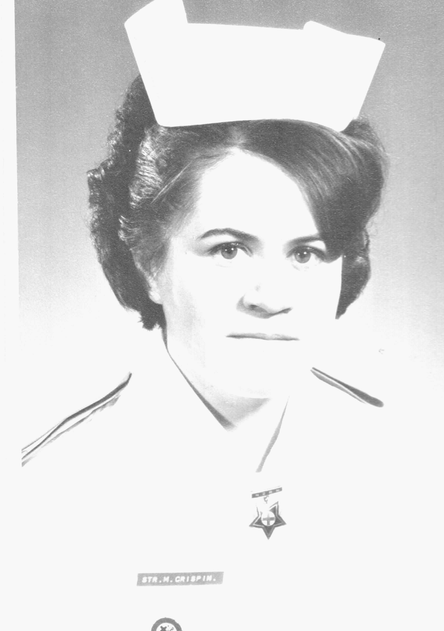Photo 1 | 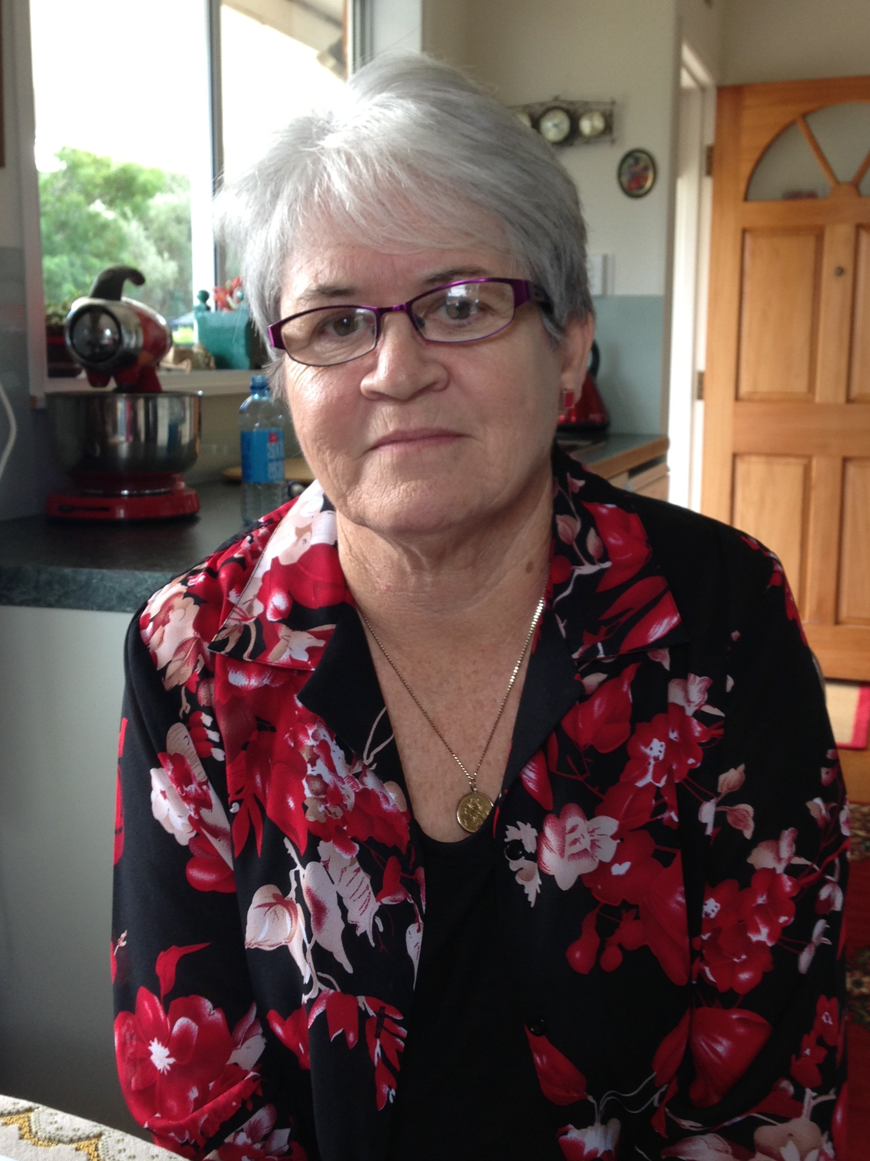Photo 2 | 1. Diane Crispin, Studio portrait 1972  2. Diane Crispin, 12 April 2013. Photograph, Margaret Horsburgh

000'09" | FILE 1 INTRODUCTON
000'36" | GROWING UP
 | Born WHANGAREI. Lived there until aged four years. Family moved to AUCKLAND because no CATHOLIC education in Whangarei. Explains.
001'12" | FAMILY
One brother. Father in ICE-CREAM trade. Average family. Describes.
Parents had come back from WAR, married overseas, lived with father's parents until could get own house.. Had met during WORLD WAR 2, on boat going from EGYPT to ITALY in 1944. Father in ARMY, mother a VAD NURSE. Details.
Mother worked as WINDOW DRESSER in MCKENZIES, HAMILTON before War. Describes.
002'50" | INTEREST IN HEALTH PROFESSIONS
 | Grew up with family interest in NURSING and MEDICINE. Mother worked for a DOCTOR to pay for education. From age seven wanted to be a DOCTOR. Describes.
003'16" | SCHOOLING
 | Family moved to AUCKLAND. Cut off from NORTHLAND family. All of schooling at ST MARY'S COLLEGE, PONSONBY, from age seven. Brother attended ST PAUL’S and SACRED HEART COLLEGES, AUCKLAND. Explains.
004'09" | SCHOOL ACHIEVEMENT
 | Average student. Achieved SCHOOL CERTIFICATE, UNIVERSITY ENTRANCE, 'second year sixth'. Left school at age 17. Followed academic course. 'Knew in third form that wouldn't be able to achieve MATHEMATICS.' Resigned to be a NURSE, rather than a DOCTOR. Describes.
005'26" | CHOOSES NURSING
 | Disappointed that would not be able to go to MEDICAL SCHOOL, had been inspired by GP [GENERAL PRACTITIONER]. Nursing was second choice. Describes.
005'44" | SCHOOL LEAVER OPTIONS
 | Options for women leaving school limited; teaching, nursing or office work. Some girls went to UNIVERSITY. Describes.
006'21" | SUPPORT FOR CAREER CHOICE
 | Parents supported decision to enrol in Nursing. Social norm at time was ‘to marry and have family'. Describes.
007'25" | SIBLING
 | Brother had a cadetship with U E B INDUSTRIES LTD. Did ACCOUNTANCY papers part-time. Describes.
007'54" | FAMILY STAYED IN AUCKLAND
 | Kept in touch with NORTHLAND relatives. School holidays in NORTH. Originally planned to do Nursing in WHANGAREI with cousin, only 16 at time applied, so was asked to wait until older. Describes.
008'32" | APPLYING FOR NURSING
Applied to AUCKLAND HOSPITAL BOARD SCHOOL of NURSING before left school, end of 1965. Accepted for April class 1966. Worked at IPANA TOOTHPASTE factory for three months before starting nursing. Describes.
Never thought of PSYCHIATRIC Nursing,'not interesting enough'. Describes.
010'03" | NURSING APPLICATION AND ACCEPTANCE
Interviewed at HOSPITAL BOARD offices. Went alone to interview. Medical checks at AUCKLAND HOSPITAL, 'examined groups of us at same time'. References from neighbour and HEAD MISTRESS.
Applied for GREENLANE or AUCKLAND HOSPITAL. Describes.
011'56" | FIRST DAY
 | Commenced Sunday 10 April 1966. Arrived GREENLANE HOSPITAL NURSES' HOME, 'it was pretty scary'. Parents left at front door, had collected all required clothes on list. Shown how to put buttons on uniforms. First year nurses lived in 'old’ NURSES' HOME. Describes.
013'23" | NURSING CLASS
 | Nineteen women and three men in class. Men lived at CORNWALL HOSPITAL. 'Didn't know much about the men ... they were kept separate.' Girls came from AUCKLAND. Didn't mix with counterparts at AUCKLAND and MIDDLEMORE HOSPITALS until after PRELIMINARY SCHOOL. Describes.
015'09" | UNIFORMS
 | Last class to have 'blue uniforms'. White short sleeved uniforms for working on wards. Epaulettes designated status or level of training with red stripes, blue capes. 'Got very proficient at putting buttons on.' Paper caps 'were just coming in'. White shoes and stockings. Describes.
016'56" | PRELIMINARY SCHOOL
Found PRELIMINARY SCHOOL 'daunting ... felt lonely ... strange new world'. MARIE HOSKING, HEAD of SCHOOL and SISTER McALEER said 'either stay or go'. Describes.
CURRICULUM included basic nursing skills; making beds, sponging patients, dressings, injections. Supervised 'on the wards ... taught to be polite and respectful ... anyone three months ahead of you was of greater value than you were ... as the years would progress we would climb the ladder'. Describes.
Spent Monday to Friday in class and Saturday mornings on wards while in PRELIMINARY SCHOOL. 42 hour work week over six days for ward work. Describes.
020'00" | WARD WORK FOR STUDENT NURSES
First ward was a SURGICAL WARD. 'A lot of responsibility ... checking people for theatre ... giving injections ... absolutely shook drawing up ampoule ... WARD SISTER calmed me down'. Describes.
Worked in a 'team' assigned to care for PATIENTS in one half of ward. 'Intensive physical work ... people stayed in bed ... lot of equipment ... just got on and did it ... learned from person above you ... not much input from TUTORS'. Describes.
Very few REGISTERED NURSES. Students ran the wards with supervision from a REGISTERED NURSE. Describes.
024'16" | NON-NURSING WORK
'Ward cleaners had just at started ... we did damp dusting ... cleaned stainless steel bed-pans ... spent a lot of time in SLUICE ROOM as a junior.’ Describes.
Meals served from meal trolleys by WARD SISTERS and STAFF SISTERS, students handed meals to patients. Describes.
Ward tidy twice a day, ' before DOCTOR'S round ... before visiting time'. Describes.
025'50" | GREENLANE HOSPITAL WARDS
 | 'Main block' wards had four to six bed and some two-bed patient rooms. Two MEDICAL wards (Wards 17 and 18), TUBERCULOSIS wards (Wards 14, 15 and 16). CARDIOLOGY WARDS [Wards 7, 8, 9] NIGHTINGALE type wards. Describes.
026'52" | NURSING SHIFTS
Three shifts, 7 am to 4 pm, 3 pm to 11 pm and 11 pm to 7 am. Explains.
Responsibilities increased on afternoon and night shift, 'as a two-striper you could be in charge of a ward ... SUPERVISOR came around'. SUPERVISOR 'covered six or seven wards'. Describes.
028'28" | STAFFING PATTERNS
COMMUNITY NURSE training had started, supplemented staffing, most Community Nurses were from NATIONAL WOMEN'S HOSPITAL. Explains.
Team nursing, four nurses from each level of nurse, 'and if you were lucky a STAFF NURSE ... to care for patients at one end of ward'. Wards had 46 patients, four nurses to care for 22 patients, most patients were in bed. Describes.
Roles changed as went up hierarchy, from second year could do 'MEDICINE ROUND'. Describes.
030'28" | DOCTORS
DOCTORS ‘were gods ... in charge of everything'. Junior Nurses had nothing to do with DOCTORS, assisted with procedures; third year nurses might go on ward rounds. Describes.
HIERARCHY amongst doctors, CONSULTANTS gave the orders. Describes.
032'18" | SUPPORT FROM FELLOW STUDENTS
'First DEATH ... third striper took me through how to lay out a person ... the ability to help through sad and upsetting time'. Describes.
Emotional support came from fellow students, talked in lounge of NURSES' HOME, 'including about who had told you off ... as junior nurse got told off all the time ... because you were learning ... kept in your place'. Describes.
036'33" | WARD SISTERS AS TEACHERS
 | Only some WARD SISTERS were teachers. Excellent WARD SISTER was one able to explain, supported to get on. Describes.
037'28" | STUDY BLOCKS
Regular 'STUDY BLOCKS'. Classes from AUCKLAND and MIDDLEMORE HOSPITALS combined with GREENLANE HOSPITAL class for study at CENTRAL SCHOOL, located on two top floors of 'new' NURSES' HOME at GREENLANE HOSPITAL. Describes.
'Could have sleep in on days in Block.' Describes.
Block five days a week, 'normal hours, like being on holiday'. Explains.
039'09" | RARE TO HAVE WEEKEND OFF
 | Very rare to have a weekend off when on ward duty, depended on WARD SISTER who did the rosters. ‘We didn’t know anything about the administration ... told what our duties were ... before went to a ward would introduce yourself to WARD SISTER ... changed wards every month or every six weeks.' Describes.
039'30" | EXPERIENCE AT OTHER HOSPITALS
NATIONAL WOMEN'S HOSPITAL for MATERNITY Nursing, six weeks as a junior and three months as a senior student. Explains.
ORTHOPAEDIC Nursing at MIDDLEMORE HOSPITAL in third year for one month. 'Daunting ... MIDDLEMORE HOSPITAL out of city ... we didn't drive'. Lonely experience, didn't know anyone when off duty. Describes.
Work was heavy and challenging, young people with spinal injuries. Describes.
NATIONAL WOMEN'S HOSPITAL on same site as GREENLANE, new modern hospital, opened in 1964. Women stayed in bed after childbirth for ten days, 'hard physical work ... loved the babies'. Describes.
043'38" | NURSING TUTORS/ONGOING EDUCATION
After PRELIMINARY SCHOOL classes were very big. TUTORS didn't have time 'for one-to-one as they had in PRELIM'. Called up to 'sixth floor if didn't achieve', Tutor competence was variable, 'only one book ahead of us ... learned on the job'. Describes.
Few on-going educational opportunities for nurses, SANS [SCHOOL OF ADVANCED NURSING STUDIES] available for nurses going into administration. No TEACHING courses. Some HOSPITALS offered clinical courses; ORTHOPAEDIC NURSING at MIDDLEMORE HOSPITAL, CARDIO-THORACIC NURSING at GREENLANE HOSPITAL. Describes.
046'05" | TEACHING CONTENT
 | DOCTORS lectured on specific conditions. Theory did not relate 'at time' to ward work,'could be on SURGICAL ward and doing MEDICAL conditions in block'. Describes.
047'01" | COMMUNITY NURSING
 | COMMUNITY NURSING was with PUBLIC HEALTH or DISTRICT NURSE. In second year 'went out with PULBIC HEALTH NURSES in city, PONSONBY ... went to schools ... followed up TB [TUBERCULOSIS] contacts’. Describes.
047'44" | DISSATISFACTION WITH NURSE TRAINING
Aware that an overseas expert had come to NZ, said that it would be good for NURSE TRAINING to be 'done through UNIVERSITIES'. UNITED STATES OF AMERICA nurse training was different, may have trouble working there. Describes.
CARPENTER REPORT, 'brought into focus ... significant changes proposed'. Describes.
049'16" | COMPLETION/ENTRY REQUIREMENTS
Nineteen girls had started in April 1966 class, ten sat STATE FINALS and nine passed. 'By second year half the class was gone'. One out of three of the males completed. Describes.
SCHOOL CERTIFICATE became a requirement for entry to nursing. 'Paid one pound a week extra if had UNIVERSITY ENTRANCE'. Describes.
050'54" | EXAMINATIONS
 | Regular TESTS during each BLOCK; last class to sit FIRST PROFICIENCY STATE EXAMINATION at end of first year; HOSPITAL FINALS three months before STATE FINALS. Study was in own time, 'hard ... doing nights, afternoons ... one day off a week'. Describes.
052'58" | EXAMINATION RESULTS
EXAMINATION RESULTS were mailed; 'ours held up ... MOON LANDING ... June 1969 ... results did not come until late July'. Friend collected envelope from home. Describes.
'Went back on duty ... it was my lunch hour.' Describes.
055'58" | EQUIPMENT CHANGES/DISPOSABLE EQUIPMENT
Disposable equipment became available, STERILISED DRESSING PACKS, previously huge number of procedures to learn, ' tome of book of nursing techniques ... each ward had different procedures to learn'. CENTRAL STERILE SERVICE DEPARTMENT provided most instruments, dressings, cleaned instruments in THEATRE. SYRINGES were disposable, glass syringes for INSULIN. Describes.
INTRAVENOUS FLUIDS in glass bottles until early 1970s. Describes.
ENEMA CANS still used. Explains.
SURGICAL patients might have WAGENSTEIN SUCTION, two quart bottles above the bed, heavy equipment. Describes.
'Never allowed to turn lights on at night ... everything by torch ... fall over equipment.' Describes.
ORDERLIES brought OXYGEN CYLINDERS to wards. Explains.
061'39" | HEART ATTACK PATIENTS
 | GREENLANE was the HEART HOSPITAL, CORONARY CARE UNIT. 'Not a shift went by when we didn't have a CARDIAC ARREST.’ Patients stayed in bed for many days, on bed-rest after MYOCARDIAL INFARCTION, heavy to nurse, patients very restricted, CARDIAC MONITORS, frequent monitoring. Complications occurred resulting from way patients were nursed, pressure area care, mobility exercises. Describes.
064'25" | MEDICATIONS
 | MEDICATIONS changed, 'new drugs all the time ... trials of drugs'. Explains.
065'30" | TRAINING NOT KEEPING PACE WITH MEDICINE
 | Theory not keeping pace with MEDICINE, ‘practical very good ... efficient and competent ... could run a ward by end of training'. Describes.
066'08" | END OF FILE 1

Recorded: | 12 APR 2013 | File: 2 of 2
Interviewer: | Margaret Horsburgh
Abstracter: | Margaret Horsburgh
Equipment type: | Fostex FR- 2LE Digital Recorder

000'03" | INTRODUCTION TO FILE 2
000'26" | NURSES' HOME LIFE
Accommodation provided in single rooms initially in cold old brick building, lounges at end of each corridor, good bathrooms and laundry facilities. Describes.
Dining room in NURSES' HOME. Meals were bulk 'carbohydrate rich', sat with friends, separate area for REGISTERED staff, came off wards for meals. Facilities available for making hot drinks. Describes.
003'00" | NURSES' HOME RULES
 | Strict rules around times to be in, permission required from MATRON for late leave until 1 am. HOME SISTERS shone torches into cars parked in forecourt of NURSES' HOME 'trying to catch people with their boyfriends'. Men allowed into lounge to wait 'if going on a date'. Describes.
004'07" | LIVING OUT
 | Required to live in NURSES' HOME until third year when could 'live-out' with parents’ permission. Could live out if married, had to leave if 'got pregnant', later girls were able to have their babies and come back. Describes.
005'23" | HOMESICK
 | 'Dreadfully homesick initially.' Able to go home for visits if had transport. Describes.
005'46" | LATE NIGHT ACCESS
 | Would leave window open for nurses returning late if had a room on ground floor, 'if in rooms deemed to be those where HOME SISTER wouldn't catch you ... expected to let people in'. Describes.
006'29" | KEEPING IN TOUCH WITH HOME
 | Generally went home on Days Off, 'there wasn't much time', if lived at PUKEKOHE or WAIUKU ‘would not have enough time to go home'. Describes.
007'27" | SPECIAL FRIENDS
 | Made life-long friends, cliques of girls depending on interests. Explains.
008'20" | HEIRARCHY
 | Lived in NURSES' HOME with students on same level, didn't mix with more senior students, 'until end of training'. Explains.
009'18" | FLATTING
Moved in to flat in third year, with three other students, had to have permission from parents. Describes.
'We were tired of being told what to do ... some girls in relationships ... just normal to try flatting.’ Study was difficult, moved home six months before 'finals'. Describes.
010'15" | MEMORABLE NURSES
 | Outstanding nurses, those with 'confidence in what they were doing ... theoretical knowledge'. Excellent nurses 'taught you a lot'. Describes.
011'43" | MALE NURSES
 | Male students did not live in NURSES' HOME, had a different journey and curriculum, and moved around hospitals. Two of the three dropped out very quickly. Describes.
013'12" | SOCIAL LIFE
Wanted to get out of NURSES' HOME after work, dances, parties, 'could always get a date'. Describes.
Lost touch with friends from school, life as student nurse 'so intense and working six days a week'. Even difficult to keep up with cousins in NORTHLAND, 'whole life revolved around nursing'. Describes.
014'56" | HOLIDAYS
 | Holidays frequently were with class mates, hitch-hiked around SOUTH ISLAND. Had to apply 'in advance ... to get time off together ... four weeks a year but only two weeks at a time.' Describes.
016'03" | GREENLANE SOCIAL/SPORT ACTIVITIES
GREENLANE had social and fund-raising events, trying to build a SWIMMING POOL. DRAMA Group, sports groups. Duties limited opportunities to participate in outside interests. Describes.
Frequent parties, in flats, HOUSE SURGEONS’ residence. Describes.
018'13" | SMOKING
 | Everyone smoked, 'taught to smoke ... in NURSES' HOME'. Patients smoked in wards with OXYGEN on. Describes.
019'20" | ALCOHOL
 | Minimal ALCOHOL use, available at parties, two nurses on probation for drinking in NURSES' HOME. Some alcohol allowed with patients in TUBERCULOSIS ward, 'might go out on a Friday night'. Describes.
020'37" | BOYFRIENDS
 | Possible to have boyfriends while training. Explains.
021'12" | FEMALE RELATIONSHIPS
 | Not aware of close female relationships, felt was naive. Explains.
021'42" | CHRISTIAN GROUPS
 | Some Hospital based CHURCH groups, 'nursing stopped me going to CHURCH', was always working on Sunday. Explains.
022'16" | SICK PARADE
 | Clinic each morning in NURSES' HOME, reported if sick. If not well enough to work 'put in a room on a separate floor'. HOME SISTERS looked after sick nurses. Describes.
022'57" | HOME SISTERS
 | HOME SISTER, had assistants, lived on site. MATRON and two DEPUTY MATRONS lived on site in individual flats. Single women. Describes.
024'01" | STUDENT NURSES' ASSOCIATION
 | Did not belong to STUDENT NURSES' ASSOCIATION. Explains.
024'05" | PAY AND CONDITIONS
Accepting of pay, able to save and pay rent for a flat. Never worried about pay, 'didn't talk about money'. MALE students were paid more, generally older. Describes.
Pay parades every fortnight, received cash in small brown envelopes. Describes.
Towards the end of training worked only five days a week instead of six, REGISTERED NURSES worked five days a week and not every weekend. Describes.
026'31" | GRADUATION
Graduation ceremony at AUCKLAND TOWN HALL to receive medals. MATRON-IN-CHIEF handed out certificates; wore uniform, parents came. Describes.
Arranged own graduation ball, PETER PAN in QUEEN ST, AUCKLAND. Wore beautiful dresses. Describes.
028'19" | STAFF NURSE
STAFF NURSE, June 1969. First ward ENT [EAR, NOSE AND THROAT], did not choose ward, planned to stay 12 months before going overseas. Moved to 'NIGHT RUN’ for six months, saw all of hospital, involved in emergencies, good practical knowledge and experience. Describes.
Had much more responsibility than as a student. STAFF NURSES on morning and afternoon shifts, night duty student nurses with REGISTERED NURSES covering hospital. Explains.
Responsible for students, for MEDICATIONS, setting up INTRAVENOUS FLUIDS, putting drugs into intravenous fluids, POTASSIUM, ANTIBIOTICS. Student nurses not allowed to change INTRAVENOUS drips. By time became a STAFF NURSE had been doing many of these things. Describes.
031'56" | NIGHT SUPERVISOR
 | Would cover six to seven wards as REGISTERED NURSE on NIGHT DUTY. REGISTERED NURSES on all shifts in EMERGENCY DEPARTMENT, CORONARY CARE and INTENSIVE CARE UNITS, still attended emergencies in these units. Describes.
032'34" | WORKING IN ENGLAND
After 15 months as a STAFF NURSE travelled by sea with friend to LONDON, ENGLAND, joined a NURSING BUREAU, nursed in people's homes or in PRIVATE WINGS of Hospitals, UCH [UNIVERSITY COLLEGE HOSPITAL], ST MARY'S , PADDINGTON, MIDDLESEX. Describes.
Work in people's homes included palliative care; in private wings would be post-operative surgical patients, 12 hour shift staying with one patient. Describes.
Would work three to five months and then trip to EUROPE. Shared flat in HAMPSTEAD, LONDON with brother, cousin and others. Away fifteen months. Describes.
035'18" | STAFF SISTER, GREENLANE HOSPITAL
 | Returned to NEW ZEALAND [1972] and successfully applied for position at GREENLANE HOSPITAL, surgical ward, wanted more education. Describes.
035'42" | MIDWIFERY TRAINING
 | Applied for MIDWIFERY 1973, initially turned down, class was over-subscribed, someone pulled out. Training at ST HELEN'S HOSPITAL, new hospital [1968] in MT ALBERT, AUCKLAND, lived on site, didn't drive. 'Only a way of getting a post-graduate qualification.’ Describes.
037'13" | RETURN TO ENGLAND
 | Following MIDWIFERY returned to ENGLAND, a lot of travel, 'had more money', private nursing. Describes.
037'29" | MATER HOSPITAL
 | on return from ENGLAND, Night duty at the MATER HOSPITAL [1976-1977], surgical wards. Lived with parents, didn't drive. MATER HOSPITAL phasing out NURSE TRAINING. Describes.
038'36" | UNITED STATES OF AMERICA
 | Applied for position 'in what I hoped was DALLAS, TEXAS, USA ... when arrived ... put in a hospital 600 miles west of DALLAS ... LUBBOCK'. Had applied through an agency, shared an apartment with a NEW ZEALAND nurse. 800 bed METHODIST HOSPITAL, mainly night duty, 'frantic ... did everything ... like a junior HOUSE SURGEON ... inserted IVs [INTRAVENOUS LINES] ... learned a lot of practical skills'. Employed as a GRADUATE NURSE, did not have USA qualification. Became very skilled at putting IV lines in,'doing many procedures that HOUSE SURGEONS did in NZ'. Worked six days a week, 'if did get two days off together ... often called back'. Different culture from NZ, patients demanding, poor practical basic nursing care. Describes.
042'33" | RETURN TO NZ AS SKILLED NURSE/AUCKLAND HOSPITAL
Returned to NZ in 1979, very experienced nurse, STAFF SISTER worked AUCKLAND HOSPITAL, surgical ward, CHEST and ABDOMINAL SURGERY, three rostered duties, mix of student nurses and REGISTERED NURSES, a few POLYTECHNIC students. Describes.
Medical and nursing advances, PARENTERAL FEEDING. Shift work becoming difficult. Describes.
044'50" | NURSING ADVANCES
 | Many equipment changes, pre-packaged dressing packs, IV [INTRAVENOUS FLUIDS] fluids with additives, nurses doing minimal cleaning, 'still cleaning beds ... serving meals ... meals came up on trays'. Describes.
046'00" | DISTRICT NURSING CAREER CHOICE
 | Career choice to apply for DISTRICT NURSING [1981], knew would transfer on CHARGE NURSE pay rate. Wished to do further study,'but all positions ... on ADVANCED DIPLOMA were filled by CHARGE NURSES'. Describes.
047'31" | DISTRICT NURSE EMPLOYMENT
 | Employed as DISTRICT NURSE, separate EXTRA-MURAL HOSPITAL, with MEDICAL SUPERINTENDENT, PRINCIPAL NURSE, NURSE SUPERVISORS. Wore plain blue uniform, shoes and stockings supplied. Induction process was two weeks with another District Nurse,'get on with it'. Given a car, bag and area 'to attend to patients in their homes doing everything ... babies through to elderly ... lot of POST-NATAL work’. As MIDWIFE received extra pay. Describes.
049'24" | MANAGING GEOGRAPHICAL AREA
 | Managed a broad geographical area, STUDENT NURSES worked with DISTRICT NURSES, assisted with bathing patients, 'up to five baths a day ... terminally ill patients ... babies ... surgical wounds ... STOMATHERAPY ... 15 to 25 patients a day'. Afternoon and weekend shifts. Describes. Had learned to drive, living with parents. Explains.
050'52" | DISTRICT NURSE CHANGES
 | DISTRICT NURSE for 32 years. Many changes 'from doing everything for everybody to split into specialist services'. No POST-NATAL work, 'lost need to bath people ... services which took care of bathing people'. Structural changes, 1986, AUCKLAND AREA HEALTH BOARD, costings and funding 'became an issue'. Describes.
052'36" | ADVANCED DIPLOMA IN NURSING
 | Completed ADVANCED DIPLOMA IN NURSING, ATI [AUCKLAND TECHNICAL INSTITUTE], 1987. On full salary, 'bonded to the BOARD ... for two years afterwards'. Felt base knowledge improved, enjoyed year. Describes.
053'46" | PROFESSIONAL DEVELOPMENT
 | DISTRICT NURSING provided opportunities for on-going education, short courses, continuing professional development. Describes.
054'02" | ONGOING CHANGES
 | DISTRICT NURSES out of uniform by end of 1980s received a shoe and stocking allowance 'for a few years'. Uniforms re-instated 'in last few years'. No uniforms in specialist services, works in GERONTOLOGY service. Describes.
054'39" | CURRENT EMPLOYER
 | AUCKLAND DISTRICT HEALTH BOARD current employer of DISTRICT NURSES, since 1990, no separate hospital. CHARGE NURSE for District Nurses and CHARGE NURSE for specialist nurses. Describes.
055'27" | SPECIALIST NURSE
 | Transferred into specialist GERONTOLOGY team. Completed STOMATHERAPY course at WAIARIKI INSTITUTE OF TECHNOLOGY [ROTORUA], only such course in NZ. Describes.
056'50" | NURSING FAMILY MEMBERS
Had 12 months leave to care for mother, privilege of nursing mother in her own home for eight weeks. Describes.
Nursed cousin who shared a home with. 'Was able to do these things because I was a nurse ... became the nurse for … periods of time'. Describes.
Cared for grandmother during period working at MATER HOSPITAL. 'Always able to take time off to care for FAMILY.’ Describes.
060'10" | RETIREMENT
 | 'Nursing has been my life.’ Retirement after 47 years will be a life not looking after people. Describes.
061'24" | END OF FILE 2

