Recorded: | 4 DEC 2013 | File: 1 of 5
Interviewer: | Kate Prebble
Abstracter: | Debbie Dunsford
Equipment type: | Fostex FR-2LE Digital Recorder

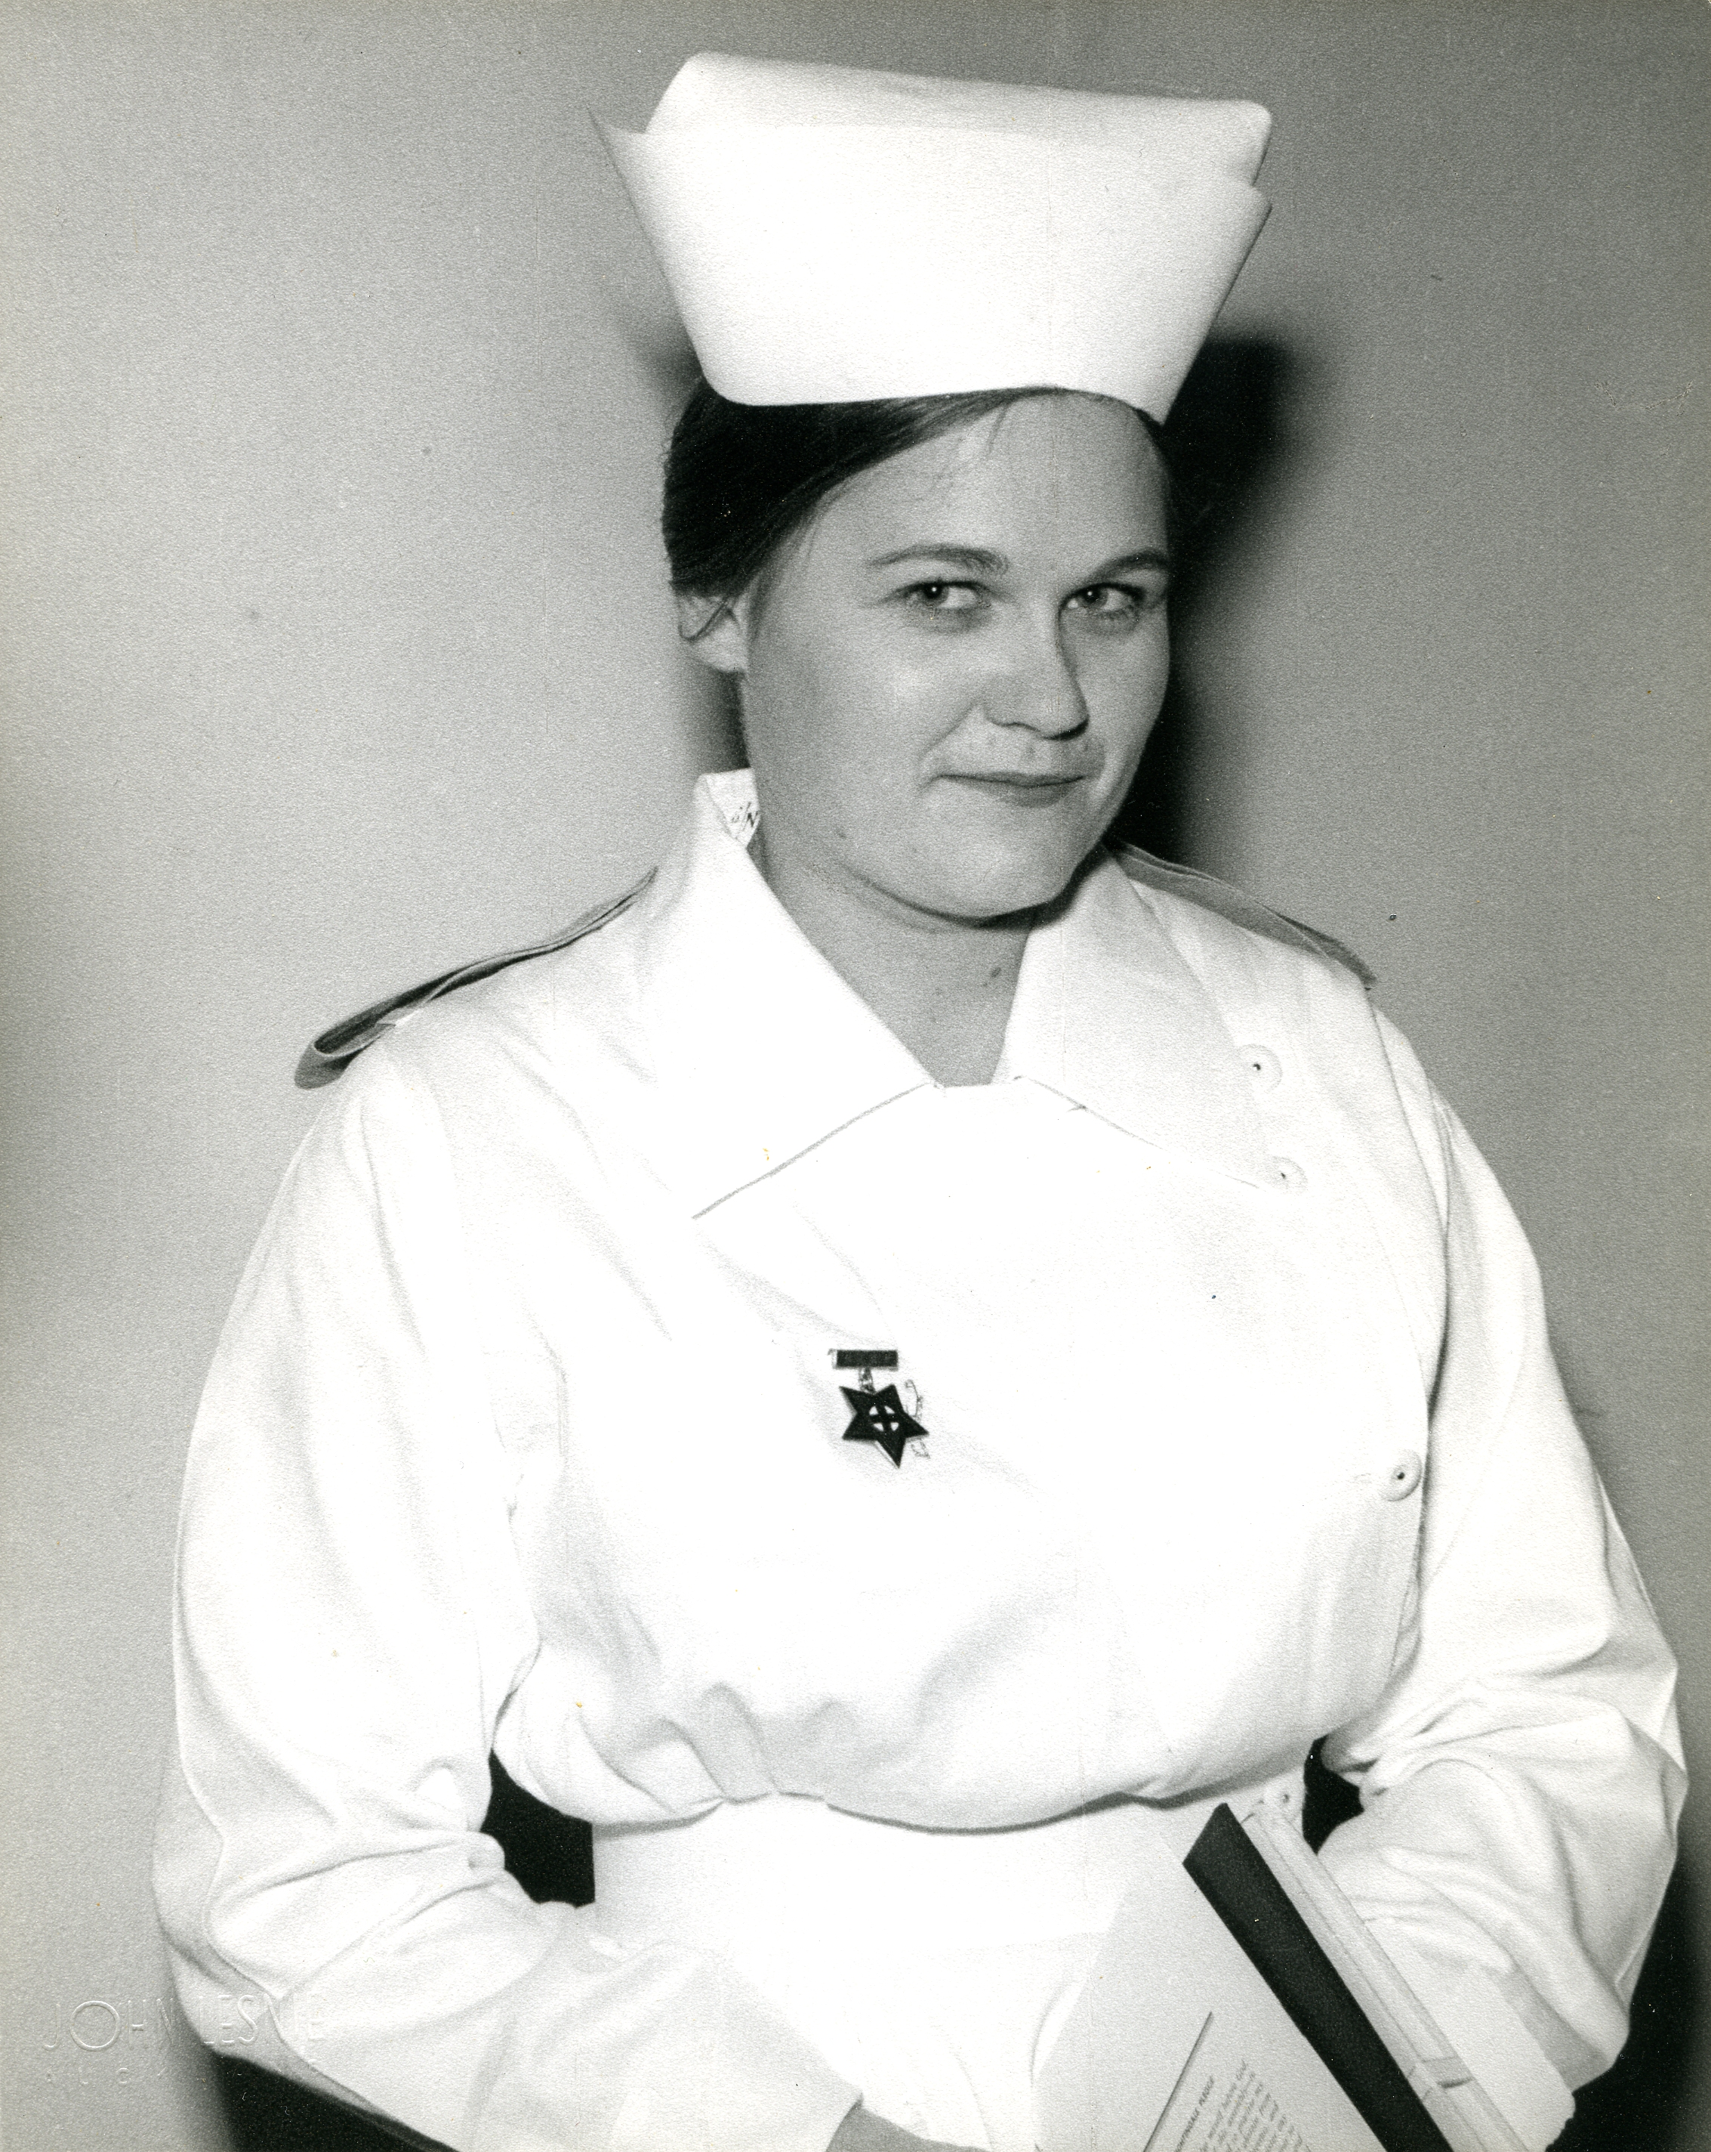Photo 1

000'05" | INTRODUCTION AND FAMILY BACKGROUND
Born 1939 in KING COUNTRY at TE KUITI. Father worked for LANDS & DEVELOPMENT DEPARTMENT. He was a diesel and marine engineer. Worked with heavy haulage equipment for earth moving. Mother born TE KUITI and lived on isolated farm. Refers PIO PIO, ARIA.

Claire's family moved to live at MURRAYS BAY [AUCKAND] when CLAIRE about one year old. Describes. Recalls barbed wire on beach at MURRAYS BAY and HOME GUARD [WORLD WAR 2]. Describes small community. Recounts how she did not know her father when he returned from war. Refers POST TRAUMATIC SHOCK, MALARIA, PACIFIC. Father was a mechanic on the SUNDERLANDS [AIRCRAFT] during war and responsible for building the breakwater at LAUTHALA BAY, FIJI. Comments on father's earth moving knowledge.

Moved to WAIUKU land on estuary when CLAIRE 6 years old. Describes. 'It was a good country life for kids. We didn't realise how good it was in those days. We learnt self-sufficiency, we really did.' Comments on how everyone was poor but thought nothing of it. Never went hungry.

Father had own agricultural contracting business and working with farmers and on land development. Describes their 'very old' house and life. New house plans drawn up when CLAIRE around nine years old. Describes treatment of timber for foundations and how family helped to build house.
011'28" | SCHOOLING AND GOING NURSING
 | Attended WAIUKU PRIMARY SCHOOL and WAIUKU DISTRICT HIGH SCHOOL. 'School was quite fun actually.' Refers MILITARY DRILL, FOOTBALL, NETBALL, SWIMMING. Recalls she was not allowed to sit SCHOOL CERTIFICATE in the fifth form because they said she would fail. Made up her mind to pass and then leave school.
012'30" | DECISION TO GO NURSING
Decided she wanted to be a nurse when nine and admitted to Ward 22A [PRINCESS MARY HOSPITAL] with what was thought to be an infectious type of MUMPS. Found out she had ACUTE NEPHRITIS. Spent two months in hospital. Refers to PENICILLIN. 'Mum used to come up [to visit] once a week. And she'd bring me up a little bunch of violets.' 'They knew I was fine.' Recalls how the experience made her want to become a nurse.

When left school, got job at local MATERNITY HOSPITAL for a year before starting nursing. Parents against her becoming a nurse at first. 'Too hard for a girl.' Applied to do nursing at AUCKLAND HOSPITAL. Refers NURSES' HOME, CAREERS DAY. Once accepted for training, parents accepted her decision. Parents worried that would be too hard physically and academically. 'What they didn't know was, if I made up my mind to do something, look out.'

Recounts that mother accompanied her to the second interview and she underwent special tests because she had had NEPHRITIS. Local GP carried out the tests. 'He called me into his surgery and he said "you can go nursing". I said "Really". So he handed me the results and I said "Now have you sent those into them?" And he said "You're already thinking like a nurse, aren't you".' Reflects on parents' support.

FILE ENDS 19 MINUTES 36 SECONDS

Recorded: | 4 DEC 2013 | File: 2 of 5
Interviewer: | Kate Prebble
Abstracter: | Debbie Dunsford
Equipment type: | Fostex FR-2LE Digital Recorder

000'05" | PARENTAL ATTITUDES TO NURSING
 | Opposition by parents to Claire going nursing based on experience of a cousin who developed PERNICIOUS ANEMIA during nursing training. Discusses. Parents came around to the idea in time. Father of SCOTTISH heritage. 'He was determined that his four daughters were all going to be educated so that, if anything happened in life, they could look after themselves and they could look after a family if they had a family as well.' Discusses father's attitudes to what was a suitable career for a girl. Refers SCHOOL TEACHING, HAIR DRESSING. Discusses careers of her three sisters and influence of her father on his daughters and their children.
004'05" | FIRST DAY
AUCKLAND SCHOOL OF NURSING took 100 nurses, 50 at MARKET ROAD and 50 at GREEN LANE (PRELIMINARY SCHOOLS). CLAIRE at GREEN LANE. 'You arrived as a little country kid amongst all these 50 other people with their parents and everything else. And you knew nobody. But that didn't seem to worry me. I was going to do my training.' Discusses how became friends with another 'country girl' and lifelong friendships among those nurses to this day. About 30 completed their training. Quite a few left as soon as they completed training. Reasons included giving up nursing entirely, some got married, some went overseas.

Describes being shown NURSES' HOME and parents' involvement in first day. Parents were told 'Your daughters are here in our care and they will be accepted'. Lady in charge of NURSES' HOME was 'a disciplinarian'.
007'35" | NURSES' HOME
 | Rules included being in by 11pm at night. Taught about being quiet because others were asleep and how to wear the uniform. First time CLAIRE had had her own bedroom. 'I thought I was made.' A lot of other girls came from private school backgrounds and professional fathers. 'Very quickly, I found my niche wasn't quite with that range. I was more with the country girls.' Comments on range of social backgrounds. A few MAORI girls. 'They sort of blended in with everybody.'
010'00" | PRELIMINARY SCHOOL
GREEN LANE PRELIMINARY SCHOOL was 13 weeks long. First class that had included OBSTETRICS included in their training. Reflects on how some from previous years looked down on her class because they did not have to do separate MATERNITY TRAINING. Influenced the way CLAIRE treated the first COMPREHENSIVE NURSES when they completed their training.

Responded well to the teaching of MISS MARIE HOSKINGS. Describes her as gentle, patient 'and she listened to what wasn't said as well as what was said. And she wasn't dictatorial but she had a very genteel way of being able to say things so that it really got through to you and you knew that she meant it and you'd better listen. So I made up my mind I was going to be a nurse like that, thank you.' Refers MISS WILLIAMS.

Describes being on ward during PRELIMINARY SCHOOL. Recalls being a nurse and preparing a patient who was going to be sponged by a PRELIMINARY SCHOOL nurse.

One day off a week. Country girls tended to do things together because they couldn't get home. Describes briefly.
014'54" | ON THE WARDS
At AUCKLAND SCHOOL OF NURSING, went 'touring' to different hospitals. CLAIRE spent two months in ORTHOPAEDICS at MIDDLEMORE, two months of OBSTETRICS at NORTH SHORE, two months of PAEDIATRICS at AUCKLAND, two months INFECTIOUS at AUCKLAND. Describes how made move from one hospital to another and value of those specialised experiences. Refers GREEN LANE, CARDIAC, CHILDREN'S HEART, TB [TUBERCULOSIS].

In first year, did SLUICE ROOM, pans, damp dusting and cleaning. Learned quickly to be very thorough about everything.

Taught how to do stitches, dressings, drug rounds. Describes. One complete ward devoted to STAPHLOCOCCUS INFECTION. Dressings very difficult for patients but CLAIRE found it intriguing. Describes.

FILE ENDS 21 minutes 37 seconds.

Recorded: | 4 DEC 2013 | File: 3 of 5
Interviewer: | Kate Prebble
Abstracter: | Debbie Dunsford
Equipment type: | Fostex FR-2LE Digital Recorder

000'05" | TREATMENT OF TUBERCULOSIS
Discusses problems for patients being treated for TUBERCULOSIS. Based on rest with minimal chemotherapy. Isolation very difficult for patients. Refers PNEUMONECTOMY, LOBECTOMY. Describes treatments including STREPTOMYCIN injections. Some patients waited for CLAIRE in particular to give them their injections. Refers SIDE EFFECTS, DEAFNESS. 'It's only when I sit and think about it now that I realise, because I had all those injections, all those PENICILLIN injections when I was 12, I think I really learnt to value a very well-given injection and to really appreciate the nurse who talked you through it, who relaxed your muscle, who got you in the right position and made sure you weren't anxious.' Reflects on benefit of walking in someone else's shoes. Mentions social hardships TUBERCULOSIS patients faced.

Discusses how nurses were taught to consider a patient's whole health, relationships with and pastoral care for long-term patients.
006'25" | MEDICAL WARDS
 | Quite a few long term patients in MEDICAL WARDS. Recounts story of one very active patient who had had a heart attack and was on bed rest. Knew about the CARDIAC work being carried out and [BRIAN] BARRATT-BOYES. Reflects on her preference for focus on people. Thinks that's why she moved in PUBLIC HEALTH. Later did MENTAL HEALTH at TOKANUI.
009'45" | ORGANISATION OF TRAINING
After PRELIMINARY SCHOOL, went on STUDY BLOCK. All organised for them in order to cover the CURRICULUM. Travelled by bus from GREEN LANE to AUCKLAND HOSPITAL TUTORIAL SCHOOL. Explains how blocks organised. Did not go on the wards at all during block. Describes. 'I didn't find it hard but I had to work. I had to put in the hours.' Refers MISS WILLIAMS, tutor. Taught by nurse specialist, surgeons (ENT, OPTHALMOLOGIST), Dr BOYD SWINBURN in charge of INFECTIOUS DISEASES.

Often a disconnection between ward work and education. Describes. Senior nurses taught nurses on the ward. 'I was good at asking questions.'
014'30" | WARD HIERARCHY
 | CLAIRE did not find WARD HIERARCHY a problem. 'It's like being at school.' 'You just accepted that other people knew things that you didn't know.' Describes how one medical ward sister did small training sessions for nurses.
016'20" | EXAMS
Determined to pass exams and did. Describes final exams. Not allowed to sit STATE EXAM until passed HOSPITAL EXAMS. Pressure maintained between the two exams to ensure you passed STATE. CLAIRE achieved the top marks in NUTRITION exam.
FILE ENDS 20 minutes 08 seconds.

Recorded: | 4 DEC 2013 | File: 4 of 5
Interviewer: | Kate Prebble
Abstracter: | Debbie Dunsford
Equipment type: | Fostex FR-2LE Digital Recorder

000'05" | NURSES' HOME SOCIAL LIFE
Minimal income of 2 pounds a week after board and lodging. Had to be careful how you spent it. Social activities done with others on the same shift. Describes how had to be careful about going to the pictures in the morning and being back in time for afternoon shift at 3pm. 'So, there'd be many a time we had to walk out before the picture really finished.' One trip was to go to Devonport 'but you couldn't afford to buy your lunch and catch the ferry and catch the bus, so you had to take something with you'. Able to pre-order lunch from the NURSES' HOME. Did this when going on DISTRICT NURSE TRAINING.

Describes experience with DISTRICT NURSING. 'I might have thought I'd had a fairly low-key childhood but some of these poor people who were living in these one-room places way at the top of these rickety stairs. And they'd be people with dressings and diabetes and old men. Oh, I really wondered what the heck had hit me.' Gave her a new insight into SOCIAL WORK. Refers PLUNKET NURSE.
003'45" | SOCIAL LIFE
Other GREEN LANE nurses had a car, a scooter, family came and picked them up, party at home that night. Nurses earned less than girls in other jobs. CLAIRE did not SMOKE but a lot of others did. Recalls taking a drunken nurse home one night [ALCOHOL] and other risky behaviour. One girl PREGNANT when sat FINAL EXAMS. Not that many stayed on as nurses after training. Comments on SOCIAL ACCEPTANCE and changes since the 1950s. Not aware of any relationships between women during training time.

One friend played in the NURSES' HOCKEY TEAM. Describes the injuries she received. Hard to play team sport because of SHIFT WORK. Had a sports section in NURSES' HOME and could play TABLE TENNIS. TENNIS COURT was in poor repair.
010'10" | CHURCH
 | CLAIRE was a CHURCHGOER. Attended EPSOM PRESBYTERIAN CHURCH. Not involved with NURSES' CHRISTIAN FELLOWSHIP. If at AUCKLAND HOSPITAL, sometimes attended PITT STREET METHODIST CHURCH because it was walking distance.
011'47" | GRADUATION
AUCKLAND HOSPITAL BOARD held GRADUATION CEREMONY at TOWN HALL. A big event. 'You had to make sure your UNIFORM was worn exactly so.' Presented following year with AUCKLAND HOSPITAL BOARD fourth year certificate.

GRADUATION BALL held at PETER PAN [CABARET]. Made own long frock, wore long gloves.
014'00" | WORKING AS A TRAINED NURSE
Very valuable to consolidate training by staying on after graduation for fourth year. Worked in MEDICAL UNIT and then asked to be a PRELIMINARY SCHOOL TUTOR. Taught practical NURSING ARTS. Found she had to get her own skills 'absolutely spot-on'. Stayed a year and decided not for her. 'I'm really not cut out for this. I'm not one of these stiff, starched, laced type people.' Also found she missed the patients. Refers MISS MARIE HOSKINGS. CLAIRE awarded Dr GILBERT'S PRIZE For Most Practical Nurse Of The Year. Went back to a SURGICAL WARD as JUNIOR SISTER. Became AFTERNOON NIGHT SUPERVISOR. Describes extremely varied duties. After one year, looked at going 'out in the field'. Refers DISTRICT NURSING, PUBLIC HEALTH. Accepted position as PUBLIC HEALTH NURSE at KAWAKAWA, NORTHLAND. Liked the role 'because you are out there with real people'. Learned during theatre work that 'I don't like my patients anaethetised'.

Discusses how not many Auckland nurses joined PUBLIC HEALTH. Refers MARLENE BUSH [TRUBSHAW].

File ends 21 minutes 06 seconds.

Recorded: | 4 DEC 2013 | File: 5 of 5
Interviewer: | Kate Prebble
Abstracter: | Debbie Dunsford
Equipment type: | Fostex FR-2LE Digital Recorder

000'05" | PUBLIC HEALTH NURSING AT KAWAKAWA
Recalls how 'green' she was going off to do PUBLIC HEALTH NURSING at KAWAKAWA. Lucky that she lived in a cottage with a very experienced public health nurse and mentor, WYNN MOYNIHAN from SOUTHLAND. Describes her qualities. 'I watched how she worked and I thought "I'm going to master this" because it's about planting seeds and backing off and then letting people sort out where they are.'

Work very diverse. Included DISTRICT NURSING, PUBLIC HEALTH, INFECTION CONTROL, WELL CHILD and SCHOOL WORK. If a crisis and a major TB case, everything shelved and it took precedence. Refers CONTACT TRACING, HEAF TESTING. Describes treatments and procedures. 'We had huge TB clinics. Buses used to come through from KAIKOHE with people on it. Big caseload.' Describes. 'Terrific amount of TB.'

Other priorities were dressings and bedside nursing. 'It was very busy. You never got bored. In fact you got peopled out. When you had a holiday, you had a break, you left the area, it was the only way. Because they knew where your house was, the clinic was attached to the house and invariably they'd knock on your door.' Worked closely with doctors and hospital. Learned that in a small area, everyone must work together.

Brought good knowledge from training about dressings, infection, TB, disease control, paediatrics, general medical and surgical, orthopaedics. Generally it was all useful. Refers EAR INFECTIONS. Discusses difficulty in changing behaviours.
007'10" | PUBLIC HEALTH NURSING AT KAWAKAWA
Only things left behind at training school probably HIERARCHY, anaethetising patients and surgical procedures. Reflects on how everything she learned was useful at some stage. Comments on how easy to recall practical training.

Grew up in TAINUI area. Went to school with DAME NGANEKO MINHINNICK. Learned about MAORI CULTURE as a child but learned much more when went to KAWAKAWA. Became part of community, attended MAORI functions and gala days. They taught her how to tickle a trout, left bags of kumara and corn on doorstep. Let MAORI help themselves to pears from tree at nurses' house.

Recalls family relationship with MAORI during childhood.
011'30" | MARRIAGE AND CHILDREN, PLUNKET TRAINING
Met and married husband who was a POLICEMAN at KAWAKAWA. He left Police and went farming at TE AROHA. CLAIRE had children and left PUBLIC HEALTH for a while. Left farming and husband worked for INLAND REVENUE DEPARTMENT. Then moved to WAITOA and he worked as a TANKER DRIVER.

CLAIRE did part-time GERIATRIC work while children little. While based at KAWAKAWA, did four months PLUNKET TRAINING at KARITANE HOSPITAL, MT ALBERT, AUCKLAND. Loved the babies. Describes. Refers MOTHERCRAFT, REMUERA, ORAKEI, CLASS. Reflects on how she related to lower socio-economic, multi-cultural and rural clientele.
015'30" | PUBLIC HEALTH NURSING AT KAWAKAWA
 | Recalls visiting an emaciated baby with diarrhoea. Mother had been told to feed it flour and water. Discusses whether due to poverty, ignorance, priorities. Refers BUDGETING, MAORI WOMEN'S WELFARE LEAGUE, MONEY MANAGEMENT, AFFCO FREEZING WORKS, MOEREWA.
017'35" | TE AROHA, TOKOROA, TURANGI
Asked to work three days a week as PLUNKET NURSE. Got CHILDCARE for pre-schooler. Wanted to return to PUBLIC HEALTH and offered a job in TOKOROA. 'In Public Health, if you don't take the vacancy when it's going, it will be filled and then it's hard to get another one.' Started part-time and moved to full-time. Family moved to TOKOROA.

Husband got job as PRISON OFFICER at TURANGI and suggested family move there. HOUSING provided on prison grounds. Refers HAUTU VILLAGE. CLAIRE got nursing job at RANGIPO PRISON. One nurse for 120 prisoners. Comments on differences today with team of nurses working shifts.
022'55" | PRISON NURSING
'By the time I left after six years, I wondered who was locked up.' CLAIRE was first female registered nurse appointed to a male minimum security prison. Authorities very worried about her security and 'watched me like a hawk'. CLAIRE regarded all prisoners as humans worthy of nursing care irrespective of crime. Since then, philosophy of prison officers has changed to be more rehabilitative. After six years, returned to PUBLIC HEALTH work.

At prison, set up support services by phone to 'girls up at MT EDEN' [PRISON]. Worked with GP who also gave her support 'but it was an isolating job'. Had to draw on own resilience and examine own personal practice at times.

Attended annual PRISON NURSES' CONFERENCES but these were discontinued after a time. 'It was the poor Cinderella of the PRISON SERVICE.'

Recalls incident when she was a PUBLIC HEALTH NURSE and a prisoner was diagnosed with TB [TUBERCULOSIS]. Had to overcome difficulties getting access to that patient/prisoner. Her experience in the prison enabled her to get access. Describes how brought in MEDICAL OFFICER OF HEALTH because prison nurses not experienced in TB. Refers DR PHIL SHOEMACK, MANTOUX TESTING. Two cultures of nursing and prison security. 'It made me a stronger person. Oh, I learnt a lot about men. Gee, they're backstabbing.' Refers OFFICERS, INMATES, NURSING PRACTICE, ETHICS, PROTOCOLS. Recalls how you had to mask your feelings at times.
033'27" | PUBLIC HEALTH NURSING IN TURANGI
Loved going back to PUBLIC HEALTH work. Considers highlight was an EAR programme educating pre-schoolers and KOHANGA REO in EAR care. Had a high profile with babies and good relationship with practice nurses. Could negotiate appointments for a mum with sick baby from out in the field. Describes how Claire had the networks and was taken seriously. COMMUNITY HEALTH NETWORK GROUP ensured people knew each other well.

Did LACTATION CONSULTANCY while at TURANGI. Describes.

Asked to do ARTHRITIS HELPLINE. Describes. Reflects on ability to keep doing job as she gets older. Offered a part-time job with WELL CHILD last year but turned it down. Refers KIM GOSMAN. Describes giving advice to another prison nurse about the best type of work for her. Reflects on heart-warming aspect of giving 'women the power to move forward to do'.

Public health work over 20 years has been with women, the school and TB. Describes changes over time. Offered job at TAURANGA doing PRE-SCHOOL PUBLIC HEALTH work. Discusses how stayed for 3 years but then retired back to TURANGI. Prefers small communities to the city. Discusses getting through the tough days. Learned to be very good on the phone.
045'45" | FINAL REFLECTIONS ON NURSING CAREER
'I'd do it again.' Need to know yourself. Believes people given information, support and encouragement will follow through or there's a reason for it. Describes occasions when recognised DOMESTIC ABUSE and advocated for the child. Describes. Refers CHILD YOUTH & FAMILY, CARE AND PROTECTION PANEL, [WOMEN'S] REFUGE. Reflects on dealing with gangs, dogs and personal safety. Discusses eventual introduction of CLINICAL SUPERVISION and support of DOMESTIC VIOLENCE CO-ORDINATOR.

Reflects on importance of knowing yourself and understanding your philosophy of life.

FILE AND INTERVIEW ENDS 55 minutes 06 seconds.

