Recorded: | 7 DEC 2012 | File: 1 of 6
Interviewer: | Debbie Dunsford
Abstracter: | Debbie Dunsford
Equipment type: | Fostex FR-2LE Digital Recorder

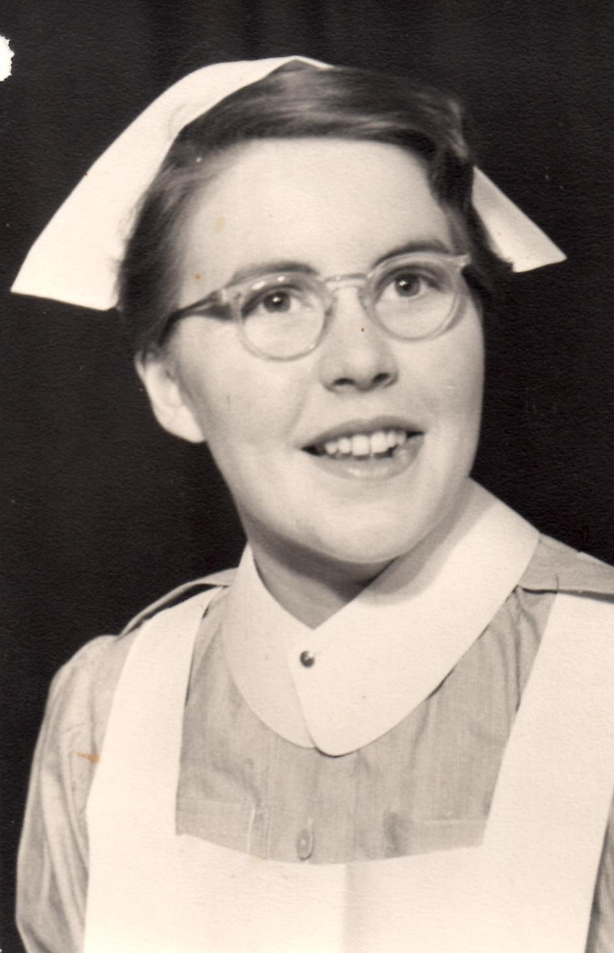Photo 1 | 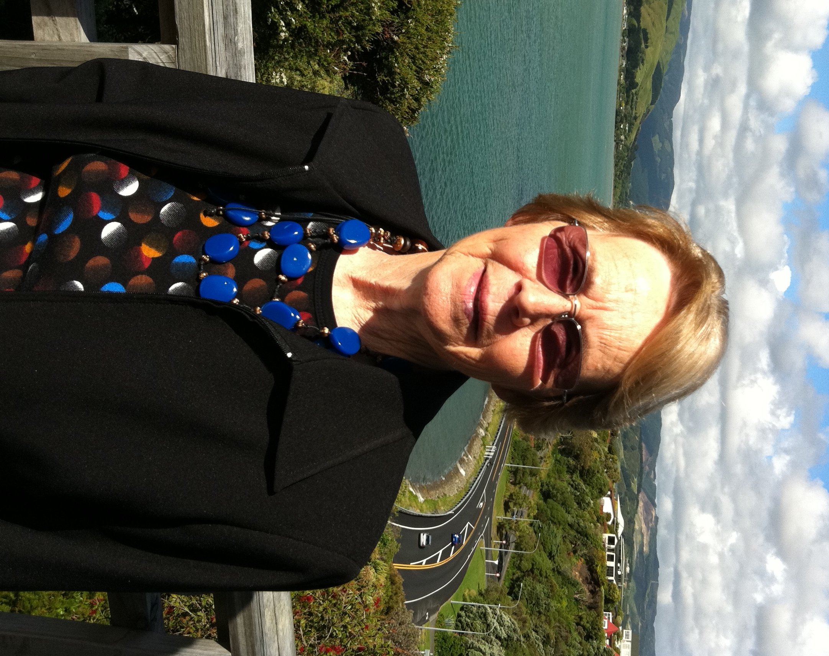Photo 2 | Photo 1: Margaret Faulkner, c.1955  Photo 2: Margaret Faulkner, 7 December 2012, Photographer Debbie Dunsford.

000'05" | INTRODUCTION & BACKGROUND
MARGARET ANNE FAULKNER born TEMUKA, SOUTH CANTERBURY, 20 September 1934. Father GILBERT GEORGE SOUTH, family lived WRIGHT'S BUSH, INVERCARGILL then GERALDINE. Mother's family from ORARI between ASHBURTON and TIMARU. Father's OCCUPATION/BUSINESS was water supply, windmills and as WATER DIVINER. Describes. Mentions his work with local FLOUR MILL. Father had strong COMMUNITY focus and led local BOROUGH COUNCIL of WINCHESTER.

Grew up in WINCHESTER and attended WINCHESTER SCHOOL. Two pupils in her year. Describes.

Spartan standard of living but never felt hard up until sent to TIMARU GIRLS' HIGH SCHOOL. Boarding school very restrictive. Friendships formed over time. Describes. SIBLINGS attended GERALDINE HIGH SCHOOL.

Mother HETTIE GLOVINA (nee HEWSON) SOUTH lived on farm at ORARI. Contracted TUBERCULOSIS at 14 years old. Lived in room at back of house until disease cleared about 18 years old. Eldest sister, named WANAKA, was a teacher and helped HETTIE with her EDUCATION. Describes. Her parents regarded EDUCATION as important.
012'10" | PARENTS, SIBLINGS & EDUCATION
Mother never had a paid job. Describes. Parents met at a local dance and married in ORARI. Describes.

Mentions SIBLINGS, PETER SOUTH (a FARMER), HELEN, JUDITH (both TEACHERS), ALISON (worked in bank) [OCCUPATIONS]. Refers CHRISTCHURCH EARTHQUAKE 22 February 2011.

Parental attitude to EDUCATION meant children expected to do well. Enjoyed SCHOOL and sporting activities. Describes contribution of older children to teaching of younger children. Describes Miss WORTHINGTON, infant mistress.
018'00" | TIMARU GIRLS' HIGH SCHOOL
About a third of girls boarders. Describes geographic and farming backgrounds. School had good ACADEMIC REPUTATION. Two other girls' BOARDING SCHOOLS in TIMARU were CRAIGHEAD (ANGLICAN) and a CATHOLIC school (MERCY COLLEGE).

Streaming of classes at school into academic or commercial. Describes early shaping of career. Four years secondary schooling. Refers SCHOOL CERTIFICATE. Left school 16 years old.
022'25" | WANTING TO BECOME A NURSE
Aware of and influenced by local nurses serving in WORLD WAR 2. Describes. Some discussion of career at school. Few genuine career options for women or in WINCHESTER. NURSES' HOME offered secure accommodation. Describes.

Parents did not want her to go nursing. Roll models in family were teachers, cooks, bank people but not nurses. Father objected on general hygiene grounds and found her a job when left school 'to put me off nursing forever'. Describes.

Friends' further EDUCATION and careers included UNIVERSITY, TRAINING COLLEGE, NURSING. Two friends trained at TIMARU HOSPITAL. Explains 'B' grade hospital limitations. Preferred to move to CHRISTCHURCH SCHOOL OF NURSING. CHRISTCHURCH TRAINING HOSPITAL reputed to be best in NZ. Explains.
029'25" | WAITING TO BEGIN NURSING
Father secured her a job as aide/cleaner at BIDWILL HOSPITAL, TIMARU. 'Meant to be my cure.' Disliked it and did not stay. Refers THEATRE CLEANING, TONSILLECTOMY. First time came in contact with nurses who trained around world, English, Irish and NZ. Everyone made a bed a different way. Describes.

Worked for a sole PHYSIOTHERAPIST. Contributed to her anatomical knowledge prior to beginning nursing. Treatments included hot packs, diathermy, routine exercises under supervision. Still wanted to be a nurse.
034'00" | APPLYING FOR NURSING & INTERVIEW
Applied to CHRISTCHURCH HOSPITAL. Waiting list. Describes. INTERVIEW DAY with Matron, MEDICAL EXAMINATION and written test. Describes. TIMARU HOSPITAL less attractive as B grade training hospital. Discusses. Describes Matron's 'very English' CHRISTCHURCH HOSPITAL uniform. Impressed by and scared of Matron. Refers MATRON CHAMBERLAIN taking over as matron. Describes management triad of CHIEF MEDICAL OFFICER, CHIEF NURSE (MATRON) and MANAGER. Refers to responsibilities of each.

Describes CLOTHES worn to INTERVIEW and first day of PRELIMINARY SCHOOL. Some wait before accepted. Describes how more applicants than places and one friend not accepted at CHRISTCHURCH. Refers to friend's broken training.

Mentions relationship to her REFEREES.
044'15" | FIRST DAY PRELIMINARY SCHOOL
Travelled to CHRISTCHURCH (PRELIMINARY SCHOOL) with friend of family. Quickly saw the looks on everyone's faces: 'What have we done? What have we signed up for?' Lived in THE MANSE, opposite CHRISTCHURCH HOSPITAL. Describes shared rooms and similarity to boarding school. Describes pink UNIFORM. Felt conspicuous and called 'pinkies'. Grey UNIFORM after PRELIMINARY SCHOOL.

Describes PRELIMINARY SCHOOL activities. Refers to TUTOR SISTERS, SISTER STURGESS and SISTER SLIGO. Describes 'horror' of early experience on NIGHT DUTY. Accompanied body to morgue. Refers NIGHT SISTER ANNIE CLARK (later died in WAHINE DISASTER). Gave guidance when uncle died.

Describes attrition rate from PRELIMINARY SCHOOL. HOSPITAL took their responsibility for nurses' safety very seriously. Nurses felt more restricted by curfews as training progressed. Half of intake from CHRISTCHURCH, others from TIMARU, ASHBURTON, BLENHEIM, NELSON, DUNEDIN. Two girls from WELLINGTON because their mothers had trained at CHRISTCHURCH. A few MAORI NURSES. Older students included a NORWEGIAN girl, a KARITANE NURSE. Refers to BETSY's shoes.
057'20" | FRIENDSHIPS AND ACTIVITIES
 | Refers to playing TENNIS, HOCKEY, SWIMMING. NORWEGIAN girl had difficulties with some terminology. Some did not like FOOD. Refers to restaurant in REGENT STREET, CHRISTCHURCH.
060'25" | UNIFORM
Explains RULES about wearing UNIFORM. Refers rolled down lyle stockings and VARICOSE VEINS. HIERARCHY. Pride in being a nurse at CHRISTCHURCH TRAINING SCHOOL. Describes. STAFF NURSES wore a blue UNIFORM. Refers to high standards of cleanliness to prevent INFECTION.

FILE ENDS 66 minutes 01 seconds.

Recorded: | 7 DEC 2012 | File: 2 of 6
Interviewer: | Debbie Dunsford
Abstracter: | Debbie Dunsford
Equipment type: | Fostex FR-2LE Digital Recorder

000'07" | PRELIMINARY CLASSES AND WARD DUTIES
PRELIMINARY SCHOOL teachers 'amazing'. SISTER STURGESS interested in health of individual nurse. Describes. Refers SMOKING. Nurses from large families at an advantage. Describes. First WARD DUTIES included bed baths, cleaning teeth. Students well tutored, well supervised and evaluated. Describes careful teaching of students in wards. Reflects on contemporary situation and basic nursing skills. Refers HEALTH & DISABILITY COMMISSIONER REPORTS. Long days and shifts. Difficulty of getting home to SOUTH CANTERBURY. Describes.

CHRISTCHURCH SCHOOL OF NURSING had strong CATHOLIC influence within nursing HIERARCHY. Describes. Bullying by some SENIOR and STAFF NURSES. Describes. Teaching on ward and in classroom. Describes. Refers 'absolute exhaustion'. Intensity of caring for surgical and accident patients straight from theatre and accident and emergency department. Describes. Discusses attrition rate.
014'25" | SHIFTS AND HYGIENE
SHIFT hours and heavy work. Describes duties and routines on each SHIFT. Refers STROKES. NURSES' BREAKFAST in DINING ROOM. CLEANING, HYGIENE. If a patient got an infection 'it was a major disaster, because that meant somebody wasn't doing their work properly'. UNIFORM and shoes only ever worn within hospital precincts. Reflects on contemporary nursing practice.

WARD ROSTER for 3 months. Refers roles of roving nurse, SPECIALING, LOCKJAW, TETANUS. Straw on floor to deaden sound and prevent spasm.

QUEEN (ELIZABETH II) visited NZ (1953). Her dressmaker tried to kill herself and was nursed at CHRISTCHURCH HOSPITAL for four days. Describes. PRIME MINISTER (KEITH) HOLYOAKE visited daily. PRINCE PHILIP visited.
027'43" | TEACHING BY INDIVIDUAL SISTERS
 | Individual sisters important in teaching nurses. Refers NEONATES UNIT. If a nurse showed promise, was given more responsibility and pushed. Describes responses of individual nurses and role models. Refers BURWOOD HOSPITAL PLASTIC SURGERY UNIT. Refers to being tired.
033'50" | HOSPITAL HIERARCHY AND PATIENT CARE
SENIOR NURSES and STAFF NURSES responsible for PATIENT CARE. Describes training in PATIENT CARE. Comments few patients died even though JUNIOR NURSES in charge of wards. Reflects on contemporary situation. Refers HEALTH AND DISABILITY COMMISSIONER.

Doctors were 'top of the heap, absolutely'. Describes HIERARCHY and regimentation. DOCTORS' ROUNDS poor learning for nurses. Refers to working in THEATRE and being shocked at how SURGEONS spoke about women. Did not like GYNAECOLOGY. Recounts story of woman with little understanding of her body.
040'00" | ORGANISATION OF CURRICULUM AND TEACHING
Nurses were the workforce and the hospital's needs came first. Training had to fit in. Describes how affected nurses on wards. Describes nurses' training records.

Formal classes one day a week. Difficulty of designing rosters. Refers SISTER STURGESS and SISTER SLIGO. Quality of teaching. Instruction on ward also. Ward experience of most use.

One day with DISTRICT NURSE during training. Recounts story of man who died and had several thousand pounds cash in cocoa tins in the house. Explains MATERNITY not part of general training then.
051'25" | EXAMS AND ATTRITION RATE
Describes HOSPITAL EXAMS and STATE EXAMS at the end. Mentions nurses leaving, MARRIAGE, SICKNESS.

Practical and formal EXAMS. Difficulties of STUDY and SITTING EXAMS. Well prepared but some failed and had to repeat. Describes. Exam results. CELEBRATIONS. Describes.

Class headed off in many directions. Refers MARRIAGE, MATERNITY TRAINING at WAIKATO, GOING OVERSEAS, PLUNKET. NZ trained nurses could get specialist jobs in the UK, e.g. PAEDIATRICS.
058'35" | BURWOOD HOSPITAL
Loved BURWOOD HOSPITAL. Mentions BURNS, THEATRE, PLASTIC SURGERY. Heartbreaking cases. Recounts later needing PLASTIC SURGERY herself for VENOUS HERMANGIOMA on face. Became a patient at BURWOOD (HOSPITAL), underwent 'first-time in NZ surgery'. Describes. Refers to DR SUI TAN at HUTT (HOSPITAL). Recounts incident of surgeon taking great care with a child's hands. Refers SALINE BATHS. Did not spend time at PRINCESS MARGARET HOSPITAL. Comments that some nurses disliked BURWOOD HOSPITAL because too far from town. Long term patients and nursing. Refers to CLEFT PALATES and tube feeding.

FILE ENDS 63 minutes 58 seconds.

Recorded: | 7 DEC 2012 | File: 3 of 6
Interviewer: | Debbie Dunsford
Abstracter: | Debbie Dunsford
Equipment type: | Fostex FR-2LE Digital Recorder

000'04" | PATIENT CONDITIONS & EMOTIONAL RESPONSES
Some WORLD WAR 2 VETERANS as patients. Received special treatment. Refers to later work with DEPARTMENT OF VETERAN AFFAIRS. TONSILECTOMIES, 'Bloodiest day of the week', GROMMETS. Describes.

Difficulty of balancing emergency to planned surgery. Refers APPENDECTOMY, GALLSTONES. Describes. Describes MEDICAL WARD. Refers PNEUMONIA and too much bed rest.

Outbreak of POLIO(MYELITIS). EYE cases. Describes using sandbags around CATARACT patients' heads to stop movement. No dramatic changes during three years of her training. CANCER surgery severe. Describes.

EMOTIONAL SUPPORT of other nurses a benefit of living in NURSES' HOME. Describes. HOME SISTER 'POPPY' supported nurses so well. Describes. Refers to NURSES' CHAPEL.
008'10" | DISEASE, CONDITIONS AND TREATMENTS
LUNG CANCER did not seem a major issue. CARDIAC TREATMENT was bedrest. Describes DRUG TREATMENT for TUBERCULOSIS. Refers routine medications and sedation (LARGACTIL for mental illness).

Innovative treatments not mass but individually produced. Describes. Adjustable beds uncommon. Nurses taught patient lifting. Describes.

Later improvements in KNEE SURGERY came from meeting need of injured (knee capped) servicemen in IRELAND.
014'58" | NURSES' HOME
Mostly single rooms. Moved around NURSES' HOME for different reasons and over time. Describes. Shared bathrooms.

Noise in background.

FILE ENDS 17 minutes 44 seconds.

Recorded: | 7 DEC 2012 | File: 4 of 6
Interviewer: | Debbie Dunsford
Abstracter: | Debbie Dunsford
Equipment type: | Fostex FR-2LE Digital Recorder

000'05" | NURSES' HOME, MEALS, LAUNDRY
Elegant dining room. Describes. Quality and quantity of MEALS. Describes. Enjoyed visiting homes of nurses who lived in CHRISTCHURCH and eating out.

UNIFORMS laundered by hospital. Washed own personal items. Describes.
007'45" | CURFEWS
 | CURFEW on ordinary working day, late and overnight passes. Close monitoring of nurses. Describes. Reprimanded if late or climbed in window. Learned to live within the barriers. Describes. Refers HOME SISTER 'POPPY'. Older nurses were from the generation of women whose potential husbands died in WORLD WAR 2. Became career women. Describes. Visitors had to stay in NURSES' HOME sitting rooms. Describes.
015'15" | STUDY & FRIENDSHIP WITH OTHER NURSES
Not difficult to STUDY in NURSES' HOME. Describes.

Groups of friends formed around interests. Refers to CHURCH, CHRISTIAN NURSES' ORGANISATION, SPORT, SWIMMING, PICNICS, BEACHGOING, DANCES, INVITATIONS TO MILITARY CAMP DANCES.

**Noises in background**

Life long FRIENDSHIPS from the class. NURSES' HOME experience essential to those friendships. Describes. Some may have felt slightly outside the group. Describes.
020'00" | HOMESICKNESS
 | Felt HOMESICK. Recounts going home to WINCHESTER for tea. Recounts grandfather being alarmed that boyfriend was CATHOLIC [SECTARIAN DIFFERENCES]. Very close family. Describes.
022'30" | SENIOR NURSES AND MALE NURSES
Always a distance between SENIOR NURSES and JUNIOR NURSES especially away from the ward [HIERARCHY]. Describes.

No MALE NURSES being trained. MALE NURSES in MEN'S RENAL WARD. Very competent. All trained in ENGLAND. Describes. Refers to working with GAY men. Discusses CAREER potential for MALE NURSES.
027'00" | LESBIAN RELATIONSHIPS
 | Two TRAINEE NURSES dismissed. Harsh treatment. Describes.
030'00" | SOCIAL LIFE & CHRISTMAS
SOCIAL LIFE limited by LOW PAY. Describes. Refers BALLANTYNES [SHOPPING]. Sewed own clothes and made hats. Describes. Refers MILLERS fabric shop.

Difficult to socialise within HOSPITAL. Concerts or activities held as fundraisers. CHRISTMAS DAY breakfast the 'best meal of the year'. Describes. Refers to CHURCH, singing in choir.

FILE ENDS 33 minutes 50 seconds.

Recorded: | 7 DEC 2012 | File: 5 of 6
Interviewer: | Debbie Dunsford
Abstracter: | Debbie Dunsford
Equipment type: | Fostex FR-2LE Digital Recorder

000'05" | SMOKING & ALCOHOL
Took up SMOKING. A lot of nurses, patients, doctors smoked. Unaware of health concerns. Describes.

Annual NURSES' BALL. Recounts challenge of smuggling in ALCOHOL. Refers PIMMS. Nurses weren't drinkers. Family tea total.
005'30" | BOYFRIENDS, RELATIONSHIPS, MARRIAGE
Nursed future husband as a PATIENT with TUBERCULOSIS of hip. Describes.

Nurse and doctor relationships disapproved of. Recounts story of MATRON trying to stop relationship. Refers BURWOOD (HOSPITAL).

Became engaged towards end of training and married (eloped) soon after. Describes. Difficult to get hospital work later with small children and as had not been STAFF NURSE. Describes attitude of hospital management to mothers working. Did some nursing work in private homes and through first NURSING BUREAU. Describes how worked and coped financially as single mother.

STAFF NURSE an important year for NURSING CAREER and for HOSPITAL WORKFORCE. Describes.
013'00" | SICKNESS
 | Hospital looked after sick nurses well. Describes. Refers OVARIAN CYST, PNEUMONIA. Expected to be stoic about minor illness. Wore masks. Describes.
014'55" | WOMEN'S WORK, PAY & CONDITIONS
 | Member of STUDENT NURSES group. Idealistic but not engaged on women's issues. Sense that NURSING better than other's women's jobs. Benefit of security of career and satisfaction. Describes. PAY not high but few expenses. Benefit of NURSES' HOME. Describes.
019'55" | GRADUATION
 | Did not attend GRADUATION ceremony because married. Staff tried to persuade against elopement and resignation. Refers SISTER STURGESS and SISTER CAMPBELL.
021'40" | NURSING WORK AFTER MARRIAGE & CHILDREN
Three children under three and separated from husband. Looked for work. Describes. Refers to children. MARTIN, CHRISTINE, ALISTAIR, SIMON, CHILD BENEFIT.

PRIVATE NURSING and PRIVATE HOSPITAL WORK through NURSING BUREAU to fit around childcare. Describes. CHRISTCHURCH PUBLIC HOSPITAL would not employ someone with three children [SOCIAL ATTITUDES]. Later refused TUBAL LIGATION [CATHOLIC INFLUENCE]. Refers VENOUS HERMANGIOMA. Describes.
026'45" | WORK AT REST HOME
 | Full time work came out of BUREAU NURSING. Managed 20-bed REST HOME while DUTCH owners on holiday. Became permanent. Describes. Refers TONY VAN DER BOOM, CASPER VAN DER VERE, CHILDCARE.
032'06" | ELDER CARE SECTOR, LOW PAY
Opened own REST HOME. Continued to work with previous employers for about 12 years until 1975. Refers ST NICHOLAS HOSPITAL, CHRISTCHURCH. Describes.

Interested in NURSING WORKFORCE and LOW PAY in RESIDENTIAL CARE sector. Recounts paying staff more highly than other CHRISTCHURCH REST HOMES. Established a PAY AWARD for rest home carers. Describes. Refers CANTERBURY-WEST COAST REST HOME CARERS AWARD. Describes underhand tactics and attitudes of other REST HOME owners. Industry changing from cottage industry of up to five elderly in private homes. Describes. MINISTRY OF HEALTH licensed REST HOMES. Describes facilities at ST NICHOLAS HOSPITAL.
039'25" | CERTIFICATE IN SOCIAL WORK
 | Attended (CANTERBURY) UNIVERSITY for CERTIFICATE IN SOCIAL WORK. Employed NURSING STUDENTS and encouraged NURSE AIDES to do NURSE TRAINING at ST NICHOLAS' HOSPITAL.
041'25" | MOVE TO WELLINGTON & DISTRICT NURSING
Fresh start 1974, MARRIAGE ended. Explains reasons for move to WELLINGTON. Refers HOME OWNERSHIP, PUBLIC HOSPITAL system. Recounts difficulties getting home loan as a SINGLE WOMAN.
Wanted to do SOCIAL WORK but offered work as DISTRICT NURSE. Refers CANNONS CREEK HEALTH CENTRE, PORIRUA, POLYNESIAN, MAORI. Describes.

File ends 48 minutes 09 seconds.

Recorded: | 7 DEC 2012 | File: 6 of 6
Interviewer: | Debbie Dunsford
Abstracter: | Debbie Dunsford
Equipment type: | Fostex FR-2LE Digital Recorder

000'04" | WAITANGIRUA HEALTH CENTRE, PORIRUA, IN 1970S
Reflects on difficulties of move to PORIRUA. Work very different. Issue with PAY because had not been in public hospital. Refers PAULINE McGUINNESS, head of COMMUNITY HEALTH & DISTRICT NURSING in WELLINGTON. Recounts leaving service to go on holiday to CHINA. Problem with leave.
Worked with COMMUNITY HEALTH NURSING SERVICE, WELLINGTON PUBLIC HOSPITAL, then seconded to WAITANGIRUA HEALTH CENTRE, PORIRUA, as PRACTICE NURSE (1976). Refers WHITEREIA (POLYTECHNIC).

Health centre set up to meet social needs. HOSPITAL BOARD built and owned building and paid staff. Refers PHYSIOTHERAPIST, SOCIAL WORKERS, DIETITICIAN, EDUCATION BOARD PSYCHOLOGIST, GPs (GENERAL PRACTITIONERS). Describes payment system. Close contact with other community nurses in area. Refers DISTRICT NURSES, PUBLIC HEALTH NURSES, COMMUNITY NURSES. Services to families. Refers ANTE-NATAL CARE, PACIFIC. WELLINGTON NURSING SCHOOL students, then WHITEREIA POLYTECHNIC students did WORK EXPERIENCE. Refers PACIFIC, MAORI. FUNDING MODEL changed and subsidy for PRACTICE NURSES reduced.
009'16" | WAITANGIRUA HEALTH CENTRE
Missed social side of hospital work. Some social events at WAITANGIRUA HEALTH CENTRE. Describes HOURS and staffing at WAITANGIRUA. Low staff turnover. Employed nurses with young children.

Stressful to work (somewhere like PORIRUA) because demanding. Risk of making people dependent. Comments on PILOT SCHEMES being driven by individuals but structure not strong enough to keep going without those individuals. Problems of scaling up. Discusses. Recalls a REGIONAL PUBLIC HEALTH NURSE who refused promotions because doing best work with families. WAITANGIRUA HEALTH CENTRE changed some families' lives. Recounts story of telling someone to make a list of questions before going to a specialist. Refers NAVIGATOR system, TARIANA TURIA, MAORI. NAVIGATOR system being used at CANNON'S CREEK for PACIFIC people.

Did COMMUNITY HEALTH NURSING CERTIFICATE through WELLINGTON POLY(TECHNIC). Describes usefulness.
017'06" | WHITEREIA COMMUNITY POLYTECHNIC
Interest in CHINA. Refers BAREFOOT DOCTORS. Resigned WAITANGIRUA HEALTH CENTRE to make trip. Describes.

Formation of WHITEREIA POLYTECHNIC in 1980s. Need for more NURSE TRAINING and also for TERTIARY INSTITUTION in PORIRUA. Nursing selected to be three year anchor course. Huge community interest. Asked to be NZ NURSES ASSOCIATION representative on the WHITEREIA POLYTECHNIC BOARD. Describes. Refers MAORI, PACIFIC and GENERAL NURSING COURSES.

Career choices. Describes. Refers NURSE EDUCATOR, DEPARTMENT OF SOCIAL WELFARE, HEALTH POLICY.
027'02" | NATIONAL REVIEW OFFICER, WAR PENSIONS
Describes difficulties of creating policy. Refers DEPARTMENT OF SOCIAL WELFARE. Public servant restructuring in late 1980s. Transferred to WAR PENSIONS section. Problem of delay in granting WAR PENSIONS. Became NATIONAL REVIEW OFFICER of WAR PENSIONS. New position. Describes.

Antipathy from RETURNED SERVICES ASSOCIATIONS to a WOMAN and to non-RETURNED SERVICES ASSOCIATION member. Being a NURSE was a benefit. Won over by getting out of the office and talking to people. Describes. Recounts story of visiting a veteran. Refers PROSTHESIS, PHYSIOTHERAPY. In 2000, WAR PENSIONS transferred to NZ DEFENCE FORCE. Describes difficulties.
037'00" | TERTIARY QUALIFICATION
Completed BACHELOR OF ARTS (SOCIAL SCIENCES) degree part-time through MASSEY UNIVERSITY in 1989. Describes climate of encouraging degrees.

Differences between POLYTECHNIC and HOSPITAL training. Mentions opposition in CHRISTCHURCH to CARPENTER REPORT. Challenges facing nursing today. Limitations to nursing training and care. Problem of too few nurses for next twenty years. Discusses. Refers CAPITAL COAST HEALTH, PARTNERS PORIRUA.

Need for one nursing voice. Refers NZ NURSING COUNCIL, NZ NURSES ORGANISATION. Problem of fragmented services being created. Need to define what it is to be a nurse. Describes. Problem of multiple nursing providers. Describes. Refers NCEA (NATIONAL CERTIFICATE OF EDUCATIONAL ACHIEVEMENT), MINISTRY OF EDUCATION.
047'04" | CHANGES IN NURSE TRAINING
CARPENTER REPORT in 1970s a classic example of 'baby and bathwater'. Need for some changes, variety of models. Discusses. Recounts recent experience of poor and excellent nursing. Issue of supervision, financial pressures on boards and staff.

Moved away from nursing whole person. Health issues being defined in terms of compliance or non-compliance.
054'55" | ELECTED MEMBER, CAPITAL & COAST HEALTH BOARD
Elected in 2000 to CAPITAL & COAST HEALTH BOARD. Previously COMMUNITY REP(RESENTATIVE) on local (CAPITAL COAST) CROWN HEALTH ENTERPRISE. Refers HEALTH FUNDING AUTHORITY. Concerned about lack of nursing voice in health management. NZ NURSES ORGANISATION reluctant to get involved. Too many controls on nursing practice. Describes. Deficits in care system. Refers to HEALTH & DISABILITY COMMISSIONER and CORONER. Describes. Need routine nurses as well as highly skilled specialist nurses. Describes. Refers MIDWIFERY.

Member of series of five different CAPITAL & COAST HEALTH BOARDS (1998-present). Describes difficulties faced by and different characteristics of boards, removal of board autonomy, merging with other boards by government direction. Refers CAPITAL COAST HEALTH, CAPITAL & COAST HEALTH BOARD, PRIMARY HEALTH, WELLINGTON HOSPITAL, JUDITH AICKEN, ELECTED MEMBER, GOVERNMENT APPOINTEE, JOHN ANDERSON, DR VIRGINIA HOPE, HUTT (HEALTH BOARD), WAIRARAPA (HEALTH BOARD). Describes complex needs of PORIRUA community.
071'38" | CURRENT PROBLEMS IN NZ HEALTH
HEAD INJURY numbers increasing and a new disabled group in NZ. Many health issues not being addressed. Refers AGE CONCERN. NURSING work need for many issues and groups. Discusses HOUSING SHORTAGE, HOME SUPPORT FOR ELDERLY.

Reflects on dynamics of and being a nurse on CAPITAL & COAST HEALTH BOARD. Refers DR VIRGINIA HOPE, PETER GLENSOR, BARBARA DONALDSON, DAVID CHOAT, HELEN RITCHIE, JUDITH AICKEN, WELLINGTON REGIONAL COUNCIL, KEITH HINDLE. Concern that board discussions about what will happen when three boards join up rather than what's happening to services. Possible loss of proven local services. Describes. Refers VICKY NOBLE. Concern at Government money for ELDER CARE INDUSTRY going out of NZ to English and Australian companies.
082'50" | COMMUNITY RECOGNITION
 | Received QSM (QUEENS SERVICE MEDAL) for HEALTH and EDUCATION. Received first ever JEAN HARRIS AWARD from ROTARY (INTERNATIONAL). Plaque from HEAD OFFICE, NZ RETURNED SERVICES ASSN special. Describes. Refers LIFE MEMBERSHIP, NAPIER RSA. Discusses. Refers 'TOBE' (DESMOND 'TOBY' TOBIN).
086'54" | FINAL REFLECTIONS
Improvements over time include MEDICAL TECHNOLOGY and in WOMEN'S LIVES. Refers HERCEPTIN. Generational shift in way medical people treat their patients and families. Refers CAPITAL AND COAST HEALTH. CHILD POVERTY, CHILD ABUSE still not being addressed.

Reasons for becoming and staying a nurse include image of WORLD WAR 2 nurse, provided INCOME for family, and gave wider value to her life. Describes. Family example of working in and for community. Refers GERALDINE.

Reflects on PERSONAL IDENTITY as a nurse. Still about making a difference in lives of others.

FILE AND INTERVIEW ENDS 94 minutes 45 seconds.

