Recorded: | 25 NOV 2013 | File: 1 of 5
Interviewer: | Margaret Horsburgh
Abstracter: | Margaret Horsburgh
Equipment type: | Fostex FR- 2LE Digital Recorder

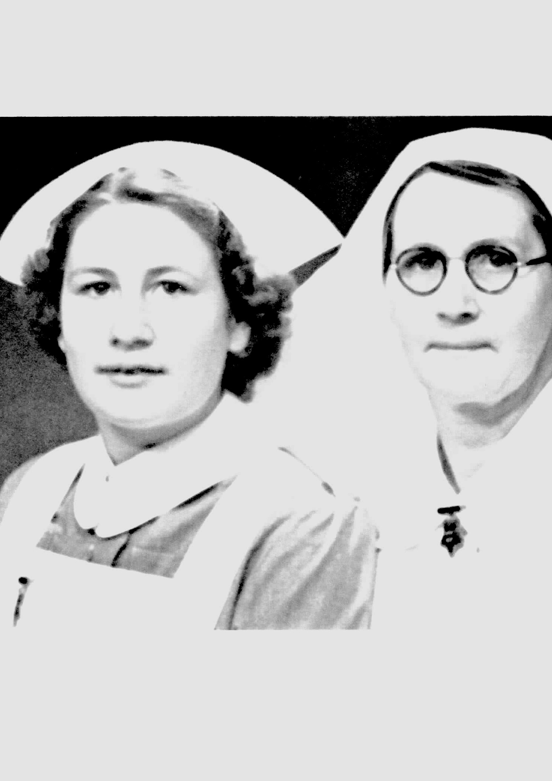Photo 1 | 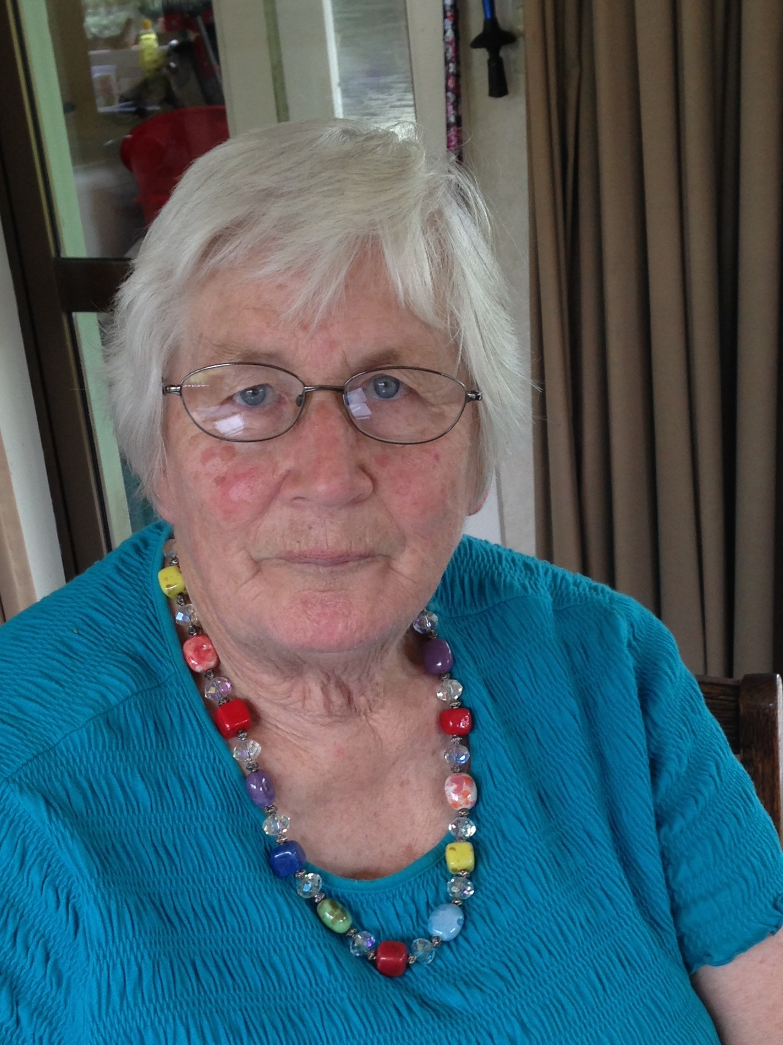Photo 2 | 1. Phyllis Bawden (Nelson) with her mother, Dorice Nelson 1950  2. Phyllis Bawden, 25 November 2013

000'04" | INTRODUCTION TO FILE 1
000'34" | GROWING UP
 | Born NELSON, grew up in MURCHISON on a dairy farm. Grew up in grandmother's home as father died when nine months old. Father had been rehabilitated as a returned serviceman from World War 1, 'to a farm on the banks of the BULLER RIVER'. Family farm, SIX MILE VALLEY, on MATAKITAKI RIVER. Describes.
002'42" | MURCHISON EARTHQUAKE
 | MURCHISON EARTHQUAKE, when eleven months old, hillside 'on other side of MATAKITAKI RIVER came down'. Mother and grandmother describe. Neighbour 'caught in mud ... her husband caught in sea of mud ... his leg severed by a sheet of iron ... bled to death' ... , MRS MORREL soaked and mother put her own dress on MRS MORREL 'and walked home in her petticoat'. Details.
006'07" | FAMILY
 | No siblings, two families of cousins living on farm, mother's brother managed the farm. Mother's younger brother worked in a shop in the village. Describes.
006'40" | SCHOOLING
 | Attended MURCHISON DISTRICT HIGH SCHOOL, two and a half mile bike ride from home. Primary and three years secondary in MURCHISON, and then two years NELSON GIRLS' COLLEGE. Describes.
007'34" | MOTHER A NURSE
Mother a nurse, helped her mother, farm hands to feed , two uncles and a young aunt all lived on farm. 'Busy household'. Describes.
Mother had trained as a GENERAL NURSE in NELSON, relieved as a nurse at local cottage hospital. Hospital Board had wanted her to train as a MIDWIFE, reluctant to go away. Describes.
'Frequently would come home from school ... mother had gone to look after someone ... usually for weekend ... sometimes lasted six weeks ... people who were sick at home ... couldn’t afford to go to hospital.'
Mother nursed a school friend, 'discovered she was losing feeling in her limbs ... sent her through to NELSON ... held up inter-island ferry ... wanted to take her to WELLINGTON ... put her in iron lung ... had POLIOMYELITIS ... she recovered'. Describes.
Describes mother nursing woman expecting seventh child, cared for whole family. Woman sent to NELSON, MEDICAL SUPERINTENDENT told 'mother off ... said she should have been there long before'. Describes.
013'18" | HELP THROUGHOUT COMMUNITY
 | Father had been an APIARIST, mother kept the bees when her husband died, did not have time to look after 'her bees ... another APIARIST took over... his way of helping ... sort of thing happened a lot'. Describes.
014'01" | NELSON GIRLS' COLLEGE
Two years boarding at NELSON GIRLS' COLLEGE, teaching at MURCHISON 'had not been good ... struggled at NELSON to catch up'. Describes.
Achieved a few subjects in SCHOOL CERTIFICATE. Describes.
Had not commenced schooling until age 6 years, meant older than class, three of girls left at end of first year in NELSON to train as nurses in CHRISTCHURCH, 'they wrote glowingly about life in CHRISTCHURCH PUBLIC HOSPITAL'. Describes.
015'43" | DECISION TO TRAIN AS A NURSE
Had always said would never be a nurse ,'sick of mother always going away ... decided would go nursing at NELSON HOSPITAL ... school friends convinced me to go to CHRISTCHURCH'. Describes.
Had grown up quite adamant would not be a nurse. Home on holiday from NELSON, had a job at the Cottage Hospital in MURCHISON, 'sister-in-charge, SISTER ALLEN encouraged me to go on and do my training'. Describes.
016'51" | NURSING
Applied to CHRISTCHURCH HOSPITAL, 'many country girls from around CHRISTCHURCH'. Friends from DARFIELD, HORORATA, GREENDALE, also INVERCARGILL and WELLINGTON.
Had caught bus from MURCHISON, day before class commenced, 'taxi into NURSES' HOME'. Describes.
019'30" | APPLICATION PROCESS
 | Required to have references, from school and MURCHISON Cottage Hospital. Medical examination, two cousins had TB [TUBERCULOSIS], 'spent summers with us ... worried wouldn't pass chest X-Ray'. Describes.
022'19" | PRELIMINARY SCHOOL
Twelve weeks in PRELIMINARY SCHOOL, ‘where you proved yourself'.
TUTOR SISTER, SISTER CHAMBERS, 'nick-named potty', learned nursing techniques, ANATOMY and PHYSIOLOGY, ' muscle man called Fritz ... skeleton ... big manikin called Belinda ... baby doll called Donald ... took turns at being patients'. Describes.
'Best advice I ever got ... SISTER ALLEN [MURCHISON] don't let on you know anything'. Describes.
025'23" | UNIFORMS
 | 'Pinkies' in PRELIMINARY SCHOOL, followed by grey. Smock with starched cuffs and collar, apron, long black stockings. Triangle on sleeve designated status after 'JUNIOR STATE’, second year ‘a stripe'. Sisters had blue uniforms. Describes.
027'16" | RULES
 | Many rules, 'as pinkies had to be home by 9.30 ... then 10 pm ... one late pass a week ... lot of fun breaking the rules ... most of us too tired to break the rules'. Describes.
028'28" | CLASS
 | Class mostly school leavers, 'MARIE, 21 ... had been working in office ... HILDA, 21 ... had been working in a shop'. No MAORI girls. Describes.
030'01" | JUNIOR NURSE WARD WORK
Ward work very busy, a lot of cleaning in sluice room, dusting, 'one ward ... WARD SISTER followed you when you started ... didn’t let you out of her sight ... always find some dust ... followed again just before left her ward ... “nurse I'm not having you leaving this ward not knowing anything”'. Describes.
Describes bed making.
032'57" | SHIFT WORK
 | Shift work, morning, afternoon and two lots of night duty, 'junior nights six weeks ... senior nights three months'. Describes.
033'36" | STAFFING PATTERNS
 | STAFF NURSE on morning and afternoon shifts, senior and junior nurse, 'junior pro... usually ... sometimes someone on divide as an extra'. Busy wards, 'big screens to cart around'. Describes. [Note, this interview was carried out on a farm, there is a rooster crowing vigorously in the background].
034'00" | NURSING CHILDREN
Twenty-bed ward for small boys, 'lovely ward sister ... could really enjoy'. Early days of PENICILLIN, 12-year-old patient, having four hourly injections,' father gave him sixpence every time he had an injection ... when he left the ward ... gave half the money ... to spend on the children who haven't got much', was DOCTOR GREENSLADE's son. Describes.
Small boy from SUNNYSIDE, mental hospital, having ear surgery, did not speak, 'eventually got him to say nurse ... older children who were mobile ... played with him ... he became a happy little boy ... saw nurses from SUNNYSIDE coming to get him ... he changed ... didn't want to go'. Describes.
'Got run off your feet ' in the bigger children's ward. Explains.
036'40" | EQUIPMENT
 | Technology was limited, no disposable equipment, 'did own autoclaving in theatre'. Metal instruments for wound dressings, boiled to sterilise, autoclaved some packs. Syringes and needles were boiled. Describes.
040'50" | ONGOING LEARNING
 | Lectures in off duty times, followed by one study day a week. SISTER ORBELL, HEAD TUTOR SISTER, SISTER TOLERTON, 'very nice person ... got message through ... felt wanted to do well for her'. DOCTORS gave lectures, DOCTOR BENNETT, senior surgical lecturer, 'called him puffy BENNETT ... because he had a good opinion of himself'. Describes.
043'17" | EXAMINATIONS
 | Examination at end of PRELIMINARY SCHOOL, at end of first year, JUNIOR STATE. DOCTOR F I BENNETT set one question, 'always insisted needed to use your initiative ... question ... “you are right out in the back blocks ... no equipment and someone needed an enema ... what would you do?”'. Describes.
045'29" | EXPERIENCES
MATERNITY and COMMUNITY NURSING not part of curriculum. All of training at CHRISTCHURCH HOSPITAL. Explains.
During third year, TYPHOID epidemic at KAIKOURA, several of nurses sent to KAIKOURA, some patients sent to CHRISTCHURCH, 'because we were close to sitting finals we were not allowed to go to KAIKOURA ... specialled one of the patients ... he was delirious'. Describes.
047'25" | LONG PATIENT STAYS
 | Patients stayed in hospital long periods, no physiotherapy, patient ready to go home, 'had collapsed in the toilet ... PULMONARY EMBOLISM ... people stayed in bed'. Describes.
048'56" | WARD SISTERS
Emotional aspects of nursing 'would depend on the attitudes of your WARD SISTERS ... important to your training'. Describes.
Two of surgical wards, had ex-ARMY SISTERS, 'thought hard as nails', took job very seriously. Describes.
051'20" | DOCTORS
Involvement with DOCTORS increased as became more senior. DOCTOR BEVAN, HOUSE SURGEON, later a DIABETES SPECIALIST, 'never went to bed at night before coming to ward to see if I was happy about the ward ... one night he was at the door waiting when I came on duty'. Describes.
Young DIABETIC patient, DR BEVAN 'knew I wasn't happy about that patient ... he stayed until four o'clock in the morning ... screened off bed in corridor so he could have a sleep ... nurse comes downstairs and pulls him out of bed'. Describes.
056'27" | RESPONSIBILITY
 | Had a lot of responsibility as a student, on night duty, SENIOR NIGHT SUPERVISOR and one other night sister. 'Called them the night snoops.' Describes.
057'21" | NURSES' HOME AND SMOKING
Two NURSES' HOMES, 'Night snoop went out and checked everyone was in right places'. Describes.
Single rooms, new NURSES' HOME had dining room, kept with own class, did not mix with seniors, each class had own lounge, developed close friendships. 'Our lounge quite pleasant ... very few in our class who were smokers.' Describes.
Friends from school would invite to join their group, 'had to cut your way through the smoke in their lounge'. Describes.
Smoking very common. Explains.
Had a lot of time sitting around in Nurses’ Home, 'became quite good at reading cups ... really good at reading faces'. Describes.
Alcohol not common. Explains.
061'29" | NURSES' MEALS
Meals were good, as class representative, 'spent a lot of time arguing about food ... eventually at dinner two vegetables and only one dessert ... better for us'. Describes.
Half hour meal breaks when on wards. Explains.
063'27" | EXAMINATION RESULTS
 | Examination results posted on notice boards, after STATE EXAMINATION, 'went to lunch with SISTER O'CONNELL ... she took off her medal and gave it to me'. Describes.
064'28" | NURSES' HOME LIFE
Made own breakfast if on afternoon duty, 'could go to kitchen and ask for a cut lunch', on days off, went for picnics, rode bikes. Describes.
Could not continue training if got married. Explains.
'Too tired to have much social life ... one girl did stuff her bed... plaster cast of her face'. Describes.
068'30" | KEEPING IN TOUCH WITH HOME
 | Able to go home once a year, home was 'too far', might go home with friends on days off. Explains.
069'22" | CHURCH YOUTH GROUP/DANCES AND BIKES
 | Belonged to CHURCH youth group, had dances in various suburbs, 'biked around to these dances ... rode our bikes everywhere'. Describes.
070'43" | RELATIONSHIPS
Able to keep up relationships, two of friends married doctors. Explains.
Describes experience of one couple as missionaries in INDIA.
Describes another friend who married doctor in UK after doing MIDWIFERY, worked in NEW GUINEA.
074'58" | PAY AND CONDITIONS
 | Felt 'better off' than friends who were training to be teachers or at university, work clothes provided, all lecture notes, 'well fed and housed ... NURSES' HOME was warm'. Could always go for picnics, bike up CASHMORE HILLS, went to LYTELLTON. Describes.
076'58" | BALLANTYNE’S FIRE
 | Students on duty day of BALLANTYNE’S fire kept busy, 'those of us biking home from NEW BRIGHTON could see all this smoke'. Describes.
077'24" | END OF FILE 1

Recorded: | 25 NOV 2013 | File: 2 of 5
Interviewer: | Margaret Horsburgh
Abstracter: | Margaret Horsburgh
Equipment type: | Fostex FR- 2LE Digital Recorder

000'05" | INTRODUCTION TO FILE 2
000'32" | GRADUATION
Names posted on notice board. 'Crowds around notice board ... quite a nerve wracking experience.' Friend did fail JUNIOR STATE. Describes.
WARD SISTER loaned medal to wear. Graduation ceremony at hospital with supper. Describes.
003'53" | MOUNT COOK HOLIDAY
 | Twelve students holidayed together at MT COOK after STATE FINALS, skiing, 'such a lot of fun ... sun reflecting on snow ... became smothered in freckles'. Describes.
006'38" | STAFF NURSE/OPERATING THEATRE
 | STAFF NURSE in surgical ward, had requested medical ward, 'short of nurses ... needed to keep theatre fully staffed ... on the little list' for people acceptable to work in theatre [OPERATING THEATRE]. 'Theatre just a closed box', asked to go to theatre for six months, left there for twelve months, not what wanted to do. Describes. Stayed living in NURSES' HOME, 'quite comfortable'. Describes.
011'27" | MATERNITY NURSING AT HASTINGS
Chose HASTINGS for MATERNITY NURSE TRAINING, friendly with family from HASTINGS, six from CHRISTCHURCH went together to undertake MATERNITY training. Six month training, HASTINGS MEMORIAL HOSPITAL, provided the staff for the maternity section. SISTER-IN-CHARGE, MISS STENBERG, 'called her Aunty Polly ... treated as one of family'. Describes.
Required to deliver babies, DOCTOR came in for deliveries. Women stayed in hospital for a week. MAORI girls, some from MORMON settlement, others from less privileged environment, 15 pound baby. Describes.
New NURSES' HOME had been built to withstand earthquakes, realised seriousness of earthquakes. Women had experienced the NAPIER earthquake. Describes.
020'17" | CAREER DIRECTIONS/PUBLIC HEALTH
 | While walking MILFORD TRACK, met lady doing PUBLIC HEALTH, 'sowed seed of PUBLIC HEALTH ... knew about double areas in NORTH ISLAND ... applied to HEALTH DEPARTMENT with friend'. Double area, two nurses lived together in a cottage ... 'asked for centre of NORTH ISLAND ... required to have PLUNKET NURSE training ... given a bursary to do PLUNKET training'. Describes.
023'46" | PLUNKET TRAINING
 | Four month PLUNKET NURSE training at KARITANE HOSPITAL, DUNEDIN. THAILAND nurse joined group, on a government scholarship, she suffered some discrimination. Lived in NURSES' HOME. Worked with PLUNKET NURSES. Describes.
026'24" | PUBLIC HEALTH NOTIFICATION
 | Notified by HEALTH DEPARTMENT that 'had got KOHUKOHU ... had map on the wall in bedroom ... had to stand on a chair to see where KOHUKOHU was ... never occurred to me to see how far NEW ZEALAND went after AUCKLAND'. Describes.
028'23" | PUBLIC HEALTH TRAINING
Three weeks orientation at HEALTH DEPARTMENT, WELLINGTON, course in PUBLIC HEALTH. Had been asked if THAI lady from PLUNKET training 'could travel with me ... went by bus to CHRISTCHURCH, through LEWIS PASS ... stopped at MURCHISON for weekend .... local doctor met at bus ... mother was relieving in local hospital ... she was exhausted', asked to do the night shift so that mother could have a sleep. Describes.
Stayed in hostel in WELLINGTON, 'did own cooking', THAI lady took out to CHINESE restaurant. Describes.
Course included MAORI protocol, immunisation, child health, TB [TUBERCULOSIS], reporting requirements. Describes.
033'25" | NORTHLAND
Reflects, 'we were young and on an adventure'. Collected from WHANGAREI, driven to KOHUKOHU by NURSE INSPECTOR, 'from MANGAMUKA to KOHUKOHU seemed an eternity ... windy metal road'. Describes.
NURSE INSPECTOR, a senior based in WHANGAREI, northern and southern group of nurses, each had a NURSE INSPECTOR, later monthly staff meetings and annual conference in WHANGAREI. Describes.
036'20" | DISTRICT NURSE/PUBLIC HEALTH NURSE
 | Called DISTRICT NURSE, became PUBLIC HEALTH NURSES, now COMMUNITY HEALTH NURSES, HOKIANGA HEALTH SERVICES. Explains.
036'41" | COMMUNITY AREAS SERVED
 | Lived in nurses' cottage in KOHUKOHU, replacing two nurses, each with on area. ‘NURSE INSPECTOR said “which one of you is used to country roads?” ... I got the area out to MITIMITI'. Helen had two schools across the harbour to go to by launch. 'No road to RANGI POINT ... every three months would hire launch … doctor, two nurses ... usually the housekeeper went to RANGI POINT for day'. Held DOCTOR's clinic, checked school children, LICE, SCABIES, treated, 'had stocks of malt and cod liver oil ... for needy families’. Describes.
039'19" | CHILD HEALTH/PRACTICE NURSE CLINICS
Worked in schools looking after CHILD HEALTH, as PRACTICE NURSE in the DOCTOR'S clinics, SPECIAL MEDICAL AREA. Clinics KOHUKOHU, MOTUKARAKA, PANGURU, MITIMITI or MOTUTI, small buildings with waiting area, 'left paper on wall ... wrote own appointments down'. Describes.
Communication poor, telephone exchange at KOHUKOHU, closed at midnight, outer districts mostly only one telephone, closed at 6 pm, often child came on horse with note. Went out if necessary, 'guided by people who had the phones’. Describes.
Nurse's car a '1936 CHEV...ex-army ...very good at breaking down'. Describes.
042'43" | UNIFORMS AND NURSES' COTTAGE
Uniforms a pink dress in summer, brown costume in winter, washed own uniforms. Describes.
Live-in house keeper, 'she was our chaperone', gardener, 'MR COBBALD ... youngest daughter PHYLLIS COBBALD, friend of YVONNE SHADBOLT ... became a nurse ... topped the DOMINION in STATE FINALS. Describes.
045'03" | SOME CULTURAL DIFFERENCES
 | Busy job, coming from SOUTH ISLAND 'had met very few MAORIS ', now largely looking after MAORI , 'quite demanding in terms of what wanted done ... very cooperative'. Describes.
048'01" | CHILD IMMUNISATIONS
 | Five-year-old children had five injections, 'they had worked out best thing was to get parents to say no ... got a bag of lollies ... only ones who cried were those whose parents had said no'. Describes
049'51" | VARIED WORK
Work varied, weekly DOCTOR's CLINICS, in between over to the nurses, carried certain amount of medicines, could ring the DOCTOR or MATRON at the local hospital [RAWENE], people generally known to hospital, 'any problems would admit person overnight ... would bring back on launch ... if necessary could organise someone to bring them in ... ambulance or taxi ... quite stressful but felt well supported'. Describes.
Maternity patients could stay in RAWENE and wait for delivery, 'men in PANGURU who delivered babies'. Describes.
One baby born on couch at home, 'that night the doctor had been over to give lectures ... pulled him out of bed'. Describes.
053'23" | WORKLOADS
 | Two-year contract, worked for one year before a holiday, HELEN [SIMTH] had first holiday, 'while she was away group came from OTAGO UNIVERSITY ... doing skin tests ... when HELEN came back ... was exhausted'. When came back from holiday, MEASLES epidemic, contracted MEASLES, sent to WHANGAREI HOSPITAL, 'diagnosis... a very tired girl'. Describes.
056'42" | BECOMING ENGAGED
 | 'KOHUKOHU was a lively place ... involved with it all.' Met future husband, STAN, and remained in KOHUKOHU. Explains.
057'42" | END OF TWO-YEAR CONTRACT
 | At end of two-year contract, Helen transferred to RAETIHI. Phyllis worked for one month at HEALTH CAMP in WHANGAREI, relieved MATRON. Explains.
058'52" | CHEST CLINIC
Clinic with CHEST PHYSICIAN, ADRIAN WEBB, once a month in KOHUKOHU. Taxi vouchers for people to come in, or nurses brought them. Follow-up of people with [TUBERCULOSIS]. Describes.
During late 1950s/1960s urban drift from area. Explains.
062'57" | NURSES DID ALL THE CALL
 | DOCTORS didn't stay long in area, nurses did 'all the call'. Professional development mainly at staff meetings. Describes.
064'24" | END OF FILE 2

Recorded: | 25 NOV 2013 | File: 3 of 5
Interviewer: | Margaret Horsburgh
Abstracter: | Margaret Horsburgh
Equipment type: | Fostex FR- 2LE Digital Recorder

000'03" | INTRODUCTION TO FILE 3
000'56" | MARRIAGE
 | Married 1955. Could not be employed by HEALTH DEPARTMENT as a married woman. Explains.
001'02" | RANGI POINT
RANGI POINT, small MAORI settlement, no road access in the 1950s, every three months DOCTOR, both NURSES, housekeeper went by launch for the day, launch driver, HARRY SLADE. No jetty at RANGI POINT, 'one time had a relieving DOCTOR ... over age 70 years... great uncle ... met by one of boys from school in dinghy ... boy too shy to tell them over balanced ... dinghy tipped over ... wet through ... had to wade ashore'. Details.
HARRY SLADE tells the story of the legend of how the harbour [HOKIANGA] was formed, 'spring of two TANIWHA'. Details.
008'01" | FAMILY
Married a local farmer, worked on farm after marriage, first son born at KAITAIA. DOCTOR in RAWENE at time 'called the MATRON out when his cat had kittens ... didn't have a lot of confidence in him'. Describes.
Three children, when youngest aged 5 approached to go back to work. Explains
010'12" | RETURNING TO WORK
 | Approached by nurse who was leaving, RUTH PUNTON, no one to replace her, part-time role. 'Didn’t find another nurse for two years'. Two designated nurse areas had amalgamated. Describes.

Recorded: | 25 NOV 2013 | File: 4 of 5
Interviewer: | Margaret Horsburgh
Abstracter: | Margaret Horsburgh
Equipment type: | Fostex FR- 2LE Digital Recorder

000'04" | INTERVIEW RESUMING AFTER TELEPHONE CALL
000'14" | CHANGED WORK CONDITIONS
Two designated nurse areas had amalgamated [1970], RANGI POINT had an access road, nurses' cottage now a clinic. Employed by DEPARTMENT OF HEALTH, WHANGAREI, seconded to RAWENE HOSPITAL, worked as PRACTICE NURSE at clinics, 'did the emergency call ... went out with ambulance from KOHUKOHU ... nurse at BROADWOOD and at MANGAMUKA'. Describes.
'Officially part-time ... mostly fairly full time ... first one home milked the cows ... STAN was driving the cream truck ... help make ends meet'. Describes.
003'39" | HOKIANGA SPECIAL MEDICAL AREA
Called PUBLIC HEALTH NURSE, had staff meetings with HEALTH DEPARTMENT once a month, met at different cottages around NORTH, also meetings at HOKIANGA HEALTH, RAWENE, Describes.
HOKIANGA, a SPECIAL MEDICAL AREA, 'health care free at point of need, nurses did the call ... supported by DOCTOR at hospital ... sometimes difficult if a locum or new GP [GENERAL PRACTITIONER] ... called out to elderly lady ... felt strongly needed to be admitted to be hospital ... new DOCTOR didn't want to call out ferry and two ambulances ... in the end she went to RAWENE', later thanked for being so persistent, lady had a PERFORATED ULCER. Details.
DOCTORS based at RAWENE HOSPITAL, not happy to be based in community, nurses 'did all the call ... works better for them to be together as a team.' Describes.
010'09" | SOME RECENT SERVICE CHANGES
 | Nurses remain based in community, 'no longer do after-hours call', ambulances are called or hospital for advice. North HOKIANGA ferry is called out, 'very loyal ambulance service'. Describes.
010'24" | REFLECTION ON CHANGES TO SERVICE
 | Routine PUBLIC HEALTH nursing work, 'plus cradle to the grave service that system provides ... now trouble getting sufficient funding for early child care ... enables introduction to the family', establishes relationship with whole family. DENTAL NURSE service cut back 'they did excellent health education ... had trust of children and parents’. Reflects.
013'17" | VARIED NURSING EXPERIENCES
 | Dealt with many emergencies. Young girl in PANGURU with RHEUMATIC FEVER who died, 'later called out to her young brother ... caught leg with post-hole borer... went to KAITAIA in ambulance with him ... he did survive but his leg didn't’. Later met up with person who had also attended the accident. Details.
023'12" | WORKING WITH MAORI FAMILIES
 | Became very involved with families, many MAORI families. Husband had 'learned to speak MAORI in local playground' as a child. Many MAORI families had not encouraged speaking MAORI in the home. MAORI families always supportive, willing to teach, experience with family visiting TOHUNGA, 'one weekend ... child died ... aunt requested nurse to come and lay her out ... time came when they wanted our service'. 'MAORI know how to deal with death ... a lot to learn from way they grieve.' Details.
026'14" | COMMUNITY INVOLVEMENT/HOKIANGA HEALTH
 | Public protest meeting in RAWENE to consider how to keep HOKIANGA HEALTH services in place, given pharmacy budget to manage, TRUST formed, two trustees from each clinic area, 'MAORI couple from here pushed me forward to be part of it', after retirement, remains a trustee, TRUST now manages the whole service. Details. Service based on DOCTOR G M SMITH's philosophy, when he started up SPECIAL MEDICAL AREA, 'used nurses ... DOCTORS the back-up and to give advice'. Reflects. Funding via the DISTRICT HEALTH BOARD, funding difficulties. Explains.
031'50" | BROAD NURSING ROLE
 | Future discussions about NURSE PRACTITIONERS, 'but we had the ability to give certain antibiotics and other drugs ... carried drugs with us ... could ring and get the OK ... next clinic give the prescriptions to the DOCTOR to sign'. Current SPECIALIST NURSES very skilled and knowledgeable, DIABETES NURSE 'also specialises in women's health', based at the hospital. Reflects.
034'06" | FAMILY AND COMMUNITY
Long nursing career has fitted in with family life, one son a GP [GENERAL PRACTITIONER], daughter now a nurse, 'ANNE used to come out to PANGURU once a week ... with DAVID [son] ... developed real affection for MAORI family ... broadened their horizons', patients came to the house. Describes.
Patients might phone in middle of night and ask if they could come in to see you, 'STAN always quick to make a cup of tea ... feel the tension go ... sometimes child had settled with the car trip in ... child with ... HARE LIP and CLEFT PALATE'. Describes.
038'02" | RETIREMENT
 | Retired at age 60, 'I was tired ... happy to be involved with HOKIANGA HEALTH TRUST', continued strong community involvement, fundraising for CHURCH centennial. Describes. Op Shop to raise funds for centennial, has continued to be strong part of community. Episode of MENINGITIS, local man took over PHYLLIS's role at Op Shop, he wanted to keep shop open at weekends, ten years. Able to give support back to HEALTH TRUST, schools and individuals in need. Details.
041'16" | REFLECTIONS ON NURSING CAREER
'Glad hasn’t had to battle with computers ... now so much recording.' Describes.
Reflects on achievement of success in 'growing own staff' in HEALTH TRUST.
HEALTH EDUCATION now has more resources. Reflects.
Reflects on value of project established by wife of PRINCIPAL of PANGURU AREA SCHOOL, involved with home economics and local play centre, senior girls attended 'mother helper course at play centre', led to girls having increased ambition. Helped girls with their own babies, enhanced children’s developmental milestones. Describes.
049'36" | END OF FILE 4

Recorded: | 25 NOV 2013 | File: 5 of 5
Interviewer: | Margaret Horsburgh
Abstracter: | Margaret Horsburgh
Equipment type: | Fostex FR- 2LE Digital Recorder

000'05" | ONE MORE STORY/SUPPORT FOR A FAMILY
Family lived at WAIHOU, mother had layette for her first baby, knew her when first worked in area, associated with family again when returned to nursing. Eldest daughter had become pregnant in AUCKLAND, her baby did not thrive, 'became friendly with local boy ... came to clinic wanting an abortion ... told her she must tell her boyfriend ... boyfriend's mother took under her wing and supported babies'.
Second and third daughters also became pregnant as unmarried mothers. Describes.

INTERVIEW ENDS

