Recorded: | 19 MAR 2013 | File: 1 of 3
Interviewer: | Margaret Horsburgh
Abstracter: | Margaret Horsburgh
Equipment type: | Fostex FR- 2LE Digital Recorder

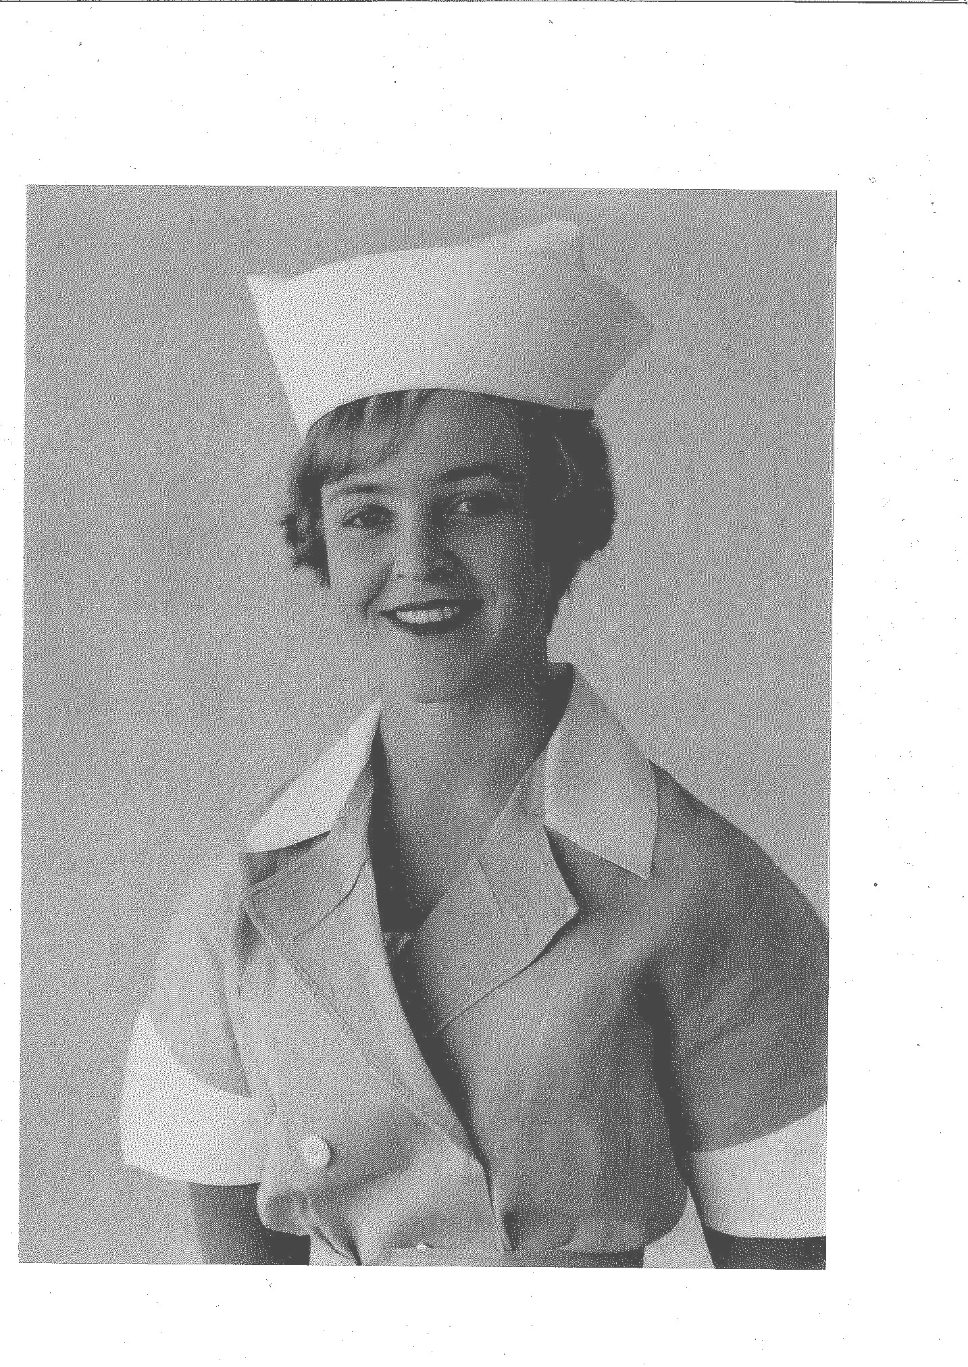Photo 1 | 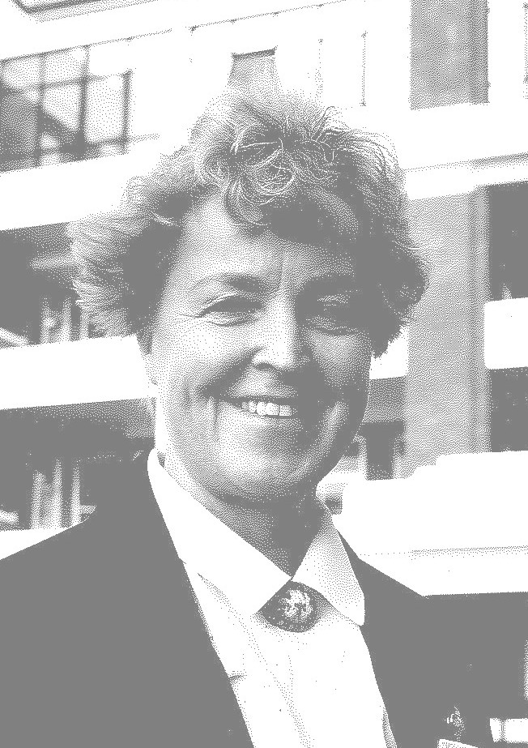Photo 2 | 1. Mary Lott 1960 Studio photo. Private Collection  2. Mary Wentworth 1994 Private Collection.

000'09" | FILE 1 INTRODUCTION
000'48" | GROWING UP
Born and lived as a child ONE TREE HILL [AUCKLAND] 1942. Sister, three years older, brother five years younger. Explains.
Father ACCOUNTANT for shipping agency, HENDERSON MCFARLANE, ' as children often invited on to overseas ships such as MATSON ships ... later ITALIAN and NORWEGIAN ships’. Middle-class family, helped father with vegetable garden, mother looked after flowers; small dwelling behind house where father's parents lived. Describes.
003'14" | MOTHER'S OCCUPATION
 | Mother left school 'to earn money'. Mary's grandfather had been in NAVY, had a stroke and was unable to work. Grandmother worked as shorthand typist. Describes.
004'03" | INFLUENCE ON CAREER DECISION
 | At aged 'about 12' grandmother who lived 'out the back ... developed CANCER ... mother learned how to nurse her ... helped mother with her ... became interested in NURSING ... always loved BIOLOGY'. Describes.
005'07" | SIBLINGS
Sister ' quite academic ... completed degree majoring in FRENCH and ENGLISH ... taught FRENCH for a number of years'. Describes.
Travelled overseas with sister at completion of Nurse Training; 'cruised to CEYLON [SRI LANKA] ... MADRAS ... NGAPOR ... DELHI'. Describes.
Brother commenced studying ARCHITECTURE; father died suddenly in 1967, brother dropped out of UNIVERSITY, worked with marine company. Describes.
008'28" | SCHOOLING
 | Attended ST CUTHBERT'S COLLEGE [AUCKLAND] for all of schooling. Sister's god-mother 'paid for my sister to go to ST CUTHBERT'S COLLEGE ... parents said that second daughter has to be treated the same.' Academically able student ' first or second in class all the way through ... little extras there ... when got to intermediate skipped one of forms ... Standard 5 straight to Form 3 ... not the best thing socially ... year younger than rest of girls in class'. Describes.
010'46" | LEAVING SCHOOL
 | Left school with HIGHER SCHOOL CERTIFICATE ' did one year post UNIVERSITY ENTRANCE not yet 17 years old.' School subjects included MATHEMATICS and SCIENCE subjects '... BIOLOGY, ENGLISH, FRENCH'. Describes.
011'55" | DETERMINED TO GO NURSING
AUCKLAND SCHOOL OF NURSING indicated that Mary would not be able to start nursing until middle of year, as did not turn 17 until December, offered NURSE AIDING as an interim. Describes.
Grandmother [Maternal] lived near MATER HOSPITAL, ' she played bridge with lady who knew the NUNS … they have a wonderful training school.' Grandmother made an appointment for an interview. Interviewed by SISTER MARY ALPHONSUS. 'Next thing I knew I was starting in six weeks time ... at beginning of December ... left school early'. Details.
Had not considered other types of nursing, 'wanted to do surgical nursing ... family had friend who was an ORTHOPAEDIC SURGEON ... didn't want to do anything like MENTAL HEALTH NURSING'. Describes.
015'07" | OTHER OCCUPATIONS
 | Several school colleagues were going to UNIVERSITY or into teaching, girls going into office work left school before senior years. One girl from year went nursing. Describes.
016'04" | FAMILY SUPPORT
Father indicated support for Mary to do MEDICINE; mother had wished to train as a nurse.
Did not think seriously about MEDICINE, 'had been persuaded by teachers to drop maths ... felt would not be able to do the PHYSICS associated with Medicine ... wanted to care for people ... be in close association with people'. Describes.
017'27" | ACCEPTANCE INTO NURSING
Mother accompanied to interview, waited outside. Wore school uniform. Medical examination after had commenced training, Dr BASIL QUIN, senior PHYSICIAN 'made us run up and down some stairs ... NUN with you', indicated that 'chest expansion not as good as should be', questioned whether would be fit enough. Describes.
School references provided. Explains.
019'33" | DECEMBER START
 | Commenced training in December, left school early to allow for two weeks holiday. Describes.
020'13" | NURSING CLASS
 | Twenty-two girls in class, about four non-CATHOLIC, wide age range, Mary four days short of her seventeenth birthday, several of class had come from other occupations, from variety of geographic areas including FIJI, one MAORI girl who didn't complete training. Describes.
022'58" | COMMENCING TRAINING
 | Not enough rooms for all the students, lived at home for four to six weeks, students without rooms had room for changing into uniforms, met ERIN LANIGAN [now BREMFORD]. ‘I thought she was so superior to me ... she had been working for a year ... had saved some money ... caught bus home with MAUREEN O'SULLIVAN.' Describes.
024'48" | UNIFORMS
 | Green uniforms with white collars, wore 'back-to-front' overall over uniform for ward work, uniforms starched, white shoes and stockings, green capes. Describes.
026'09" | INITIAL TRAINING WEEKS
 | First few weeks in tutorial school, visits to the wards on Saturday. Nursing School in GONZAGA HALL, 'dem room [demonstration room] ... bed ... model in bed ... learned bed baths ... how to move patients in bed'. Describes.
027'02" | TWO CLASSES EACH YEAR
 | MATER HOSPITAL had two student nurse intakes, June and December, each year. Explains.
027'16" | INITIAL WARD WORK
As a junior nurse 'buddied' with more senior nurse, 'ran around with them all day’.
No cleaning staff employed in the weekends, junior nurse role to do all the 'wet dusting'. Describes.
028'17" | TIME WITH PATIENTS
 | Value of cleaning work, 'patients often talked to you ... sometimes learned things they hadn't told the senior nurses'. Describes.
028'41" | MATER HOSPITAL
Nurses in training only worked in public wards, ten bed wards. Culture in hospital required all PATIENTS to be addressed by correct name, 'number one rule'. MEDICAL, SURGICAL wards for male and female patients and CHILDREN’s ward. Describes.
WARD SISTER always a NUN, third year student the senior nurse, no REGISTERED NURSES other than nuns in the public areas. Always a nun as NURSE SUPERVISOR at night, 'WARD SISTERS came back to settle patients for the night ... go around every patient ... at about 8pm'. Nuns' CONVENT connected to Hospital. 'Very caring, nurturing way to be trained ... 24 hour care of our patients'. Details.
032'13" | SHIFT WORK
 | Shifts 6am to 2pm, 2pm to 10pm and 10pm to 6am duties. Describes. Third year student the 'senior in the ward'. Explains.
033'05" | TYPICAL DUTY
 | Reported 10 minutes before duty to receive 'full report', HIERARCHY of jobs. Patient washes before breakfast, water jugs and 'help give out breakfast ... big pot of porridge'. Staff went off for own breakfast 'from 7.30 am on ... half an hour for breakfast ... run to NURSES' HOME ... make sure room was tidy'. Describes.
035'25" | NON-NURSING DUTIES
 | Toilets, bathrooms cleaned, wet dusting in weekends. Some household staff during the week. Put linen away. Describes.
036'14" | MEDICAL STAFF
Dr BASIL QUIN, Dr HANNA did medical rounds. MEDICAL REGISTRARS and HOUSE OFFICERS assisted for SURGERY with public patients. HOUSE SURGEONS on call overnight. Describes.
'As a student didn't ask questions of SURGEONS and PHYSICIANS ... sometimes allowed to join ward rounds'. Describes.
038'52" | TRAINING SCHEDULE
SISTER MARGARET TIMMS (previously SISTER MARY JAMES), NUN in charge of NURSING SCHOOL, looked after 'SURGICAL/ MEDICAL things', SISTER MARY ALEXIS 'did OBSTETRICS’. Describes.
Lectures from MEDICAL staff, PAT DUNN, LIAM WRIGHT for OBSTETRICS and GYNAECOLOGY, KEVIN McNAMARA for SURGERY, ROSS NICHOLSON for ORTHOPAEDICS. Explains.
Lectures were on regular schedules, 'if on afternoon duty would have to get up to go to the 9am lecture ... if on night duty you stayed up'. Study days one day a week for part of year.
Practical training on wards after 'PRELIM'. WARD SISTER supervised practical work. Describes.
Specialised training in STERILE SUPPLY, 'so knew how to work the autoclaves in emergencies'. Explains.
042'10" | SPECIAL EXPERIENCES
OBSTETRIC experience at the MATER. One month spent at GREEN LANE HOSPITAL for INFECTIOUS DISEASE nursing, in TB [TUBERCULOSIS] wards, lived in NURSES' HOME at GREEN LANE HOSPITAL for one month. Describes.
Short periods of observation in ED [EMERGENCY DEPARTMENT]. Explains.
042'45" | COMMUNITY NURSING
 | DISTRICT NURSING SERVICE experience with the NUNS. 'NUNs coming back and having to get out of their habits ... fleas up their habits ... in the seams'. Describes.
043'32" | ACCEPTANCE AND VALUE OF TRAINING
 | Had opportunities to question, 'needed to store them up ... Taught tremendous respect for patients ... for their individuality'. Describes.
045'37" | EXAMINATIONS
Sat JUNIOR STATE and STATE FINALS and HOSPITAL examinations. 'Several girls dropped back six months'. Describes.
Study was in off-duty times, well prepared for examinations. Describes.
Two in class got 'honours' in STATE FINALS, 'Erin and myself’. Explains.
046'48" | EXAMINATION RESULTS
 | Examination results came in the mail. List on board in NURSES' HOME. Explains.
047'50" | SURGICAL PATIENTS
Surgical PATIENTS were not sent home very quickly, 'people didn't get out of bed the next day ... lot of bed nursing to do ... in hospital for about two weeks for an ordinary surgical procedure ... GASTRECTOMY, CHOLECYSTECTOMY'. Describes.
Nursing included patient hygiene, monitoring diet, 'fully aware of how much someone had eaten'. One DIETITIAN for referral. Describes.
Comfort of patients important, 'pressure area care ... positioned comfortably'. Describes.
PROSTATECTOMIES required daily irrigations. Describes.
051'12" | WASHING THE DISHES
 | Junior nurse gave out patient suppers, washed the dishes, no dishwashers. Called back by night staff to clean saucepan that milk had been boiled in. Describes.
051'46" | EMOTIONAL ASPECTS OF CARE
 | Lived in NURSES' HOME, 'senior nurses there too ... lot of peer support ... senior peers ... like big extended family'. Describes. NUNS lived in CONVENT, one nun always stayed in NURSES' HOME. Describes.
053'57" | NURSES' HOME
NURSES' HOME next to hospital, single rooms with two to three double rooms, sash windows with bars on downstairs windows. Shared bathrooms, laundry and kitchenette. 'No men were allowed past the lounge.' No reception area. 'Whoever was there answered the telephone'. Describes.
Meals in main dining room in hospital, NUNS' dining room separate. ‘Never ate with the NUNs.' Describes.
Able to make snacks in kitchenette, eggs, cheese, bread provided. Explains.
057'28" | RULES
 | Two late passes in a week, NURSES' HOME completely locked when 'afternoon staff came off at 10pm ... if had extra late leave ... had to come through the hospital ... ring the front door bell of hospital ... NIGHT SUPERVISOR NUN would sign you in ... escorted to NURSES' HOME'. Describes.
058'33" | NIGHT SECURITY
 | GERIATRIC WARDS, MARY AGNES WARDS ‘were down the hill ... NIGHT SUPERVISOR never went alone ... nurses would wait for knock and open the door'. Describes.
059'07" | CHECKING NURSES' HOME ROOMS
 | NUNS had a roster for staying in NURSES' HOME. 'Lay person also had a key ... checked rooms'. Describes.

Recorded: | 19 MAR 2013 | File: 2 of 3
Interviewer: | Margaret Horsburgh
Abstracter: | Margaret Horsburgh
Equipment type: | Fostex FR- 2LE Digital Recorder

000'04" | FILE 2 INTRODUCTION
000'37" | MEMORABLE PATIENTS
Surgery for rectal cancer, ABDOMINO-PERINEAL RESECTION, immense loss of tissue, woman aged 40 years stayed in hospital six to eight weeks, huge wound cavity washed out each day. Describes.
CATARACT patients lay flat on their backs with sandbags on either side of head. Describes.
PULMONARY EMBOLI did occur. Pain in leg indicating DEEP VEIN THROMBOSIS, 'needed to get them medical help'. Describes.
Routine exercises to 'get patients exercising ... just knew what to do ... back rubs ... some liked a warm drink in the middle of the night'. Describes.
004'45" | MEDICAL WARDS
 | MEDICAL wards did not have acute or emergency patients, no INTENSIVE CARE ward for medical patients. Small INTENSIVE CARE UNIT for surgical patients, developed when CARDIAC SURGERY introduced. Describes.
005'29" | SOCIAL LIFE
Not a lot of time for social life, went to movies, dances at the ORANGE HALL, MATER ball. Describes.
'One of friends had a brother at ARDMORE ... often had blind date with one of ENGINEERING students’. Describes.
006'31" | DAYS OFF
 | Went home on days off, 'nice to get out of hospital'. Explains.
007'10" | KEEPING UP WITH FRIENDS OUTSIDE NURSING
 | Went 'fencing' with one of school friends. Joined choir at ST PAULS, 'used to be in the choir at ST CUTHS ... made friends outside nursing'. Describes.
007'41" | HOSPITAL SOCIAL AND SPORT
CHRISTMAS celebrations around the wards. Explains.
Nurses' Netball team. Swimming at ST MARYS COLLEGE. Describes.
009'41" | CHRISTIAN GROUP
 | Most of nurses were CATHOLIC, 'were released for MASS every Sunday morning if on duty ... non-CATHOLICS would carry the extra half hour ... CHAPEL in the hospital'. Describes.
009'54" | SMOKING AND ALCOHOL
Many nurses smoked, occasion when a lighted cigarette in NURSES' HOME room caught fire to bed-side table, 'heaps of black smoke ... panic ... fire hose ... charred the bedding'. Smoking not allowed in bedrooms. Describes.
Alcohol not 'really part of social life ... most dances were alcohol free ... guys would occasionally have a small hip flask in their pockets'. Describes.
011'32" | DANCING
 | Loved dancing, danced all night. JIVING had come in ' BEATLES ... ELVIS'. Describes.
012'11" | BOYFRIENDS/CLOSE RELATIONSHIPS
Requirement to leave if planning to marry. Explains.
Often went out with a group, ENGINEERING students from ARDMORE COLLEGE. Describes.
Not aware of intimate relationships between women, 'only after I left that knew such things existed ... none of NUNS talked about such things'. Describes.
014'13" | BEING SICK AS A STUDENT
 | Had ACUTE APPENDICITIS as a student, parents were away, ' MATRON, NUN in that role ... had to sign on my behalf to allow me to have anaesthetic and surgery ... DAVID ROGERS did the surgery'. Describes.
015'41" | PAY AND CONDITIONS
Once a fortnight received 'little envelope from MOTHER SUPERIOR ... not very much money ... about four pounds per week '. Describes.
Accommodation, food, uniforms provided. Describes.
Teachers were paid better, 'but provided their own accommodation'. Explains.
Very few 'grumbles' about conditions, 'just wanting to achieve ... get our medals'. Describes.
017'40" | HOSPITAL SILVER MEDAL
 | Received special silver medal from ‘SIR CARRICK ROBERTSON ... hospital medal'. Describes.
018'28" | STATE FINALS
 | Had been a 'query' whether could sit finals until three weeks before STATE FINAL examination, 'because not quite 20 years old at time sat STATE FINALS. SISTER MARY ALPHONSUS 'spoke to someone on NURSING COUNCIL'. Describes.
019'31" | GRADUATION
Many of class had left by time results came out. Explains.
GRADUATION day 'very special ... service in CHAPEL ... took FLORENCE NIGHTINGALE oath ... little lighted candles ... parents and family there ... formal presentation of medals in GONZAGA HALL'. ARCHBISHOP LISTON presented medals. Describes.
Annual nurses' ball arranged by students. Explains.
021'31" | MATER STAFF NURSE
One year working at MATER HOSPITAL for first STAFF NURSE year, lived at home, saving money for travel. Explains.
Very few stayed at MATER as STAFF NURSES. Moved out of public wards, 'couldn't stay working in the public wards ... wouldn't have been enough space for the students ... minimum number of patients required to be a training school'. Describes.
Chose to work in OPERATING THEATRE, useful to have extra skills, 'didn't have to do night duty ... only planned surgery'. Describes.
023'27" | TRAVEL
 | Travelled with sister. Overland from DELHI to LONDON through PAKISTAN, IRAN, IRAQ, JORDAN, SYRIA, 'overland bus trip ... stayed cheap hotels ... four months'. Describes.
024'00" | WORKING IN LONDON
Worked for two months as a 'bureau nurse ... different hospitals ... 12 hour night shifts'. Trip around CONTINENT followed this. Describes.
Applied to NATIONAL HOSPITAL FOR NERVOUS DISEASES as theatre nurse, sent to MAIDA VALE, branch hospital. CRANIOTOMIES 'might last eight to ten hours ... NEUROSURGERY was complex'. Describes.
026'22" | SIX MONTHS IN SOUTH AFRICA
'Had always wanted to go to SOUTH AFRICA and KRUGER NATIONAL PARK ... see elephants'. Friend had married a SOUTH AFRICAN, they were my sponsors. Worked in private clinic for six months, BRENTHURST CLINIC, JOHANNESBURG in OPERATING THEATRE. Describes.
Travelled to KRUGER NATIONAL PARK. Describes.
027'36" | BACK TO NEW ZEALAND
 | None of nursing friends had travelled overseas, some had married, some working in different places. Describes.
029'02" | MIDWIFERY
Knew that a 'more difficult MIDWIFERY course was coming in ... felt could extend knowledge ... get another speciality ... no plan for career’. Explains.
Enjoyed training [1966-7], ST HELENS HOSPITAL, PITT ST, lived on MT ALBERT site, 'went by taxi into work each morning’. Describes.
Worked as MIDWIFE at ST HELENS, ' lot of single girls ... aged 16 or 17'. OBSTETRICIANS variable, did not always come in when called'. MIDWIVES did the deliveries. Describes.
Found enjoyed THEATRE NURSING. Explains.
032'27" | POST REGISTRATION THEATRE COURSE
 | Enrolled in POST REGISTRATION THEATRE NURSING COURSE at WELLINGTON HOSPITAL, 1968. Year after father had died suddenly. Known as THEATRE POST-GRADUATES, had TPGS on name badges. Rotated through all operating theatres. Describes.
034'26" | ON DUTY AT TIME OF WAHINE DISASTER
 | Living in NURSES' HOME at time of WAHINE disaster, called on duty, no power in hospital. Reflects.
035'14" | THEATRE TRAINING COURSE
 | Theory included 'sterility in depth', extended knowledge of ANAESTHETICS, experience required in each speciality theatre, hospital examination. Describes.
036'46" | BACK TO MATER HOSPITAL OPERATING THEATRES
Had wanted to work at GREEN LANE HOSPITAL in CARDIO-THORACIC theatres with BRIAN BARRATT-BOYES. SISTER ADRIAN had completed CARDIO-THORACIC NURSING COURSE at GREEN LANE and been trained by BARRATT-BOYES, she wanted 'back-up' at MATER. Persuaded to come back to MATER theatres with 'tutoring up in the GREEN LANE CARDIO-THORACIC theatres'. Four years as CHARGE NURSE in OPERATING THEATRE at MATER [1969-1972], surgery with ROSS NICHOLSON [ORTHOPAEDIC SURGEON] and BARRATT-BOYES. Describes.
Student nurses no longer training at MATER. REGISTERED and ENROLLED NURSES working in theatre with some HEALTH CARE ASSISTANTS. Explains.
Responsibilities included 'scrubbing for cases', washing own instruments, helping pack for AUTOCLAVING. As senior 'would see the travellers ... work out the theatre lists', no computers. Describes.
'Great feeling of camaraderie and TEAMWORK.' Reflects.
042'24" | YOUTHLINE
 | Desire to expand opportunities for more involvement with patients. Became trained as YOUTHLINE COUNSELLOR. FELIX DONNELLY 'one of early movers' in YOUTHLINE. Led to decision to move into OCCUPATIONAL HEALTH NURSING. Describes.
043'31" | OCCUPATIONAL HEALTH NURSE
Appointed to work at NEW ZEALAND FOREST PRODUCTS. Worked with BILL GLASS, early OCCUPATIONAL HEALTH SPECIALIST. Huge complex, 'over 1100 staff on PENROSE site’.
BILL GLASS provided tuition at OCCUPATIONAL HEALTH nurse meetings. ‘Found doing a lot of listening to people ... social support ... more than accident prevention, accidents at work'. Nurses ran clinics, 'well-women checks ... DR JENNIFER WILSON ... CERVICAL SMEARS, BREAST checks ... got into trouble with some of GPs[GENERAL PRACTITIONERS]'. CARDIAC SCREENING of all staff for HEART FOUNDATION. Annual AUDIO-CHECKS throughout work-sites. Dealt with everything, 'injuries … suturing … cardiac arrests'. Details.
No formal specialist training. BILL GLASS built an experienced team. ERIC STEPHENS took over, provided a further extension to knowledge. Went to OCCUPATIONAL HEALTH NURSE conferences. Describes.
049'48" | MET HUSBAND
 | Met husband-to-be [JOHN] on SAFETY COMMITTEE. Had decided to go and work in AUSTRALIAN out-back, job in ALICE SPRINGS, resigned and came back following a holiday to find JOHN 'waiting for me ... whirl-wind romance'. Cancelled AUSTRALIAN trip and married. Describes.
051'09" | TIME OUT TO HAVE FAMILY
 | Worked briefly in LABORATORY WORK while pregnant, part-time in THEATRES at MATER during years when children were young [born 1977, 1979]. Describes.
051'48" | BACK IN WORKFORCE/DUTY MANAGER
 | Kept in contact with MERCY Hospital [previously known as MATER] with SISTER RITA MARIE and SISTER ANITA. Asked to come back 'and give us a hand'. Worked in evenings providing overall supervision of hospital. 'NUNS were always on call.' Hospital now only had PRIVATE PATIENTS, MATERNITY WARDS no longer there, no student nurses, and REGISTERED NURSES came from a variety of areas. ST JOSEPHS [HOSPICE] with SISTER MARGARET TIMMS underway. Details.
055'05" | END OF FILE 2

Recorded: | 22 MAR 2013 | File: 3 of 3
Interviewer: | Margaret Horsburgh
Abstracter: | Margaret Horsburgh
Equipment type: | Fostex FR- 2LE Digital Recorder

000'03" | INTRODUCTION TO FILE 3
000'20" | MATER HOSPITAL IN 1982
 | No longer a NURSE TRAINING SCHOOL. MATERNITY WARDS closed 1979, converted to SURGICAL WARDS with EYE SURGERY, DAY STAY SURGERY, and expanded CHILDREN'S WARD. All private patients. Describes.
002'54" | NURSE SUPERVISOR
 | As NURSE SUPERVISOR/EVENING DUTY MANAGER 'roamed the whole hospital ... spoke to all nurses ... took responsibility if a fire alarm ... boiler alarm'. REGISTERED and ENROLLED NURSES as staff. Describes.
003'03" | BECOMING HUMAN RESOURCES MANAGER
 | Finding evening shifts difficult with family life, husband required to get home for children. SISTER RITA MARIE, CHIEF EXECUTIVE OFFICER required some assistance, interviewing nurses, looking after staff issues, invited Mary to establish HUMAN RESOURCE role. 'Please come and work during the day ... 9am to 3pm with school holidays off'. Describes.
005'11" | HUMAN RESOURCE MANAGER CHALLENGES
 | Studying MANAGEMENT papers at UNIVERSITY. Became involved in pay award negotiation discussions, PRIVATE HOSPITAL NURSES' AWARD. EXECUTIVE MANAGER, THEO PETERS worked alongside SISTER RITA MARIE, was the negotiator. Major changes in industrial employment situation came in, EMPLOYMENT CONTRACTS ACT 1991, required negotiation skills. Nurses belonged to NZNO but decided to employ private employment negotiator, background was as UNION negotiator in ROLLS-ROYCE in ENGLAND. Difficult period, working with SISTER RITA MARIE and SISTER ANITA [PRINCIPAL NURSE] to establish employment contracts for NURSES, LAUNDRY STAFF, NUTRITIONAL STAFF, ORDERLIES. Worked with SERVICE WORKERS UNION for NUTRITIONAL STAFF, DARIEN FENTON union organiser. Details.
013'45" | NURSES' EMPLOYMENT CONTRACT
 | Negotiations for NURSES' EMPLOYMENT CONTRACT were protracted. Nurses continued to bring own negotiator. Second negotiator had been with SYDNEY WATER-SIDERS, 'did not understand nursing'. Eventually 'every single nurse came to my office' to sign an individual contract. Had felt that NURSES' UNION ‘had been pushing them ... were trying to work with MERCY'. Whole process took nearly three years. Details.
016'31" | BROAD ROLE
 | Supported CHARGE NURSES with discipline issues. Assisted NURSE EDUCATOR, MARILYN HARRIS to run BACK-TO-NURSING COURSES. Successful REFRESHER courses. Details.
018'19" | NURSES RETURNING TO WORK
 | Women came in and said they had done nothing, '"I'm useless" ... what does it mean to have had three kids ... budgeting, nurturing ... juggling 6000 things ... built their confidence up again'. Nursing fits in with family life. Describes.
019'31" | TRANSITION TO MANAGEMENT
 | Initially difficult to be in management role, SISTER RITA MARIE "if you can help me have a happy workforce you are doing far more for the patients than you individually could ever do". Reflects.
020'07" | MERCY HOSPITAL CULTURE CHANGE
 | LESLEY MCTURK, first non-NUN appointed to role of CHIEF EXECUTIVE, found her approach difficult, wanted to move employment from 'good-faith' to more formal legislative approach, enforce employment conditions. SISTER RITA MARIE, SISTER ANITA no longer there. Resigned [1995] and moved to DISTRICT HEALTH BOARD. Describes.
022'05" | WORK AFTER MERCY HOSPITAL
Assisted RETIREMENT HOME with QUALITY issues, ACCREDITATION. Applied for position with AUCKLAND DISTRICT HEALTH BOARD with REGIONAL BLOOD SERVICE, worked with PAT BUTCHER, GRAEME WOODFIELD. BLOOD SERVICE became a national service. Transferred to CLINICAL SUPPORT at DHB. Managed employment contract issues with NUTRITION SERVICES, PHARMACISTS, CLINICAL ENGINEERS, and LABORATORIES. Describes.
Kept NURSE PRACTISING CERTIFICATE until introduction of PORTFOLIOS. Made choice to stay in HUMAN RESOURCES. Had completed POST GRADUATE BUSINESS DIPLOMA. Explains.
023'59" | HUMAN RESOURCE CLINICAL SUPPORT
Role included working with new computerised PAY ROLL, EMPLOYMENT CONTRACTS, took groups for MANAGEMENT TRAINING, DOCTORS, CHARGE NURSES. Supported CHARGE NURSES /PEOPLE with DISCIPLINARY matters. Describes.
Nursing background excellent for role. Reflects.
026'19" | SOUTH AUCKLAND HOSPICE
 | Found work at DHB difficult after a serious car crash in 2001, in a wheel chair for a period, stayed at DHB until 2005. Position with SOUTH AUCKLAND HOSPICE allowed one day off a week. Describes.
028'25" | REFLECTIONS ON CAREER
Nursing enabled a career with a passion for HEALTH, nursing and for supporting nurses, seeing how different disciplines work together. Describes.
Many changes in nursing, 'from days when stood up when a senior came into the room to ...great casualness ... CONSULTANTS called by Christian names'. Describes.
031'24" | END OF FILE 3

