Recorded: | 18 NOV 2013 | File: 1 of 2
Interviewer: | Margaret Horsburgh
Abstracter: | Margaret Horsburgh
Equipment type: | Fostex FR- 2LE Digital Recorder

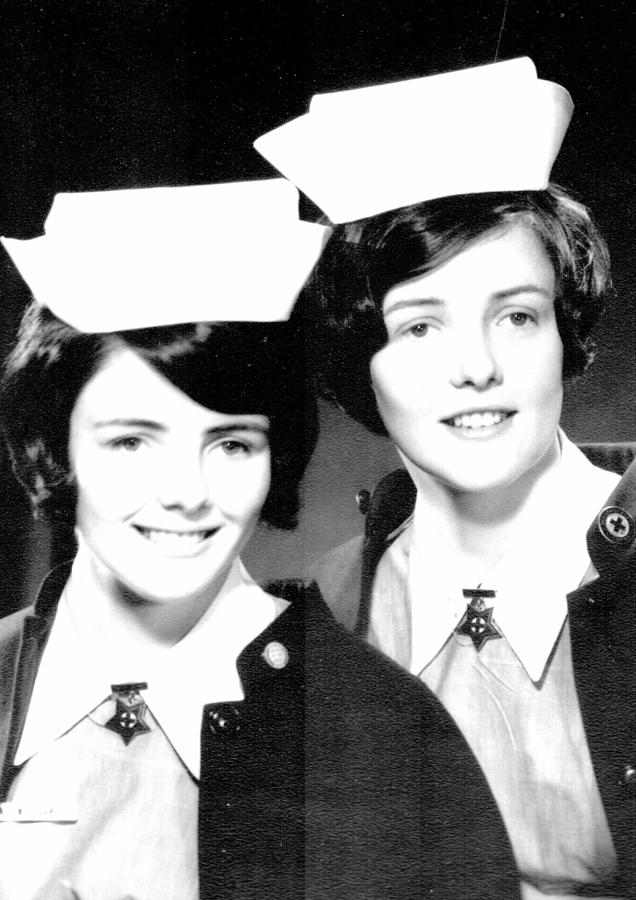Photo 1 | 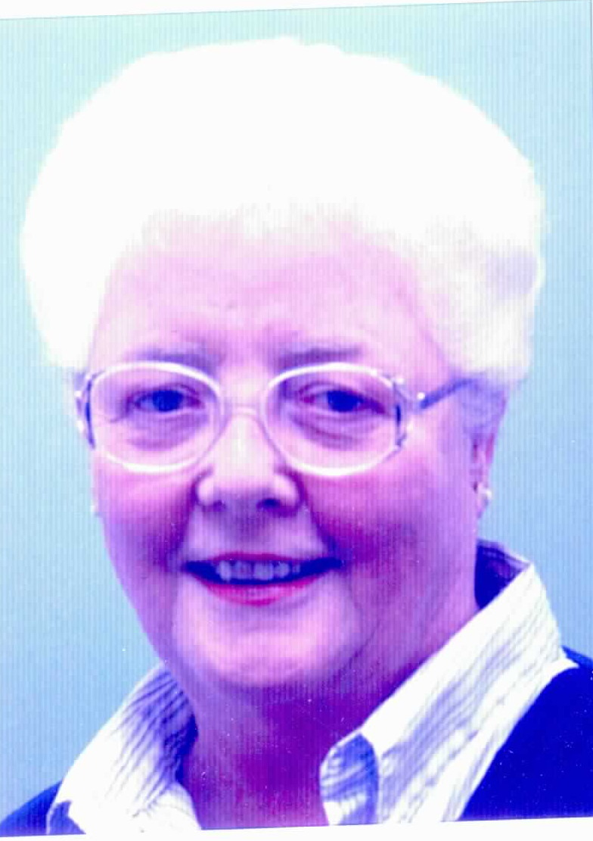Photo 2 | 1. Mary and Patricia Carroll, 1966  2. Patricia Carroll, 2013

000'04" | FILE INTRODUCTION
000'36" | GROWING UP
Born and grew up in DUNEDIN. Family pioneers in area. Schooling at ST PHILOMENA'S COLLEGE FOR GIRLS. Describes.

MARY, sister, 18 months younger and JAMES, brother eight years younger. Father a clerk and mother a homemaker. 'Comfortably off family', able to participate in all school activities, music, speech. Describes.
002'18" | CHILDHOOD ILLNESS
Aged 4, diagnosed with PERTHES DISEASE, in frog plaster for two years. In bed-wheel-chair. 'Mother constantly lifting and moving me around.'
Experience of going to circus in CRUST AND CRUST mobile truck.

Started school at age six years, ' felt behind everyone ... became competitive early to make up'.
Periods in hospital, parents able to visit for one hour ' on three afternoons a week ... terrible awful times'. Describes.
003'27" | EARLY INTEREST IN NURSING
 | Desire to be a nurse cemented from early days in hospital,' impressed me in all sorts of ways... the order, the care, the nurses in their uniforms, the routines'. Describes.
004'06" | SIBLINGS
 | Sister, MARY also became a nurse. Brother moved into a variety of jobs. Explains.
004'36" | SCHOOLING
Primary and secondary schooling at ST PHILOMENA'S COLLEGE.
At secondary school channelled into academic stream, biology, sciences, English, French.
Elocution, speech through to 'Fellowship from TRINITY COLLEGE, LONDON'.

'Always determined to be a nurse ... when I get SCHOOL CERTIFICATE that will be that.' Sister in same class but completed a further year secondary schooling.
Describes.
006'23" | OCCUPATIONS AT TIME
 | Many of class went on to UNIVERSITY, four or five went nursing. One of class went into MEDICINE. Describes.
007'38" | APPLYING FOR NURSING
 | Commenced nursing straight from school, aged 17 years. Interview with MATRON-IN-CHIEF, MISS GLADYS BOYD, 'very imposing figure'. Mother accompanied to interview. Describes.
008'42" | FATHER HAS OPPOSITION TO CAREER CHOICE
 | After being accepted for nursing, father felt nursing not a very suitable career. Describes.
009'34" | REFERENCES AND MEDICAL EXAMINATION
References required to support nursing application, school and neighbour, 'who was quite an influential person'.
Medical examination at nurses’ health clinic, and chest X-ray required.
Describes.
010'40" | WEIGH DAY
 | Medical examination at time student nurses was attending 'weigh day'. 'Every three months for first two years we were weighed ... very systemised process.’ Describes.
012'12" | APPLICATION INTERVIEW
MATRON-IN-CHIEF, MISS BOYD in uniform, sat behind her desk. 'I was very nervous.' Dressed in school uniform. Describes.
Not aware that there may have been other options for nursing, 'were going away anyway ... had to live in nurses' home'. Describes.
013'15" | FIRST DAY
Parents delivered to the NURSES' HOME, rooms allocated in alphabetical order, 'girls from P onwards had beautiful balconies'.
Uniforms waiting on bed, paper with instructions,' had been told to bring with us a duster, a doily for the dressing table ... a bed-cape in case we ever got sick and had to go to sick nurses'.

Shown around and taken to dining room by HOME SISTERS, ' all in SISTER'S uniform ... imposing'.
'After tea ... asked to introduce ourselves and say what our fathers did'.
Shown how to fold caps.
Details.
015'55" | DUNEDIN UNIFORMS
Purple dresses with porcelain buttons, short sleeves. In wards wore white overall, over uniform with hank buttons. White shoes and stockings. Cap.
Scissors and pen in pocket and a pocket watch with second hand.
Describes.

016'56" | NURSING CLASS
47 girls commenced, class broken up and joined class from next six months. 'By the time we finished our training only eleven of original group left.' All girls, all school leavers and from local area. Describes.

'Famous student in class ... Miss Vance', became Miss Vance before starting training. VANCE was an AMERICAN ship, sailors had Miss Vance contest, 'one of tutors called her Miss Vance by mistake'.
Details.
019'24" | PRELIMINARY SCHOOL
Three months in PRELIMINARY SCHOOL, 'progressive exposure to the wards ... from about third week ... five days in classroom, half day on Saturday, over in the wards'.

'Through INTRODUCTORY SCHOOL we were the cleaners ... pan room ... instrument room ... towards the end went into the wards for one or two days a week... with the junior nurse ... next one up ... had fellow feeling ... but not too sure what you learned ... fluid rounds ... cleaning rounds.' Describes.

Curriculum including a lot of ANATOMY and PHYSIOLOGY, PHARMACOLOGY, 'sessions on ARITHMETIC ... every morning, practicals ... demonstration room ... learning how to wash without exposing anyone ... none of students ever got undressed ... bandaging ... machine to roll bandages'.

TUTOR SISTER with UNIVERSITY degree, major in PYSCHOLOGY, 'talked about how people felt ... what it was like to be sick ... how nurses might behave if for example male patients got a bit stroppy'.
MEDICAL OFFICER of HEALTH reinforced what it was like for males to be in hospital, 'reinforcing idea that people in the community needed help too'. Describes.
023'22" | LINKS WITH MEDICAL SCHOOL
 | Close links with MEDICAL SCHOOL, ‘PROFESSORIAL exposure all the time'. Explains.
023'40" | CLASS DROP OUT RATE
Only eleven of class graduated, 'started to leave in first year ... mostly because wanted to get married ... one or two got pregnant ... couldn't stay in nursing if pregnant ... had to live in NURSES' HOME. Describes.

Several left 'because failed examinations ... at the end of first year'. Explains.
024'27" | FLATTING
Able to live - in for first two years, ' question of flatting in third year ... got parents involved ... BOARD finally agreed, if you get your parents’ permission you could go flatting ... DUNEDIN all about flatting'. Describes
JAMES K BAXTER 'poem about flatting written at that time'. Explains.
025'25" | DUTIES
Three shifts, 7 am to 3 pm, 3 - 11 pm and 11pm to 7 am. Six week rotations, towards end of first year 'doing six weeks of night duty'. Describes.
Morning shift, report at 10 to 7, three on a shift, 'junior, intermediate and senior and STAFF NURSE, WARD SISTER came on at 7.30am ... night nurse who was a student would tell you anything that had happened ... wrote down name of all the patients and what they needed. Senior nurse did the dressings, intermediate nurse the bed-pans, junior nurses everything else ... the sponges ... make the beds. .admit the patients ... fluid rounds ... in a hurry ... breakfast was at 8 ... all patients had to have face and hands washed, glasses collected in and breakfast trays given out'. Details.

NIGHTINGALE WARDS, about 24 patients in a ward with side rooms, sicker patients looked after by senior. Describes.

'Took turns to have own breakfast between 7.30 and 8 ... half hour for breakfast ... took whites off ... raced across main road of city to NURSES' HOME ... some raced off for a quick smoke ... fastest eaters in NEW ZEALAND'. Describes.

'Between breakfast and lunch ... admissions ... sponges ... dressings ... patients in bed for long periods ... got to know them well ... progressive care... patients about to go home helped with trollies, gave out fluids ... became an extra pair of hands.' Describes.
029'15" | DUTIES continued
Cleaners did the 'cleaning around you ... junior nurse did the cleaning in sluice room at end of shift ... only the junior answered the bells and gave out bed-pans ... REGISTERED NURSES really did nothing very much'. Describes.

On afternoon shift, 'three star nurse, a senior and junior nurse on ... and you managed ... SUPERVISOR floating over whole hospital ... often a STAFF NURSE who worked 11 am to 7 pm ... STAFF NURSE coverage until after tea'. Describes.
Split shifts 8am to 12 and 4 - 8pm, 'extra pair of hands in busier wards'. Explains.
031'06" | WORKING CONDITIONS
 | Worked six days a week, during STUDY BLOCKS had an extra day off. ‘Made me into a TRADE UNIONIST, we would come off duty and there would be a note on our doors , your study day has been cancelled ... two weeks without any day off at all ... hard physical work.’ Describes.
033'02" | NATURE OF EQUIPMENT
 | Recalls STAFF NURSE melting MORPHINE in spoon, rubber connections for INTRAVENOUS bottles.' Did move over to PHARMACY dispensed meds, plastic disposals ... REGISTERED NURSE changed the bag of fluid ... we looked after the wounds, gave out all the medicines...no name tags on wrists.’ Describes.
033'41" | WARD SISTERS
WARD SISTER ' ran the place ... very efficiently ... rosters ... rostering a big thing ... all the discussion with the DOCTORS ... wrote the report ... she sat and had morning tea that we had prepared on trays'. Describes.
'Before starting in a new ward, met the junior and the WARD SISTER ... junior told you how SISTER liked her tray and what time it had to go out'. Describes.
STAFF NURSE relieved the WARD SISTER. Explains.
035'22" | DOCTORS
Had a lot to do with the DOCTORS, REGISTRAR and MEDICAL STUDENT training, 'came over to give us lectures', student nurses invited to join discussions with MEDICAL STUDENTS, WARD SISTER , teaching hospital, 'DOCTORS in the wards all the time, REGISTRAR and HOUSE SURGEON.’ Describes.

'Distinct hierarchical difference at PROFESSORIAL level, TOM O'DONNELL... when he did his round no-one went into that ward ... made sure everyone had a bed-pan before he came ... came in with his retinue.' Describes.
037'42" | PATIENTS/MEDICAL ADVANCES
Patients all in hospital a long time, TUBERCULOSIS patients, big PAEDIATRIC unit, CANCER treatment unit, COBALT therapy, 'found looking after some of the cancer patients really difficult ... getting progressively sicker ... treatment making them worse'. No PSYCHIATRIC nursing. Describes.

Senior nurse, sitting STATE FINALS, 'specialling person having first HAEMODIALYSIS ... then first person who had a PACEMAKER inserted ... REGISTRAR slept in the room next door'. Describes.
Reflects looked after these patients as a student nurse.
040'27" | STAFF NURSE ROLE
 | STAFF NURSE role was to help SISTER, 'always collected DANGEROUS DRUGS ... kept all the stocks up ... kept the emergency equipment ready to go'. Describes.
040'49" | CURRICULUM
COMMNUITY and OBSTETRICS included in CURRICULUM. STUDY DAYS 'until final year ... had study blocks'. MATERNITY NURSES 'still training ... always felt we were so much more superior to them ... always bottom of pile until got into OBSTETRICS'. Describes.

Classroom teaching and ward work did not relate, 'SISTER MICHALEIS ... would come over to our ward once a week ... would talk about sort of things happening in that ward'. Describes.

Training was at DUNEDIN HOSPITAL and WAKARI HOSPITAL, TUTORIAL DEPARTMENT was at DUNEDIN HOSPITAL. Explains.
Some WARD SISTERS, excellent teachers, 'had little sessions at reporting time'. Describes.

DSITRICT NURSING, COMMUNITY NURSING ' nursing people in bed in their homes'. Describes.
044'01" | EXAMINATIONS
Examinations, at end of PRELIMINARY SCHOOL, theory and practical, after six months ' another exam ... if passed that got our star ... end of year FIRST PROFESSIONAL ... second star at end of first year'. HOSPITAL FINALS and STATE EXAMINATION in third year. Describes.
'Supported each other ... worked together on lots of things.' Describes.
046'02" | CHANGES TO NURSE EDUCATION
 | During training not aware of any dissatisfaction with NURSE EDUCATION, 'happened pretty soon after ... year after I graduated ... MRS BOHM coming around telling us we were having all sorts of investigations'. Describes.
046'02" | PAY AND CONDITIONS
Commenced with,' ten pounds a fortnight ... thought we were made ... had never worked before ... uniforms provided, meals provided, everything provided ... became fashion conscious... residences were very nice ... lovely old single rooms....moved to another part when on night duty. Threatened us with a HOME SISTER's inspection'. Describes.

WAKARI HOSPITAL, quite new, 'living there ... isolated ... were room inspections there ... not allowed in lounge at all ... ate in hospital for meals... used to say survived WAIKARI ... not happiest part of training'. Describes.
WAKARI HOSPITAL, CHILDREN'S HOSPITAL, TUBERCULOSIS, COBALT THERAPY, PSYCHIATRIC UNIT, BURNS UNIT. Explains.

Also PARKSIDE HOSPITAL, GERIATRIC, ' just donkeys ... horrors at lack of nursing care ... WARD SISTERS did look after patients there'. Describes.
Did grumble about conditions, went to see MATRON at WAKARI, television set in the lounge, 'we were not allowed in there ... I'm here on behalf of nurses ... would like to go into lounge and look at it ... let us go for so many hours a day ... scrupulous about taking our mugs out'. Describes.
Was nominated to be spokesperson for group, 'something had to be done ... we were isolated'. Explains.
054'18" | SOCIAL LIFE
Attended FACULTY balls each year, had boyfriends, students lived in different hostels in DUNEDIN, 'social life difficult at WAKARI ... but had enough friends with cars to come and get us ... parents came and picked us up'. Had a curfew, ' had to be in by 11 o'clock, one late night a week ... had to sign a book if going out ... for our days off ... say where would be'. Describes.

Rebellion. 'went to friends place overnight ... had been a ring from the hospital ... friend's mother told them it was not very sensible for chasing them up at their stage of training'. On another occasion, call to say day off cancelled, ' mother said she won't be home'. Describes.

Reflects that other people could see that there was outmoded way of running things.
057'12" | SMOKING AND ALCOHOL
Everyone smoked, learned to smoke during OBSTETRICS. 'Had to be on duty at 5.30am ... took babies out to the mothers to feed ... an hour to fill in ... went into bathrooms and smoked.' Describes.

Alcohol never in the NURSES' HOME 'had to be on duty early next morning ... alcohol not part of social life'. Explains.
058'49" | STUDENT NURSES' ASSOCIATION
 | Part of STUDENT NURSES' ASSOCIATION, ' invited to join right from start'. Became involved in NURSES' ASSOCIATION when became registered. Describes.
059'38" | GRADUATION
Middle of year STATE EXAMINATION, three papers and practical examination. 'I had to do the pill round on my ward ... SISTER went around with me ... all the patients in on it ... they were very supportive.' Describes.

Written examinations were not difficult, related to medical things. Explains.

Tradition that given a medal to wear 'until you got your own', PROFESSORS congratulated, afternoon tea, graduation ceremony. ‘Made the speech on behalf of the graduating class.' Describes.
063'01" | NURSES' DRAMA GROUP
 | All of OTAGO, SOUTHLAND area hospitals had drama groups, went around putting on one act plays, 'INVERCARGILL... MISS KINROSS welcomed us, stayed in NURSES ' HOME, OMARU, DUNEDIN welcomed people there'. Describes.
063'41" | GRADUATION CEREMONY
Afternoon graduation ceremony, BOARD members attended, wore uniforms, Dean of HOME SCIENCE FACULTY 'gave inspiring address ... being prepared for change'. Describes.

Presented to CHAIRMAN of BOARD at graduation ball. Describes.
064'43" | END OF FILE 2

Recorded: | 18 NOV 2013 | File: 2 of 2
Interviewer: | Margaret Horsburgh
Abstracter: | Margaret Horsburgh
Equipment type: | Fostex FR- 2LE Digital Recorder

000'05" | INTRODUCTION TO FILE 2
000'28" | REGISTERED NURSE
Worked as STAFF NURSE, DUNEDIN HOSPITAL for two years,' including stint as floating AFTERNOON SUPERVISOR ... more hair-raising than being student alone on the words ... had the responsibility remotely ... could be down one end of DUNEDIN HOSPITAL ... post-surgical collapse might happen right down the other end, five stories up '. Describes.
Had been asked where wanted to work, had been invited to be part of 'start-up of first INTENSIVE CARE UNIT ... wanted more general experience ... then went to EYE and ENT [EAR,NOSE and THROAT] ward ... then asked to do some theatre work ... turned this down ... so made me AFTERNOON SUPERVISOR'. Describes.
002'37" | FULL-TIME NURSE TEACHER
Had become interested in teaching with students in EYE, ENT ward, 'used to work with students quite a lot ... WARD SISTER brilliant'. Describes.

PRINCIPAL TUTOR invited to join DEPARTMENT, joined 'school for three months while new introductory class comes in ... never looked back'. Enjoyed teaching. Describes.

No initial orientation for teaching, JANET GARDINER, PRINCIPAL TUTOR, did suggest a course at SCHOOL OF ADVANCED NURSING STUDIES, WELLINGTON , 'will put your name forward ... perfect introduction ... curriculum, planning ... went out into schools ... watched people teach'. Course six weeks, run by DEPARTMENT OF HEALTH, BOARD sponsored attendance. Describes.
005'18" | PRELIMINARY SCHOOL TUTOR
 | Teaching roles initially with PRELIMINARY class, 'in support of teacher in charge... clinical demonstration assistant ... working in wards with students ... no lecturing'. Describes.
005'48" | ADVANCED DIPLOMA IN NURSING YEAR
Completed ADVANCED DIPLOMA IN NURSING, 1970, WELLINGTON. Following year studied Stage 1 English and Education, OTAGO UNIVERSITY, 'found really hard'. Describes.

ADVANCED DIPLOMA IN NURSING, with BEATRICE SALMON, ALICE FIELDHOUSE, RITA MCEWEN, ' looking at all these reports that had come out from the WHO [WORLD HEALTH ORGANISATION] ... changes in nursing ... discovering what nursing meant for me ... the head, the heart and the hands ... nursing came alive for me ... exciting ... changing from the DEPARTMENT OF HEALTH ... the ORBELLS had fixed things over the marmalade ... one was DIRECTOR of EDUCATION, the other DIRECTOR of NURSING ... nobody was consulted'. Describes.

'That year, 1970, huge amount of unrest about nursing ... the grip had to be loosened to allow the vision and the knowledge to flood into nursing ... VICTORIA UNIVERSITY involved ... nursing students as tertiary students ... we were part of that ... gave me a real focus for the future.' Describes.

Funded by DUNEDIN HOSPITAL BOARD, bonded for two years. Explains.
009'31" | APPLICATION TO BE PRINCIPAL TUTOR NORTHLAND
Sister and her family were in WHANGAREI, opportunity to make application to be PRINCIPAL TUTOR, NORTHLAND. Had been living with parents in DUNEDIN, lived in NURSES' HOME for first year after graduation. Describes.

Came to WHANGAREI for interview, 'said I had the job'. Describes.
010'39" | NORTHLAND, PRINCIPAL TUTOR
PRINCIPAL TUTOR for NORTHLAND SCHOOL of NURSING, three intakes of students each year,
'About thirty in each class', ENROLLED NURSE programme in three hospitals. Describes.

'Was on PROFESSIONAL SERVICES COMMITTEE OF NZNA [NEW ZEALAND NURSES' ASSOCIATION at this stage ... plotting and planning to have SCHOOLS OF NURSING done away with ... bit of contention in role ... politically difficult job'. 'Where girls went for employment, KAWAKAWA, DARGAVILLE, KAITAIA ... not many other employment opportunities ... graduation ceremonies were held locally ... unions got involved'. Reflects.

Role was mostly administration and providing leadership, no clinical teaching, did take course on 'the PROFESSION OF NURSING'. Describes.

Three TUTORS had ADVANCED DIPLOMA IN NURSING, in out-lying schools 'had years of experience’, two were clinically oriented, had been WARD SISTERS. Describes.
014'40" | NURSING COUNCIL
Appointed to NURSING COUNCIL, DEPUTY CHAIRPERSON, ANN NIGHTINGALE, CHAIRPERSON.
CHAIRPERSON of NURSING COUNCIL EXAMINATION COMMITTEE. Explains.

'Shortly after arrived in NORTHLAND big examination failure in NORTHLAND ... terrible ... needed to have a much more education focus', EDUCATION COMMITTEE didn't like approach, ' very difficult time'. Describes.
016'45" | NURSE ADVISOR/ NURSING COUNCIL
Approached to become NURSE ADVISOR for NURSING COUNCIL, moved to WELLINGTON. Describes.

Main role 'investigating complaints ... out and about following up where questions about nurses' practice'. Describes.

Changes to NURSING EDUCATION ' well underway', move to POLYTECHNICS. Explains.

Big issue for NURSING COUNCIL, 'relationship with DEPARTMENT OF HEALTH, DIVISION OF NURSING ... NURSING COUNCIL just formed ... NURSES and MIDWIVES BOARD had disappeared ... people looking for new roles ... quite a lot of tension'. Reflects.

Changed the examination system, 'started to present situations ... looking for analysis and interpretation ... big failure rate ... probably had moved a bit too fast '. TUTORS came to WELLINGTON to mark papers. 'Had standards to meet rather than regurgitate knowledge.' Describes.

'MARGARET STREET in charge of examinations ... gave great orientation to TUTORS ... moderators.' Describes.
021'57" | PROFESSIONAL NURSE PRACTICE COMPLAINTS
 | Many of complaints investigated, 'eight times out of ten ... huge great administrative hole that some inadequate person fell into ... cases where judgement were found wanting'. Reflects.
023'00" | EXECUTIVE DIRECTOR NURSES' ASSOCIATION
Invited to apply for the position of EXECUTIVE DIRECTOR of the NURSES' ASSOCIATION, [1983], struggled with the decision, whether 'to give up beloved NURSING COUNCIL for a real challenge', enjoying living in WELLINGTON, applied and took on role for four years. Describes.

'Nurses hadn’t had usual pay round ... through position ... was a member of COMBINED STATE UNIONS EXECUTIVE ... WHARFIES, POST OFFICE and everyone from STATE SECTOR ... LANGE GOVERNMENT ... nurses to be first off the rank ... public sympathy for nurses .. If nurses could get a pay rise everyone would be pulled along.'
Very difficult, STATE SERVICES COMMISSION did not want to give increase,' endless hours of negotiation'. 'Varying political views in ASSOCIATION ... trying to hold together and steer in particular direction... some in sympathy with LABOUR GOVERNMENT's problems.'
Good people came on side, JOHN BEATTIE, 'came into my office ... have been watching you on television, noticing what you have been doing ... very good reporters and journalists came on side... training with BRYAN EDWARDS ... was to do an interview on Sunday night .. faced MR BASSETT ... he had interfered with the negotiation process... that was really how we won it. DAVID LANGE called me into his office ... think we have to do a deal ... a strike notice had been signed ... managed to get the increase.' Details.
031'10" | PLANING FOR A STRIKE
 | With DEREK BEST, needed to work out a plan with HOSPITAL BOARD'S ASSOCIATION for 14 day strike, 'emergency call ... anyone rostered would be standing by ... no nurses abandoning anyone who is sick'. Describes.
032'04" | CHALLENGES/ MIDWIVES/MAORI NURSES/OCCUPATIONAL HEALTH NURSES
Further change at time ' move to put all REGISTRATION AUTHORITIES under one body ... had fought so hard to have own identity ... steered away ... DOCTORS didn't want either ... MRS BAZELY very supportive of me but strong proponent of change'. Describes.

MIDWIVES ' setting off on own direction ... MAORI NURSES ... wanting to do something'. Describes.

In position, 'was SECRETARY of OCCUPATIONAL HEALTH NURSES ... some wanted a standard contract ... impossible with individual employers'. Describes.
034'22" | VICTORIA UNIVERSITY
VICTORIA UNIVERSITY ' looking to get its first PROFESSOR of NURSING ... on selection panel ... issues around relationship between MASSEY and VICTORIA ... NAN [KINROSS] wanted a COLLEGE of NURSING ... still didn't really have an identity. VICTORIA got underway in EDUCATION DEPT, thanks to PROFESSOR FIELDHOUSE'. Describes.

Enrolled in papers at VICTORIA UNIVERSITY, NURSING, TRADE UNION, PACIFIC STUDIES, ' but became too much ... give it away'. Describes.
035'49" | VALUING WORK
Reflects on synergy between professional issues and working conditions, ' professional people ... entitled to same salary'. Describes.

Some concern amongst some that didn't pay enough attention to the professional things ... began to talk about practitioners’, possibility of a practitioners standards association'. Describes.
037'42" | ACHIEVEMENTS AND DISAPPOINTMENTS
Reflects that major achievement during time as EXECUTIVE DIRECTOR, ‘getting some recognition for the nurse ... next in long chain of EXECUTIVES who had come before, SHONA CAREY, immediate predecessor'.

Set up NURSES' LIBRARY, with help of PERYERS, started some nurse fellowships. Identified the need to change the executive structure of organisation, ‘PRESIDENT more to the fore ... JOCELYN KEITH, became the PRESIDENT'. Describes.

Disappointed at the explosion of POLYTECHNIC courses, ' had tried to move away from training in tiny little towns ... did not achieve one of main aims of changes in nursing education ... periods of internship ... in community and medical setting'. Describes.
042'13" | CHURCH MISSION WORK
'Decided if ever going to do anything with CHURCH MISSION work ... chance would pass ... joined group MISSIONARY SISTERS OF THE SOCIETY OF MARY ... went to FIJI ... worked in the TWOMEY hospital, LEPROSY hospital in SUVA ... then NALEBA ... little INDIAN village ... as hospital visitor.' Describes.

When NURSE ADVISOR, with NURSING COUNCIL, 'had been to FIJI and SAMOA to look at equivalence of training and standards'. Very basic conditions, 'toilets blocked, drains didn’t work ... too many people got into medical care too late ... no understanding of PSYCHIATRIC' conditions. Describes.

TWOMEY hospital well run and resourced. Explains.
044'45" | GERMANY
 | Lived in DESSAU, east side of GERMAN border, SISTERS setting up HOSPICES, concrete block flats, 'COMMUNISTS had to house the people ... GERMAN GOVERNMENT transforming DESSAU'. Describes.
046'04" | RETURN TO NEW ZEALAND
Sister, MARY,' became very ill in NEW ZEALAND ... 1995 ... came home'. Stayed in WHANGAREI, ' nursed sister for a few months ... she died aged 49 years'. Describes.

Married MIKE, brother-in-law, in 2006. Explains.
047'44" | NEW ROLE/ NATIONAL COORDINATOR FAMILY PLANNING
 | After MARY died, invited to become NATIONAL COORDINATOR for FAMILY PLANNING, able to work from home, role for five years until FAMILY PLANNING structure changed. Describes.
048'35" | OCCUPATIONAL HEALTH NURSE
 | Offered position as OCCUPATIONAL HEALTH NURSE with company who supplied OCCUPATIONAL HEALTH NURSES, ' monitoring, sight, hearing ... ended up at REFINERY,' [MARSDEN POINT]. Retired 2012. Describes.
050'16" | REFLECTIONS ON CAREER
Nursing,' has given the most wonderful life ... travelled all over the world ... when with TRADE UNION movement ... joined group on DUKE OF EDINBURGH study tour ... studied post-industrial society'. Describes.

Reflects on skills needed, 'why is it happening ... enquiry ... what can we do about that', value of interaction with senior MEDICAL PROFESSIONALS.
053'05" | CELEBRANT
 | Became CELEBRANT, 1997, encouraged by FUNERAL DIRECTOR, pastoral background ... ‘do a couple of funerals a week'. Explains.
054'02" | REFLECTION ON MISSIONARY WORK
During WELLINGTON years, ' involved with ST MARY OF THE ANGELS, central WELLINGTON church ... wide city outreach', need within city, compares with FIJI mission experience,' almost over missioned'.
GERMANY experience, similar ' to district nursing'. Reflects.
056'05" | FINAL REFLECTION
 | 'Head part of nursing very strong now ..., hope we do not lose the heart and hands part of nursing ... the tick box approach'. Reflects.
057'32" | END OF FILE 2

