Recorded: | 11 SEP 2013 | File: 1 of 4
Interviewer: | Debbie Dunsford
Abstracter: | Debbie Dunsford
Equipment type: | Fostex FR-2LE Digital Recorder

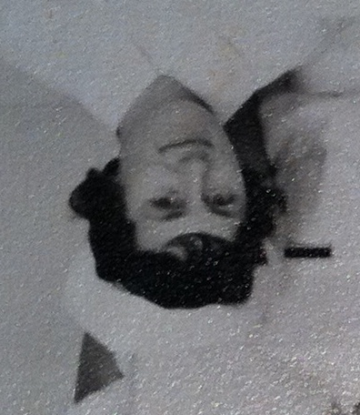Photo 1 | 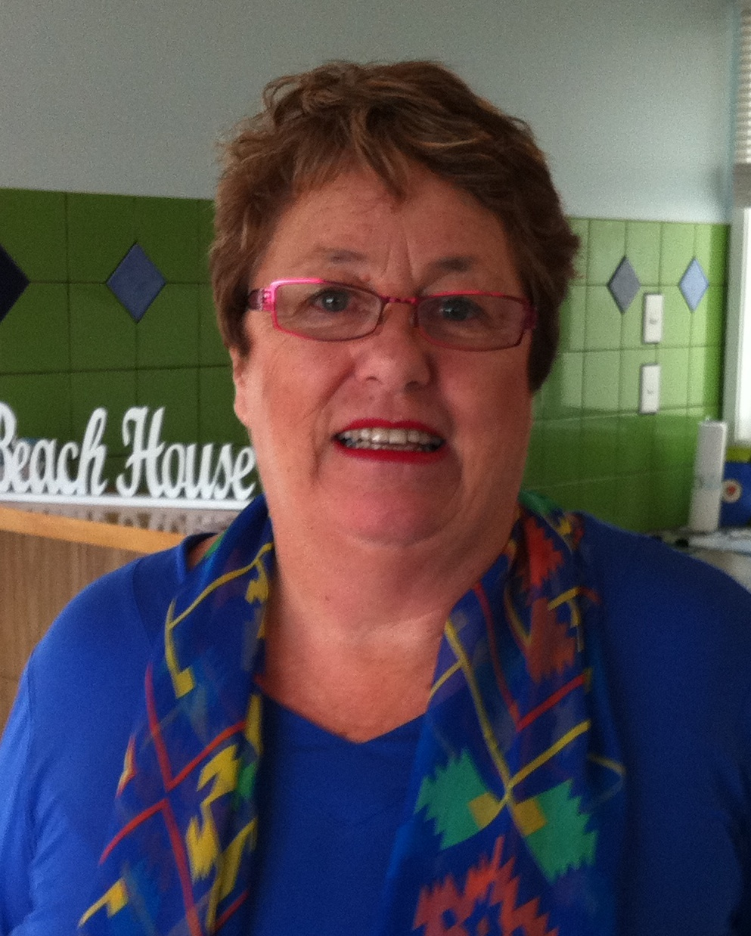Photo 2 | Photo 1: Margaret Rickard, Graduation Class Photograph, 1966.  Photo 2: Margaret Dietrich, 11 September 2013. Photo by Debbie Dunsford.

000'05" | INTRODUCTION & PARENTS
MARGARET DIETRICH, born 16 September 1945 in WELLINGTON. Recounts story of birth of twin brother and self. Twins not expected. [CHILDBIRTH]

Father MELVYN VICTOR RICKARD, a BAKER and SURVEYOR [OCCUPATION]. Father built BAKERY in TITAHI BAY. Retired in his late 50s. Mother and family involved in shop. Describes duties. Very good STANDARD OF LIVING but all worked very hard. Older sisters left school at 15 to work and help family.

Mother MARGARET EVELYN (nee CATO) RICKARD. PARENTS IMMIGRATED from SCOTLAND to PICTON. MOTHER worked as SHORTHAND TYPIST before MARRIAGE [OCCUPATION].
006'40" | SECONDARY EDUCATION
 | Attended MANA COLLEGE. Previously children travelled to WELLINGTON for SECONDARY EDUCATION. MARGARET more interested in social side of school and sport rather than academic studies. Describes parents' ATTITUDE TO EDUCATION. Did well in subjects she enjoyed. Passed SCHOOL CERTIFICATE the second time.
009'42" | DECISION TO GO NURSING
Could not start NURSING until 17 years old so stayed at school. Father not keen on her going NURSING.
DECISION TO BECOME A NURSE. As a result of brother's serious accident, MARGARET visited hospital for first time and 'totally fascinated' by it all. Wanted to be able to look after those people. Impressed by nurses and their white UNIFORMS. NURSES' work seemed 'so important'.

Some family members and a friend subsequently became nurses also. Her father 'did not like the thought of me looking after men'. Father had had time in hospital with PLEURISY following WORLD WAR 2. Thinks he also knew the demands of nursing. Mother happy for MARGARET to do what she wanted.
015'00" | APPLYING TO GO NURSING
 | Applied early in year and accepted without difficulty. Large classes but many dropped out within first year. Describes Miss COOK, MATRON, and Miss TOLERTON, MATRON-IN-CHIEF. WELLINGTON SCHOOL OF NURSING had reputation for excellence. REFEREES. Refers MRS WHEELER.
020'00" | PRELIMINARY SCHOOL
Began in January. Describes first day at PRELIMINARY SCHOOL. Assigned rooms. Describes UNIFORM. Uncomfortable because so stiff. About 60 in class. Make up of class. Refers WELLINGTON, BLENHEIM, NELSON, MAORI, IRIHAPETI RAMSDEN, CULTURAL SAFETY, MATURE STUDENTS, MALE NURSES, PSYCHIATRIC TRAINING.

Describes strict RULES about wearing UNIFORM. Recalls going FLATTING in third year and not allowed to wear UNIFORM outside HOSPITAL grounds. Refers CROSS-INFECTION, HUTT HOSPITAL.
030'25" | PRELIMINARY SCHOOL CLASSES
 | Three TUTOR SISTERS. Describes MEDICAL CHECK and ongoing health monitoring. MOCK WARD. EXAM at end of three months and became a Year 1 student. 'A lot of girls left within days.' Discusses possible reasons for leaving, FRIENDSHIPS. An achievement to get through PRELIM.
036'00" | JUNIOR NURSE, SURGICAL WARD
After passed PRELIM EXAM, allocated a ward. Refers SURGICAL WARD. Reflects on the excellent WARD SISTER. Always working with a senior nurse at first. Refers VARICOSE VEINS, HAEMMORHOIDS, BED REST, BEDPANS, BEDMAKING. WOUNDS were the job of the SENIOR NURSE. Describes CLEANING and SLUICE and STERILISING ROOM duties. Recounts incident when WARD SISTER used bed linen to mop up after steriliser overflowed.

COOKING duties for some PATIENTS. DIETITIAN gave lectures and practical instruction. Refers EGG NOGS, BEEF TEA, COMPLAN. SCRAMBLED and POACHED EGGS cooked by nurses.
045'15" | SHIFT STRUCTURE
Describes how always arrived at work early and left late. Assigned jobs on ward and had to complete them. JUNIOR NURSES had no time to talk to PATIENTS and not their role.

Describes characteristics of shifts. MORNING SHIFT busy. AFTERNOON SHIFT less busy but fewer staff. SPLIT SHIFT 'a horrible shift'. Very difficult to get time off or change rostered shifts.
051'30" | PATIENT CARE
Describes PATIENT CARE as a JUNIOR NURSE. Refers BED SPONGES, BED SORE TREATMENTS. Doing some DRESSINGS and giving out MEDICATIONS by end of first year.

Describes NIGHT SHIFT DUTIES in second year. Felt some anxiety about NIGHT SHIFT. Could call for help from SENIOR NURSE who rotated through the SURGICAL WARDS.

Describes seriously ill patients who had had POPLITEAL GRAFTS. Disoriented from long time under ANAESTHETIC. In ordinary ward as before INTENSIVE CARE UNITS. Some patients dying. No understanding of this or teaching about it. PAIN RELIEF restricted to four hourly. Very difficult especially on nights on your own. EMOTIONAL SUPPORT from friends and SENIOR NURSES.
061'50" | NURSE AND DOCTOR STAFF RELATIONSHIPS
Describes how SISTER and STAFF NURSES ran the wards.

Describes DOCTORS' role with PATIENTS. Good relationship with REGISTERED NURSES. Informal learning relationship might form in evenings between STUDENT NURSES and HOUSE SURGEONS. Sometimes able to observe DOCTORS' ROUNDS.
065'15" | MATRON'S ROUND
 | MATRON could appear at any time. Seemed to know who everyone was.
066'10" | TEACHING AND WARD WORK
Describes teachers and teaching. Refers BLOCK COURSES, MEDICINE, SURGERY, GYNAECOLOGY, EXAMS. Discusses relationship between FORMAL TEACHING and WARD WORK.

COMMUNITY NURSING experience. Refers DISTRICT NURSE, PUBLIC HEALTH NURSE, PLUNKET NURSE, TUBERCULOSIS, GERIATRIC PATIENTS, OBSTETRICS, MATERNITY.
071'30" | CHANGES IN NURSE TRAINING
Nurse dissatisfaction with hours worked and feeling that people in hospital too long. Recalls patients were all 'sitting around playing cards and SMOKING, and drinking beer. It was like a big party' while waiting for their stitches to be taken out.

Nurses couldn't understand how nurse training could be only in a school. Strongly against POLYTECH TRAINING.
073'47" | EXAMS
Hard to fit STUDY in with duties. Refers STUDY GROUPS. If failed, sat again. If passed HOSPITAL FINALS, would be able to pass STATE FINALS. Nearly always 100% pass rate for STATE FINALS.

Not allowed to be married as a STUDENT NURSE. Had to leave. Relates how one older MAORI nurse in the class was married and had a child. Mother was looking after her son. Kept it a secret.

Discusses rule that a registered nurse who was married could not be a STAFF NURSE, had to be GENERAL DUTIES NURSE. Different DUTIES and UNIFORM.

FILE ENDS 79 minutes 26 seconds.

Recorded: | 11 SEP 2013 | File: 2 of 4
Interviewer: | Debbie Dunsford
Abstracter: | Debbie Dunsford
Equipment type: | Fostex FR-2LE Digital Recorder

000'05" | DISEASES AND TREATMENTS
VARICOSE VEIN SURGERY was common.

HEART SURGERY breaking new grounds in WELLINGTON. No BY-PASS MACHINES. Brought body temperature down before surgery. Refers TRACHEOTOMY.

Basic SURGERIES were BOWEL RESECTIONS, HYSTERECTOMIES, APPENDICECTOMIES, STOMACH SURGERY. NEURO SURGERY and INTENSIVE CARE very new areas.

Did some THEATRE NURSING as part of training. Particularly enjoyed SURGICAL WARDS.
004'37" | MEDICAL CONDITIONS
Common conditions were CONGESTIVE HEART FAILURE, DTs (DELERIUM TREMENS), ASTHMA. DRUG TREATMENTS changed things. Also nursing treatment, e.g. INTENSIVE CARE UNIT.

A lot of CANCER PATIENTS and difficult to nurse because often advanced and little can be done. Describes anguish of nursing some patients with BREAST CANCER, UTERINE CANCER, CERVICAL CANCER. Refers RADIO-ACTIVE RODS, CHEMOTHERAPY, PALLIATIVE CARE, SILVERSTREAM HOSPITAL.
009'20" | SILVERSTREAM HOSPITAL AND EWART HOSPITAL
Describes being at SILVERSTREAM HOSPITAL. TUBERCULOSIS PATIENTS were at EWART HOSPITAL for years.

BEHAVIOURAL PROBLEMS with DT patients. GLASS SYRINGES for injections. Refers PORIRUA HOSPITAL, ALCOHOLISM, STIGMA.
013'30" | ACCIDENT AND EMERGENCY WARD
MARGARET loved A&E [ACCIDENT AND EMERGENCY]. Found it exciting, challenging. A real team between doctors and nurses. Describes.

Refers ACCIDENTS, FIGHTS, HEART ATTACKS, DRUNKENESS, CHRISTMAS.

Children with CROUP would come and had to be 'specialled' in the steam room.
016'15" | NEW EQUIPMENT
 | NEW EQUIPMENT in INTENSIVE CARE UNIT. Refers RESPIRATORS. Thinks hospital well-resourced but equipment at time was basic. Describes BEDS.
018'27" | NURSES' HOME
NURSES' HOME great fun. Describes FRIENDSHIPS, ROOMS, BATHROOMS.

Used NURSES' LOUNGE. TELEVISION was new. DINING ROOM in OLD NURSES' HOME. Describes FOOD. Contrast with FEVER HOSPITAL [EWART] which was small and 'the food was superb, it was like a first class hotel'. MARGARET'S group of six were allowed to stay up there. Much more homely and persuaded MATRON to let them go FLATTING rather than move back to NURSES' HOME.

Describes ROOM INSPECTIONS in NURSES' HOME. 'Best room of the week.'

LAUNDRY arrangements. Describes drying cupboards.
024'30" | VISITING HOME
 | Went home [TITAHI BAY] on days off. Recounts buying a brand new MINI CAR in second year. Refers PRIVATE VEHICLE, PUBLIC TRANSPORT, SAVING. MATRON and MARGARET each received new MINI CARS the same week. Matron said 'I couldn't believe a student had a brand new Mini.' Refers OVERSEAS FUNDS, GENERAL MOTORS.
027'55" | CURFEWS
Describes LATE PASSES allowed each week. Otherwise had to be in by 9pm each night and doors locked. Most obeyed the RULES.

Got an 'all night pass' to go to BALLS. Describes difficulties getting in after NURSES' HOME locked. 'Spent more than one night in the public toilets in RINTOUL STREET'. Misdemeanours brought the threat of dismissal.
032'17" | HOME SISTERS
HOME SISTERS were 'horrible'. Describes. Treated well when nurses were SICK. HOME SISTERS were older NURSES who lived in the NURSES' HOME.

Some WARD SISTERS were known to be 'horrible'. Recounts experience of a friend with such a WARD SISTER.
036'30" | VISITORS AND FRIENDSHIPS
 | VISITORS allowed into LOUNGE only. Describes how wider and special FRIENDSHIPS evolved. Two girls sacked for THEFT [CAMARADERIE].
040'15" | MEMORABLE NURSES
 | Reflects on one memorable nurse who was a role model.
042'06" | FEMALE STUDENT DOCTORS
 | A few coming through. Later at KENEPURU HOSPITAL, doctors and nurses working much more as a team [TEAMWORK].
043'57" | MALE NURSES
 | Describes one MALE NURSE. Refers UROLOGY, CATHERISATION. Thinks nursing would have been very hard for a man, dominated as it was by women.
045'00" | SOCIAL LIFE
Went to PARTIES on SATURDAY NIGHTS. Not a lot drinking. Refers SHERRY, SPIRITS, BEER [ALCOHOL]. Went to DANCES at ST FRANCIS' HALL. Refers WALTZ, FOXTROT, JIVE, THE TWIST.

Many including MARGARET had BOYFRIENDS. Not difficult to maintain relationship. Went to BALLS and MOVIES. MARGARET did not do a lot of SHOPPING. SEWED own clothes and SHARED CLOTHES.

Some girls went out with STUDENT DOCTORS. Went to PARTIES at DOCTORS' RESIDENCE, FEVER HOSPITAL. Refers ALCOHOL, WHISKEY, SHERRY, WINE, SPIRITS. Recounts episodes. Socialised with UNIVERSITY STUDENTS. People rang the NURSES' HOME for partners to events.

Hard to keep up with friends outside nursing.
053'00" | SOCIAL EVENTS IN THE HOSPITAL
Describes CHRISTMAS CAROLS. No other regular events.

Describes occasion when QUEEN [ELIZABETH] and PRINCE PHILIP visited WELLINGTON HOSPITAL.
054'15" | SMOKING
'Everybody smoked.' Relates how started SMOKING so didn't notice the smoke of others. SMOKING later banned in hospital so went into toilets to smoke.

Some HEALTH CONCERNS. 'It's probably not very good for your lungs. And it will certainly make your babies small. That was it.' Exception was the CARDIO-THORACIC SPECIALIST who was fiercely against SMOKING.
057'16" | INTIMATE RELATIONSHIPS
Close relationship and informal ENGAGEMENT did not affect MARGARET'S determination to finish her training. Describes OVERSEAS TRAVEL to LONDON and EUROPE. Decided did not want to work in LONDON so returned home.

Discusses how girls became ENGAGED and did not complete training or MARRIED immediately after qualifying.

Not aware of any LESBIAN RELATIONSHIPS. Wondered if some of the HOME SISTERS were LESBIAN. Recalls that friend she shared room later became a LESBIAN but not then.

If became PREGNANT, had to leave. Unaware of ABORTIONS.
066'45" | SPORTS
Too hard to keep up TEAM SPORTS with SHIFT WORK. Refers NETBALL, HAITAITAI. Some girls involved in CHURCH. Unaware of NURSES' CHRISTIAN GROUP.

FILE ENDS 67 minutes 53 seconds.

Recorded: | 11 SEP 2013 | File: 3 of 4
Interviewer: | Debbie Dunsford
Abstracter: | Debbie Dunsford
Equipment type: | Fostex FR-2LE Digital Recorder

000'05" | SICKNESS
 | Describes care if SICK. MARGARET became sick with APPENDICITIS. Was PATIENT in HOSPITAL for the first time. Describes experience of pain after ABDOMINAL SURGERY. Helped her understand PATIENT'S PERSPECTIVE and learned from experience. Also, after having her first child, understood what CHILDBIRTH was like. Mentions had been unsympathetic as a student nurse.
005'50" | OTHER GIRLS' CAREERS / NURSES' ASSOCIATIONS
Knew other OCCUPATIONS earned more but NURSING more interesting and valuable.

Not involved in STUDENT NURSES' ASSOCIATION. Only involved in REGISTERED NURSES' ASSOCIATION after registration.
007'55" | PAY / FLATTING
Pay was 'terrible.' Realised value of board. Accepted that nurses were not highly paid. When went FLATTING, it was quite an expensive exercise. Would have had to return to NURSES' HOME if wanted to SAVE.

Recalls putting case to go FLATTING. Allowed but RULES. Easier to STUDY away from NURSES' HOME. Refers KILBIRNIE, PUBLIC TRANSPORT. Describes FLAT. Worked hard and were tired.
016'15" | FINAL EXAMS AND GRADUATION
Describes receiving results of HOSPITAL FINAL EXAMS. Member of NURSES' CHOIR rehearsing for opening of new NURSES' CHAPEL. Immediately became an ACTING STAFF NURSE. Sat STATE FINAL EXAMS after.

GRADUATION CEREMONY in [WELLINGTON] TOWN HALL. Describes UNIFORM colours. FAMILY attended. Sadness also because class broke up.
022'00" | STAFF NURSE, INTENSIVE CARE UNIT, WELLINGTON
Most patients had had MOTOR VEHICLE ACCIDENTS. Refers TETANUS. As a REGISTERED NURSE, other staff treated you with EXPECTATION and RESPECT. INTENSIVE CARE UNIT was a new development and had high ratio of REGISTERED NURSES. Refers VIETNAM WAR.

Found nursing SICK BABIES very upsetting. Parents not encouraged to stay. Refers SPINA BIFIDA, HYDROCEPHALUS.

Six months as STAFF NURSE before OVERSEAS TRAVEL.
027'56" | OVERSEAS TRAVEL
Intended travelling to LONDON and working as MIDWIFE. Describes travel by SHIP and in EUROPE. Did not want to live in LONDON and returned to NZ.

Met JIM DIETRICH on return voyage. Describes. Refers BERLIN, MELBOURNE, IMMIGRANT, DUNEDIN.
032'15" | PORIRUA PSYCHIATRIC HOSPITAL
While waiting to go to SYDNEY, AUSTRALIA, worked at PORIRUA [PSYCHIATRIC] HOSPITAL in ADMISSION WARD. Saw ACUTE cases, drug overdoses, suicide, self-admissions. Majority of staff were NURSE AIDES with very little training. Each ward had one PSYCHIATRIC NURSE. One PSYCHIATRIST. Theft of groceries, lack of nursing equipment. No equipment for stomach washouts. Patients didn't get care, nurses didn't get support or training. Good money because dominated by men. Only there 8 weeks so didn't join PSA.

Did another year after son, NICHOLAS, started school. Some improvement but still custodians rather than nurses. Improvements in administering SHOCK THERAPY. Refers PENTOTHAL. Some staff cruelty towards patients.
040'05" | TO AUSTRALIA AND MARRIAGE
Worked part-time while PREGNANT in HAEMATOLOGY in CONCORD REPATRIATION HOSPITAL, SYDNEY, AUSTRALIA. Took BLOOD and worked in LABORATORY. Describes. Missed FAMILY in NZ. Break in CAREER while CHILDREN young [PART-TIME WORK, CHILDCARE].

PORIRUA PSYCHIATRIC HOSPITAL. Describes.
049'15" | KEMP HOME
Appointed as SISTER at KEMP HOME, PORIRUA [GERIATRIC, PART-TIME WORK]. Describes. Refers ENROLLED NURSES, NURSE AIDES, WELLINGTON CITY MISSION, HOSPICE, PHYSICAL DISABILITY, DEMENTIA.

Compares the care of GERIATRIC PATIENTS today.

Discusses complex responsibilities in running a home. Refers JOY JONES, MATRON, CHRISTMAS.
055'55" | KENEPURU HOSPITAL, PORIRUA
KENEPURU HOSPITAL opened [1979]. Worked SHIFTS, FULL-TIME hours in four days. Children at INTERMEDIATE SCHOOL [CHILDCARE].

ORTHOPAEDIC WARD, then GENERAL SURGICAL WARD. Had been away from HOSPITAL NURSING for some years but 'you just fell into place really easily'. All REGISTERED NURSES so there was a lot of support.

FILE ENDS 58 minutes 57 seconds.

Recorded: | 11 SEP 2013 | File: 4 of 4
Interviewer: | Debbie Dunsford
Abstracter: | Debbie Dunsford
Equipment type: | Fostex FR-2LE Digital Recorder

000'05" | KENEPURU HOSPITAL
Describes contrast to WELLINGTON HOSPITAL. Refers UNIFORMS. Describes exceptional WARD SISTER, who was AMERICAN-trained, and her LEADERSHIP skills [BUDDY SYSTEM]. Refers POLYTECH STUDENTS.

Discusses SOCIAL DYNAMICS of a new and small hospital and change for the good [HIERARCHY]. WARD became GENERAL SURGICAL AND ORTHOPAEDIC. Time for a change.
006'50" | PLUNKET TRAINING
Children getting older and MARGARET could consider a CAREER change and STUDY. Accepted for 17-week intensive PLUNKET TRAINING at TEACHERS' TRAINING COLLEGE, KARORI, WELLINGTON.

Not paid while training but no course fees. No guarantee of job. Refers NEW PLYMOUTH, NAPIER, GISBORNE.

Subjects included CHILD DEVELOPMENT, ASSESSMENT, CHILD NUTRITION, BREASTFEEDING, CHILDHOOD ILLNESSES, GROWTH AND DEVELOPMENT. Refers CHILD PSYCHOLOGY, PUKETIRO CENTRE.
011'30" | PLUNKET NURSE, WAITANGIRUA
Accepted job in WAITANGIRUA. Very low income area with many PACIFIC ISLAND and MAORI families, some EUROPEAN and ASIAN. 'It was a good experience for me.'

Problems faced include POVERTY, lack of EDUCATION, SOLO MOTHERS, lack of PARENTING SKILLS, OVERCROWDING. Refers SCHOOL SORES, SCABIES. 'The majority were fantastic families making the very best of a very difficult situation.' 'The PACIFIC ISLAND mothers, they could really teach the world about BREASTFEEDING. They were brilliant.' Refers ABUSE, VIOLENCE. Discusses complexity of dealing with families as a PLUNKET NURSE.

Recounts incident of being asked to take a mother's baby for her. Advocated for mothers and families to other professionals and agencies.
017'35" | PLUNKET COMMITTEES AND FUNDRAISING
No committee in WAITANGIRUA at first. No FUNDRAISING, more of a MOTHERS' GROUP. Service funded by PLUNKET centrally. Expectation in middle class areas that committee will fundraise. Government pays PLUNKET SALARIES. Committees raise running costs for cars and rooms.

PUBLIC HEALTH NURSES no longer caring for MAORI BABIES in district as had traditionally. PLUNKET did not have good name with MAORI but now building better relationship.

Always tried to encourage PACIFIC and MAORI PLUNKET NURSES. Not much luck. Refers KAI AWHINAS. Have to be REGISTERED NURSE before a PLUNKET NURSE so big commitment. In 1980s, effectiveness of PLUNKET services depended on who and where. MARGARET loved the job.
023'35" | PLUNKETLINE
PLUNKETLINE is anonymous and people feel able to ask. Changed in 2000. Moved from WAITANGIRUA to TITAHI BAY PLUNKET. Mixed socio economic area. Volunteers established PLAYGROUP and community network.

Transition to PLUNKETLINE while still doing relief PLUNKET NURSE work in district. Continued to learn through PLUNKETLINE. Contrasts between PLUNKETLINE and the DISTRICT role. Line is a backup to nurses. Gives examples. Children up to 5 years only.

Describes training, teething problems and procedures for PLUNKETLINE. Thinks it's a very effective service. Clients from other countries comment on lack of similar service in their countries.
033'19" | PLUNKET
The main PLUNKET work is still in the district. PLUNKETLINE is back-up and support. 24 hour service.

Thinks of herself as a 'Well-child nurse'. PLUNKETLINE not supposed to discuss illness with mothers. Transfer callers to MINISTRY OF HEALTH HEALTHLINE who in turn transfer 'well-child issues' to PLUNKETLINE. Issues often include BEHAVIOUR, DIETARY, BREASTFEEDING, SUPPORT FOR MOTHERS, DEPRESSION. Referral to other services.
036'30" | NZ REGISTERED NURSES' ASSOCIATION / NZNO
 | Currently a MEMBER. Thinks she had to be a member when at PORIRUA HOSPITAL. Membership encouraged at PLUNKET. Legal support is valuable. Reads KAI TIAKI. No involvement in LOCAL BRANCH.
038'55" | CHANGE IN NURSING PRACTICE
 | More client or patient focussed and more open. More of a team approach between doctors and nurses. High technical knowledge of younger nurses but not so much nursing and caring. Relates own experience of speed of recovery after surgery today. Describes. Refers UTERINE CANCER, HYSTERECTOMY, MOBILISATION, PAIN RELIEF, INFORMATION. Reflects that longer term patients still require nursing care.
043'40" | CHANGES IN HOSPITAL ORGANISATION
 | Greater knowledge but also greater expectation. More INTERVENTION which is sometimes questionable for older people. Refers GANGRENE. Doctors now more approachable and give more information. Discusses role of NURSE PRACTITIONER.
048'00" | FINAL REFLECTIONS ON NURSING
Attraction of NURSING has been caring for people. FRIENDSHIPS intrinsic to her NURSING EXPERIENCE. Given CAREER OPPORTUNITIES. MARGARET is proud to be a nurse.

FILE AND INTERVIEW ENDS 51 minutes 28 seconds.

